Report on Micro Teaching
1. Workshop/Seminar/Conference/Invited or Extension Lecture:
Micro-Teaching
2. Online/Offline:
Offline
3. Institutional/International/National/Regional:
Institutional
4. Title:
Anusikhanam (Micro-Teaching by under graduate students of Sanskrit Department)
5. Date:
29th November 2025, 12:30 PM
6. Organizer(s):
Department of Sanskrit, Bijoy Krishna Girls’ College, Howrah
7. Funding (with proof):
Not applicable
8. Collaborators (with proof):
N/A
9. Resource Persons (with invitation and acceptance letters):
N/A
10. Number of Participants (with proof) & typed list of participants in excel sheet.
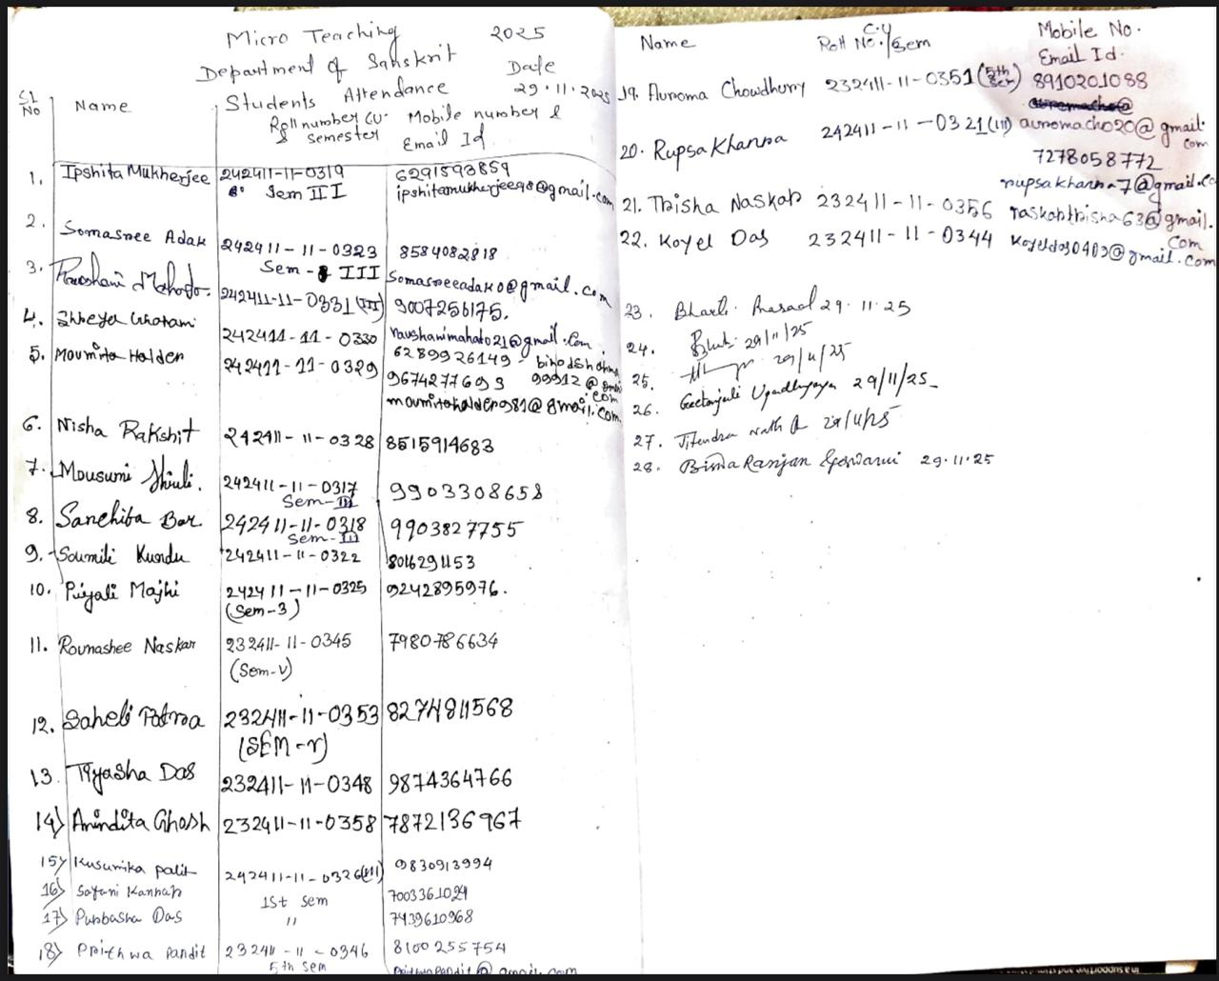
11. Report on the programme:
Micro teaching was organised by the Dept. of Sanskrit, Bijoy Krishna Girls’ College, Howrah for students of semester 1, 3 and 5 on 29th November, 2025 at 12:30 PM in departmental classroom.
The Departmental Head Dr. Bharti Prasad in her inaugural speech explained the importance of the programme and encouraged the students to take a part for their better academic future. Three students from semester 5 nominated themselves for micro teaching, namely Ms. Anindita Ghosh, Ms. Saheli Patra and Ms. Tiyasa Das and the topics they have chosen were Chanda, Karma Karaka and Śukhasopadesh respectively.
In the first session, which was chaired by Dr. Baisakhi Ghosh and Dr. Geetanjali Upadhyaya, Ms. Anindita Ghosh presented her deliberation mainly focussing on the definition of chanda (meter), concept of gaṇa, guru, laghu and especially on ekādasākharā chanda, elaborately explained indrabajra, upendrabajra and Śalini chanda.
In the second session, which was chaired by Dr. Biswa Ranjan Goswami and Dr. Bharti Pasad, Ms. Saheli Patra delivered her lecture on karma karaka (accusative case ending). She mainly focused on the meaning and definition of the word kāraka, classification of kāraka, definition of vibhakti and elaborately described karma kāraka and second case ending.
The third and last session was based on a text named Śukonāsopadesha taken from Bānabhatta’s Kādamvarī. Ms. Tiyasa Das was the teacher of the session which was chaired by Dr Jitendra Nath Das and Dr. Ajit Acharya. Ms. Tiyasa Das began her lecture with the explanation of classification of kāvya and more precisely, gadyakāvya. She read from a selected portion of the text and explained the meaning in vernacular.
All students enthusiastically participated in the programme and practically learned a lot about effective teaching. Quality questions were asked by the students which were effectively answered by the teachers. This programme was a great success.
12. Programme Outcome:
This programme will boost the confidence of the young teachers. By this micro teaching the young teachers will learn to self-prepare and manage a classroom effectively. Immediate feedbacks will allow the teachers to assess their own performances. These young teachers will definitely feel more confident in full-scale classrooms in their professional career.
13. Poster/ Brochure/ Banner:
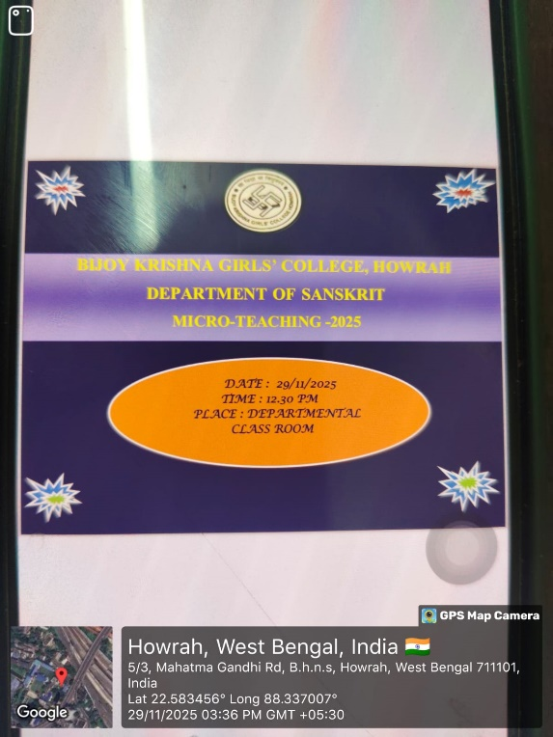

14. Sample Certificate:
N/A
15. Pictures (Geotagged):
