Report on Extension Lecture
1. Workshop/Seminar/Conference/Invited or Extension Lecture:
Extension Lecture
2. Online/Offline:
Offline
3. Institutional/International/National/Regional:
Institutional
4. Title:
An Introduction of Vedic Samhitas
5. Date:
9th of December, 2025
6. Organizer(s):
Dept. of Sanskrit in collaboration with Internal Quality Assurance Cell, Bijoy Krishna Girls’ College, Howrah
7. Funding (with proof):
Dept. of Sanskrit in collaboration with Internal Quality Assurance Cell, Bijoy Krishna Girls’ College, Howrah
8. Collaborators (with proof):
Internal Quality Assurance Cell, Bijoy Krishna Girls’ College, Howrah
9. Resource Persons (with invitation and acceptance letters):
Dr. Mou Dasgupta, HoD, Dept. of Sanskrit, University of Calcutta.
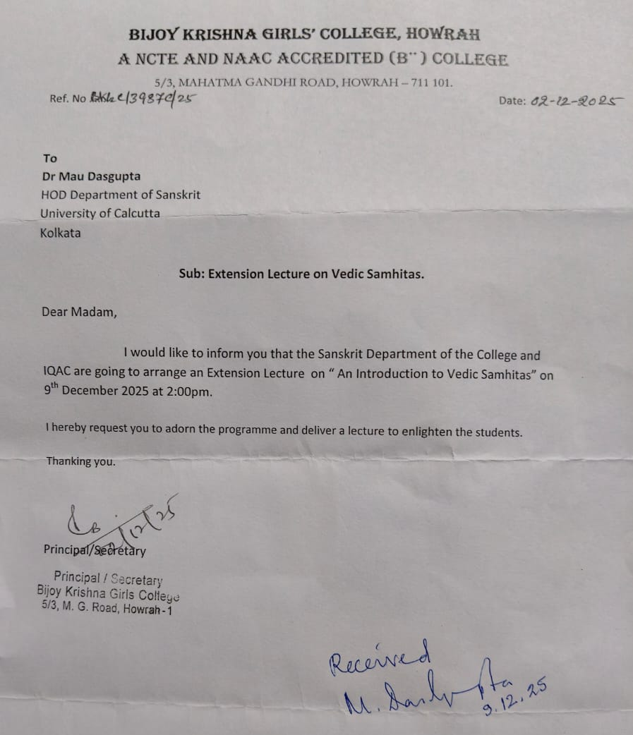
10. Number of Participants (with proof) & typed list of participants in excel sheet.
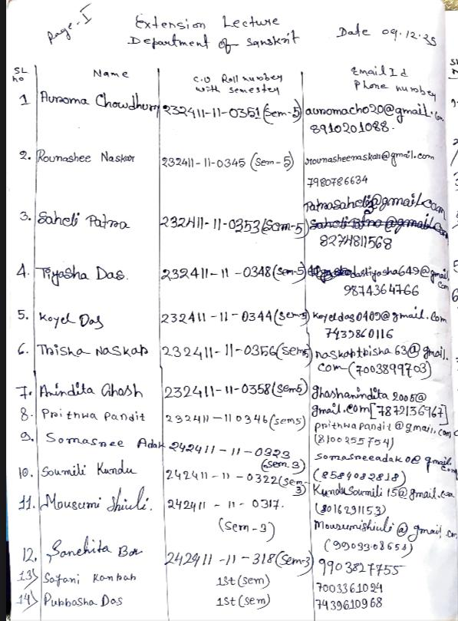
11. Report on the programme:
An Extension Lecture on ‘An Introduction of Vedic Samhitas’ was organized by the Dept. of Sanskrit in collaboration with Internal Quality Assurance Cell, Bijoy Krishna Girls’ College, Howrah on the 9th of December, 2025 at the College Campus (G-1 Classroom).
The programme was inaugurated with the garlanding of the statue of Bijoy Krishna Bhattacharya and the chanting of Sibasankalpa mantra along with two other verses. This was followed by the welcome speech of Dr. Bharti Prasad (Head of the Department and Associate Prof., Dept. of Sanskrit, BKGC). Teachers and students then felicitated Dr. Mou Dasgupta with flower bouquets and uttariya.
Dr. Mou Dasgupta’s lecture was an awe-inspiring display of intellect. She started her speech with the antiquity of Veda and mentioned UNESCO gave an honour of World Heritage to Rig Veda in the year 2008. She mentioned the value of prominent institutes like Asiatic Society and the stalwarts like William Jones, H T Colebrooke etc. who introduced us to the comparative philology. Students also came to know from her lecture that in the beginning only one imaginary language existed, which was Indo-European language, whose consonant part is preserved in Sanskrit. She then mentioned the end of vedic period is presumed around 1500 BC. How the great grammarian Panini (4th Century BC) bound Sanskrit. We follow Paninian Language since then. Panini classified language as chandas (Veda) and bhasa (Sanskrit).
She then gave explanation of the word Veda grammatically. She explained the root vid from which the word Veda came, which has four different meanings and every meaning is co-related. Veda is not only wisdom but a constant wisdom which can be gained with constant practice.
While explaining definition, she mentioned there are two ways of defining Veda, based on structure and context. For structural definition she mentioned apastamba (2nd Century BC). She elaborated different parts of Veda like, mantra, brahmana, aranyaka and Upanisad. In this context she explained yajna can be of three types viz. dravya yajna, bhava yajna and sraddha yajna. She gave example from Janaka Janabalka conversation and critically explained why Rig Veda, Sama Veda, Yajur Veda are not three types of Vedas but classification of mantras.
Quoted from Sayana (14th Century) she explained the contextual definition of Veda.
With the uttering of Mahavakya, explaining its meaning and how it is related to the fundamental thoughts of the Vedas, she concluded her engaging lecture.
12. Programme Outcome:
Veda has been recognized as World Heritage by UNESCO since 2008. Therefore, the Veda, which symbolises our old culture of society, should be known to all students, not only those studying Sanskrit. Students learned about the numerous facets of the Veda from a variety of viewpoints during this extension lecture.
There are disagreements amongst historians and Sanskrit academics over the age of the Indus Valley and Vedic civilizations. Prof. Dr. Mou Dasgupta provided a thorough explanation of the Vedic kala from an astronomical and historical perspective.

As a result, this presentation will undoubtedly pique young students' curiosity in Veda for future studies and as a research topic in the future.

13. Poster/Brochure/Banner:
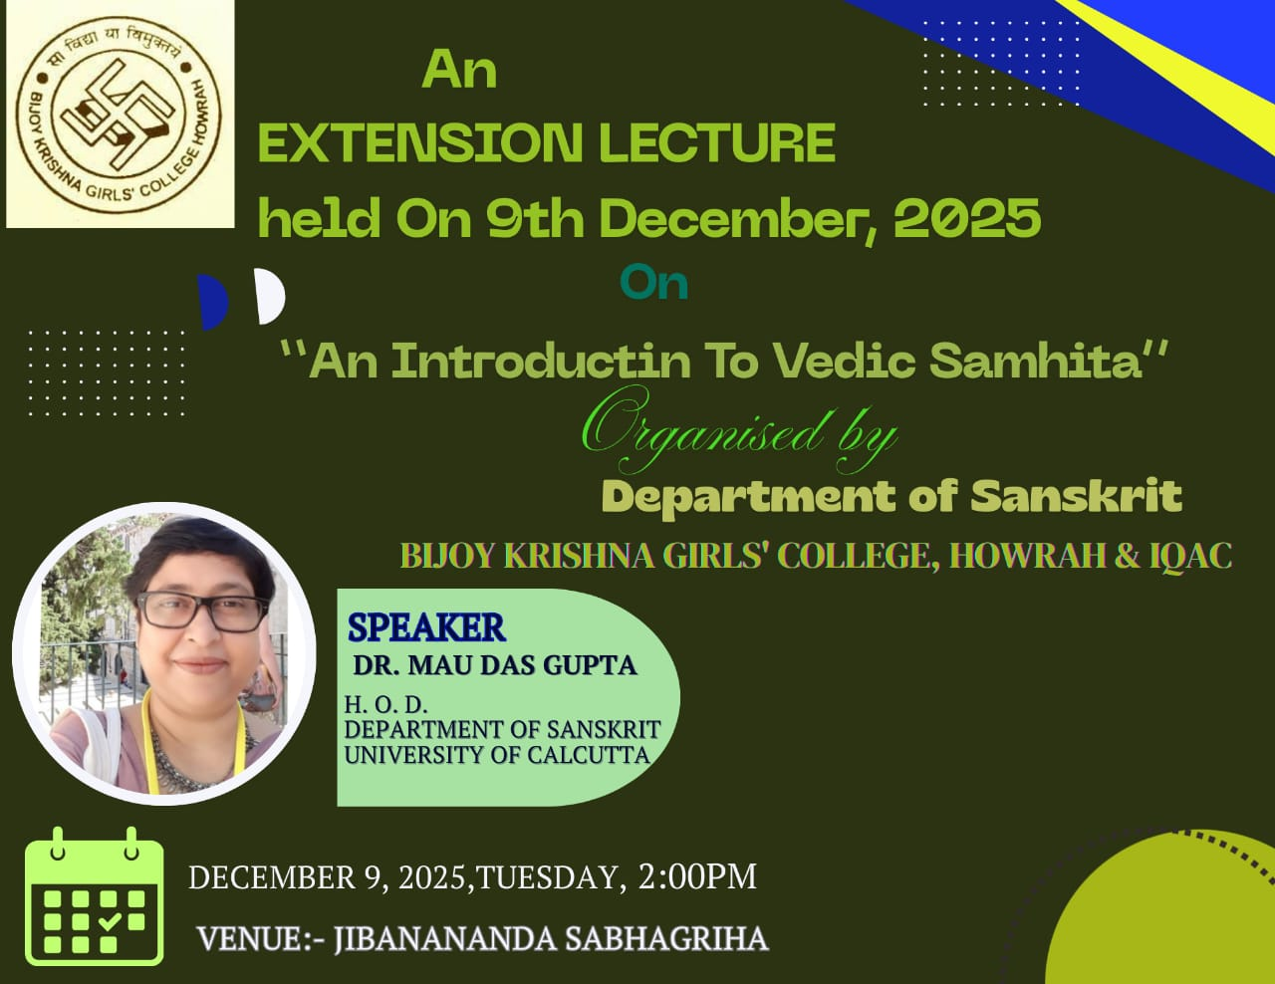
14. Sample Certificate:

15. Pictures (Geotagged):
