Report on Gita Jayanti 2025
1. Workshop/Seminar/Conference/Invited or Extension Lecture:
2. Online/Offline: Offline
3. Institutional/International/National/Regional: Institutional
4. Title : Samajik Sankat Nirasane Srimatbhagavatgitar Bhumika
5. Date : 10/12/2025
6. Organizer(S): Department of Sanskrit and IQAC
7. Funding (with proof): College
8. Collaborators (with proof):
9. Resource Persons (with invitation and acceptance letter): Sri. Dhananjay Chakraborty
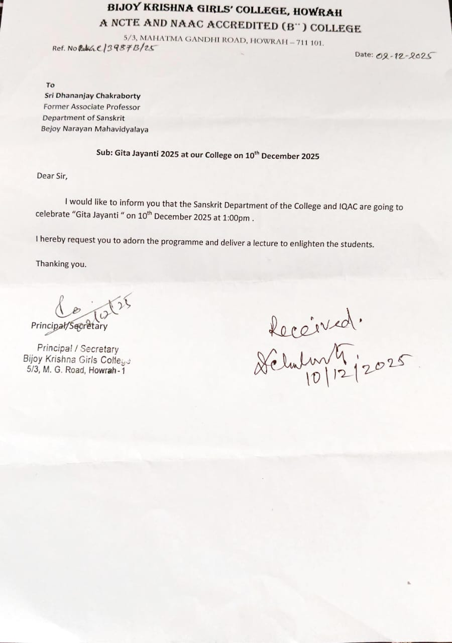
10. Number of Participants (with proof) & typed list of participants in excel sheet: 14 students,7 Teachers (separate excel file has been attached).
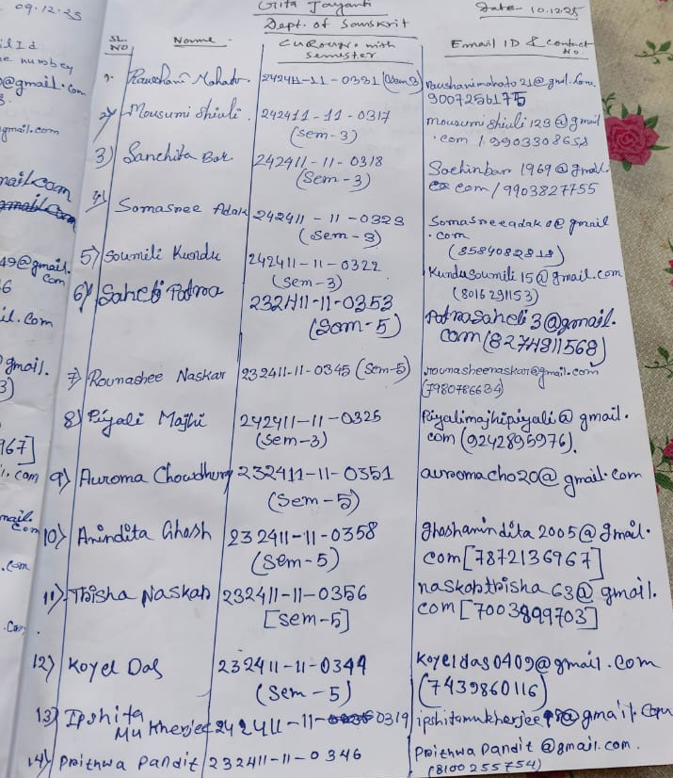
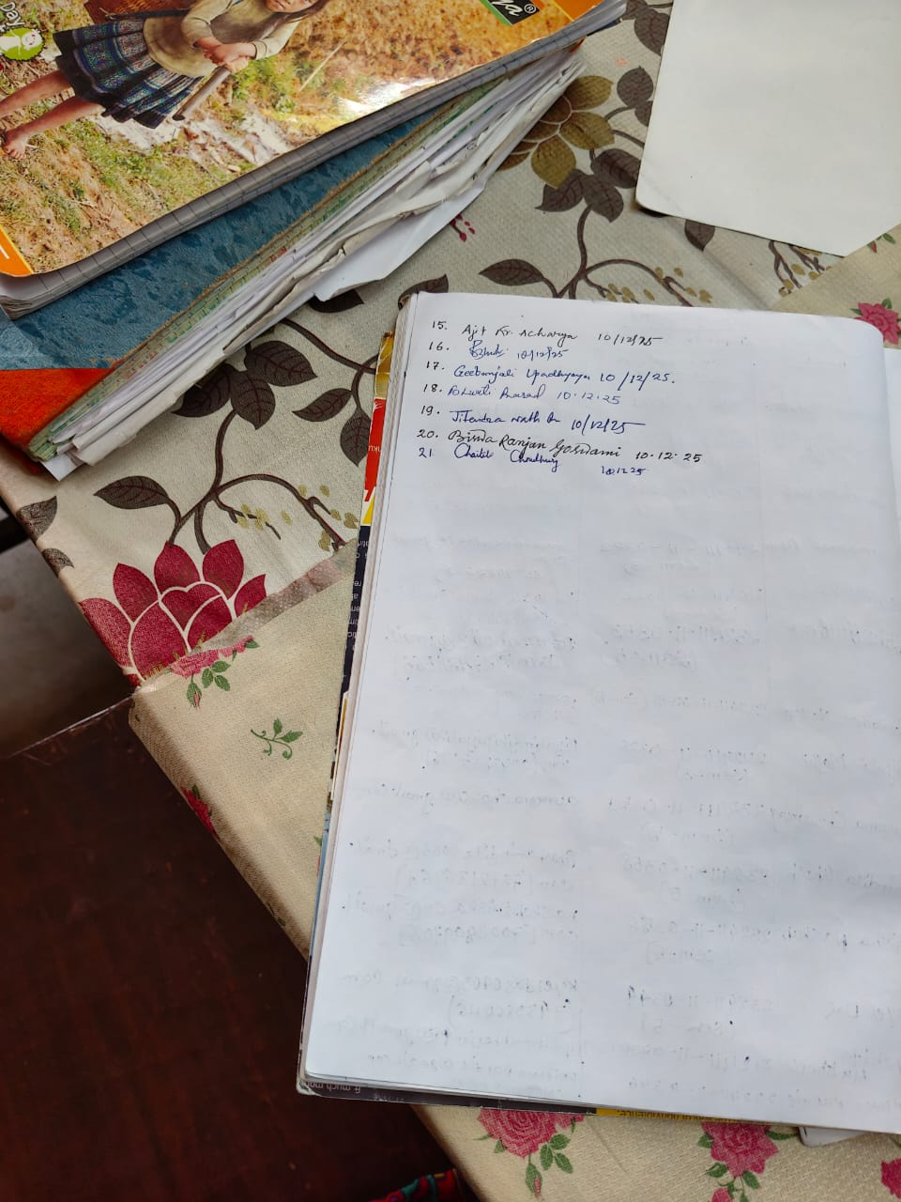
11. Report on the programme: Department of Sanskrit and IQAC had celebrated Gita Jayanti on 10/12/2025. Sri Dhananjay Chakraborty, former Associate Professor in Sanskrit, Bijoy Narayan Mahavidyalaya, Itachuna was speaker in the said programme. The programme commenced with Vedic chanting by the HOD Sanskrit Dr. Bharti Prasad; afterwards Principal of the college Dr. Ruma Bhattacharyya felicitated the speaker. Sri Chakraborty discussed how Gita is very relevant in today’s life. One of the most important lessons that we learn from Gita is to control negative emotions- lust, greed and anger are vices which must necessarily be controlled to make any contribution to the development of the self and society. The programme was ended with vote of thanks given by Dr. Jitendra Nath Das.
12. Programme Outcome: Programmes of this kind are very useful for the students. Self control and focusing on the present moment are essential for our development, and the Gita teaches us the relevance and inculcation of these qualities in detail.
13. Poster/Brochure/Banner:
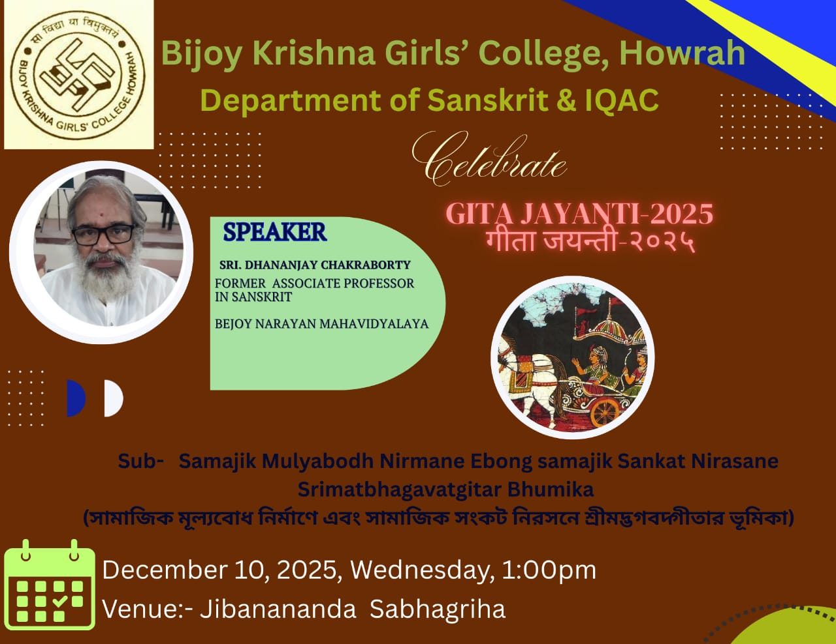
14. Sample Certificate:
15. Pictures (Geotagged):
