Report on Yajika Prasiksanam Karmashala
1. Workshop/Seminar/Conference/Invited or Extension Lecture: Workshop
2. Online/Offline: Offline
3. Institutional/International/National/Regional: Institutional
4. Title : Yajika Prasiksanam Karmashala
5. Date : 14/01/2026
6. Organizer(S): Department of Sanskrit and IQAC
7. Funding (With proof): College
8. Collaborators (with proof):
9. Resource Persons (with invitation and acceptance letter): Dr. Rohini Dharmapal, Smt. Paramita Bhattacharya
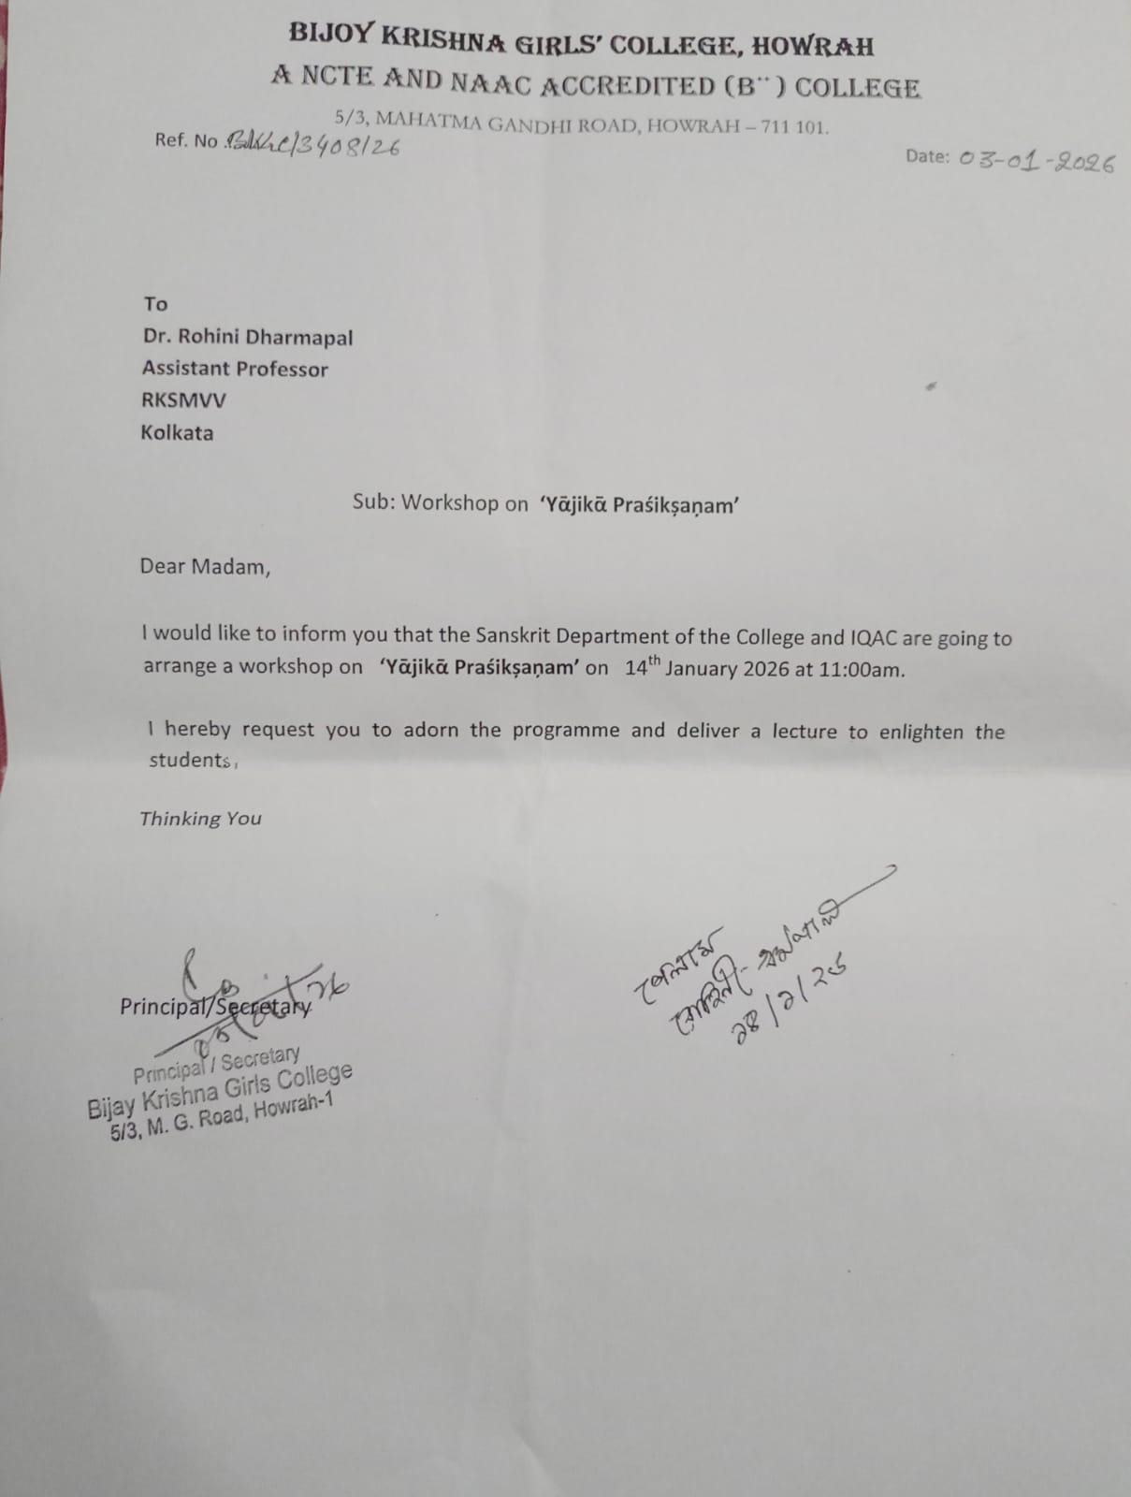
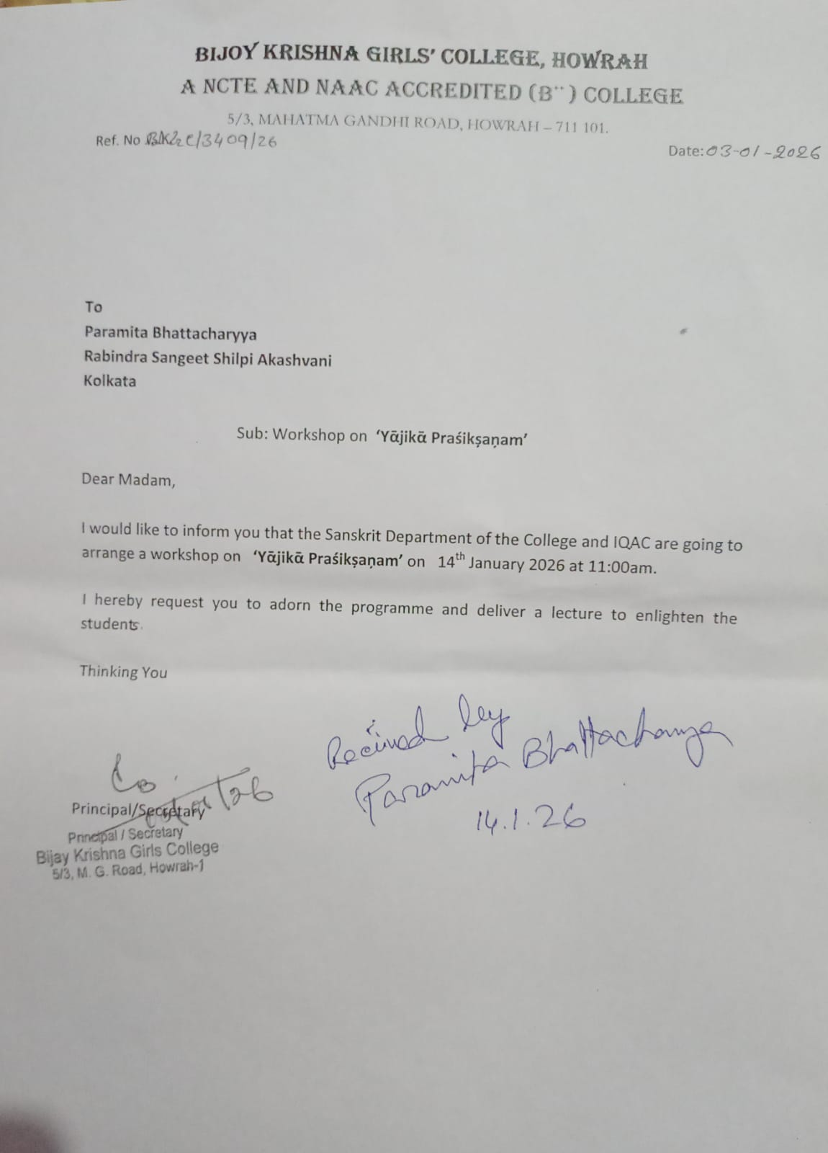
10. Number of Participants (with proof) & typed list of participants in excel sheet: 45
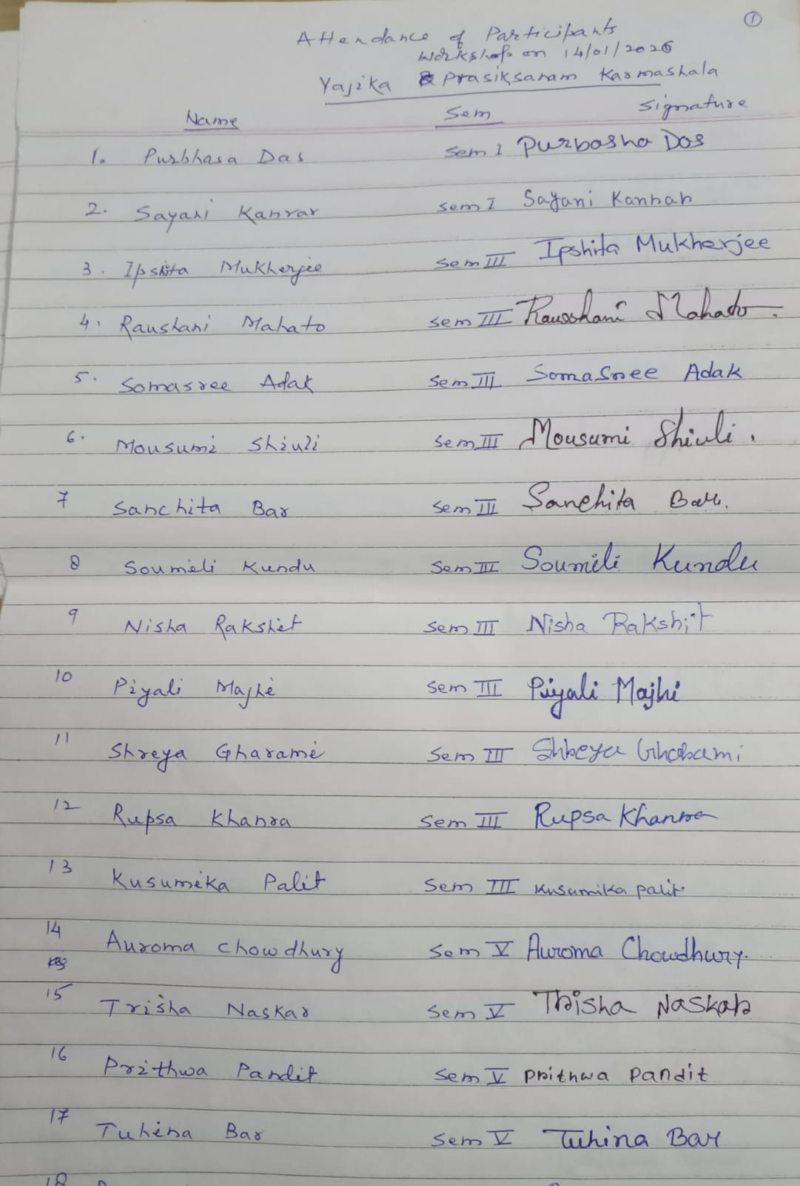
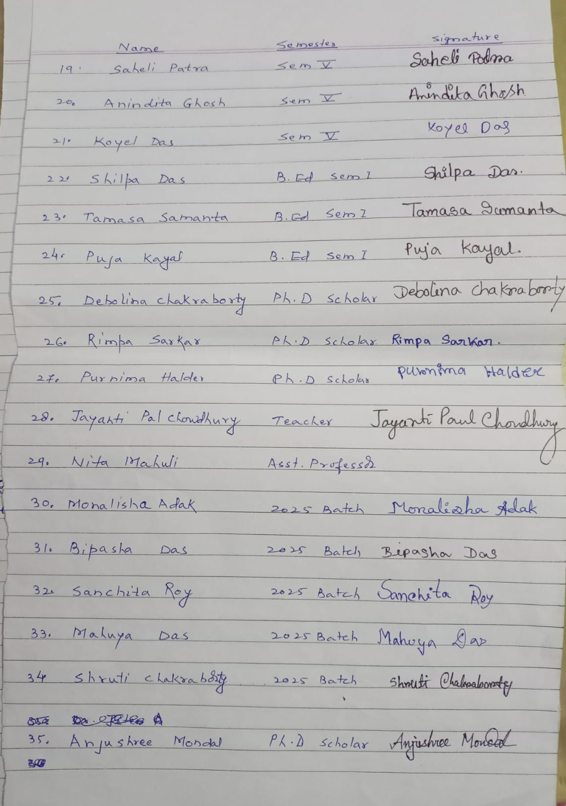
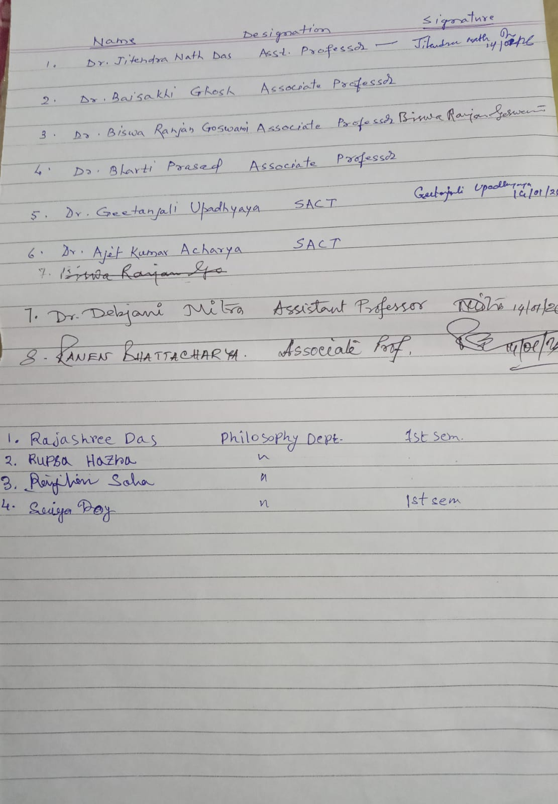
11. Report on the programme: Department of Sanskrit and IQAC conducted a workshop on Yajika Prasiksanam on 14/01/2026. Dr. Rohini Dharmapal, Assistant Professor, RKSMVV, Kolkata and Smt. Paramita Bhattacharya, Rabindra Sangeet Artist, Akashvani, Kolkata were speakers in the said programme. The programme commenced with Vedic chanting by the HOD Sanskrit Dr. Bharti Prasad. Afterwards Dr. Ruma Bhattacharyya, Principal of the college, felicitated the speakers. Dr. Ruma Bhattacharya highlighted the importance of Yajiikas in the modern society. Dr. Rohini Dharmapal mainly focused on the rituals of marriage. Srimati Paramita Bhattacharya emphasized the Vedic mantras related to marriage. The students were very interested in the speakers’ insights and the session was one of the most interactive that we have ever had. The programme was concluded with vote of thanks given by Dr. Jitendra Nath Das.
12. Programme Outcome: Apart from being informative and inspiring, workshops like this also have the merit of being hands-on and offering practical and vocational opportunities. The students were trained in the practical details of priesthood, and got acquainted with an interesting and rewarding career path which might be opted for by some of them.
13. Poster/Brochure/Banner :
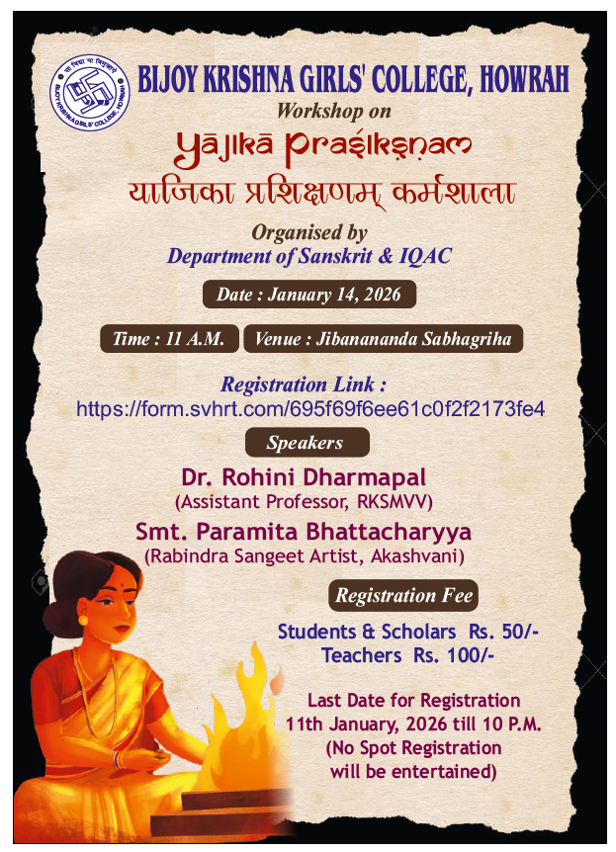
14. Sample Certificate:
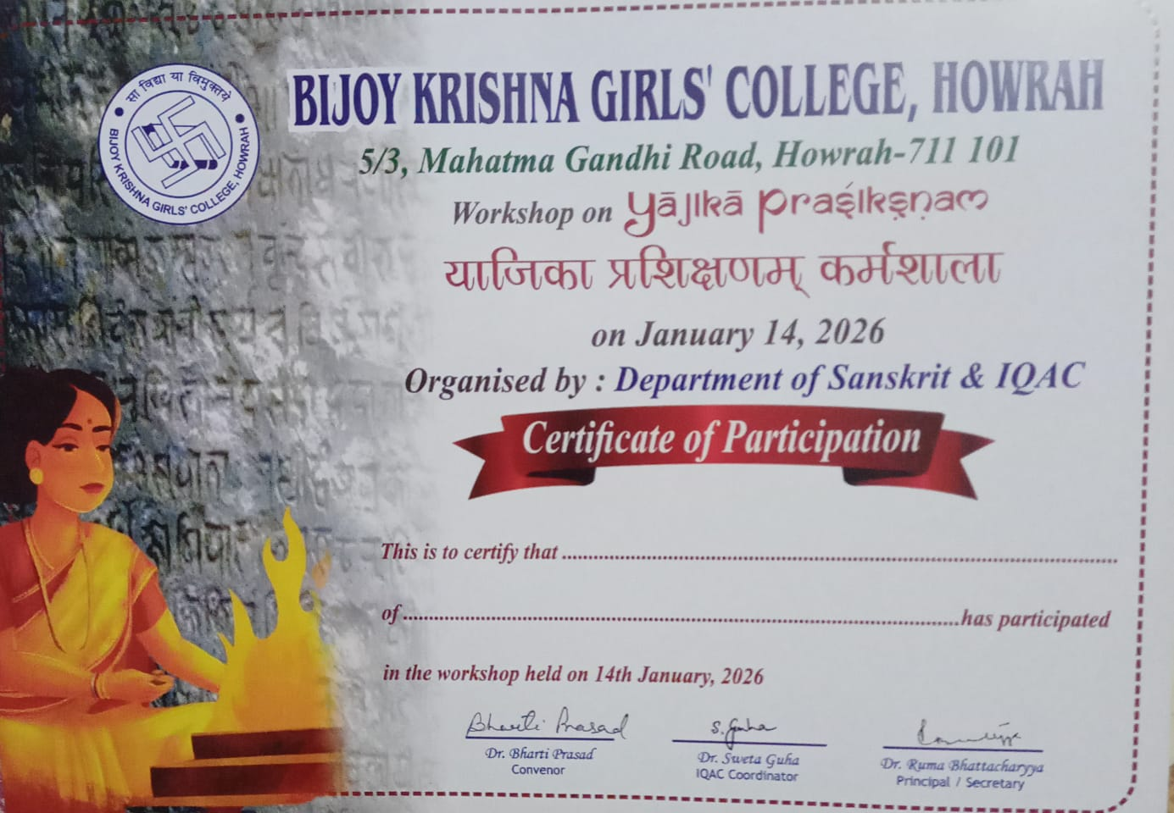

15. Pictures (Geotagged):
