Report of the Programme
1. Workshop/Seminar/Conference/Invited or Extension Lecture: Practical Yoga Session (on
the occasion of International Yoga Day)
2. Online/Offline: Offline
3. Institutional/International/National/Regional: Institutional
4. Title: International Yoga Day Celebration, 2025
5. Date: 2nd July 2025
6. Organizer(s): Department of Philosophy & IQAC, Bijoy Krishna Girls’ College, Howrah
7. Funding (with proof): Nill
8. Collaborators (with proof): Nill
9. Resource Persons (with invitation and acceptance letters): Ms. Bidwattama Chatterjee, Yoga instructor and alumna of the Department of Philosophy.
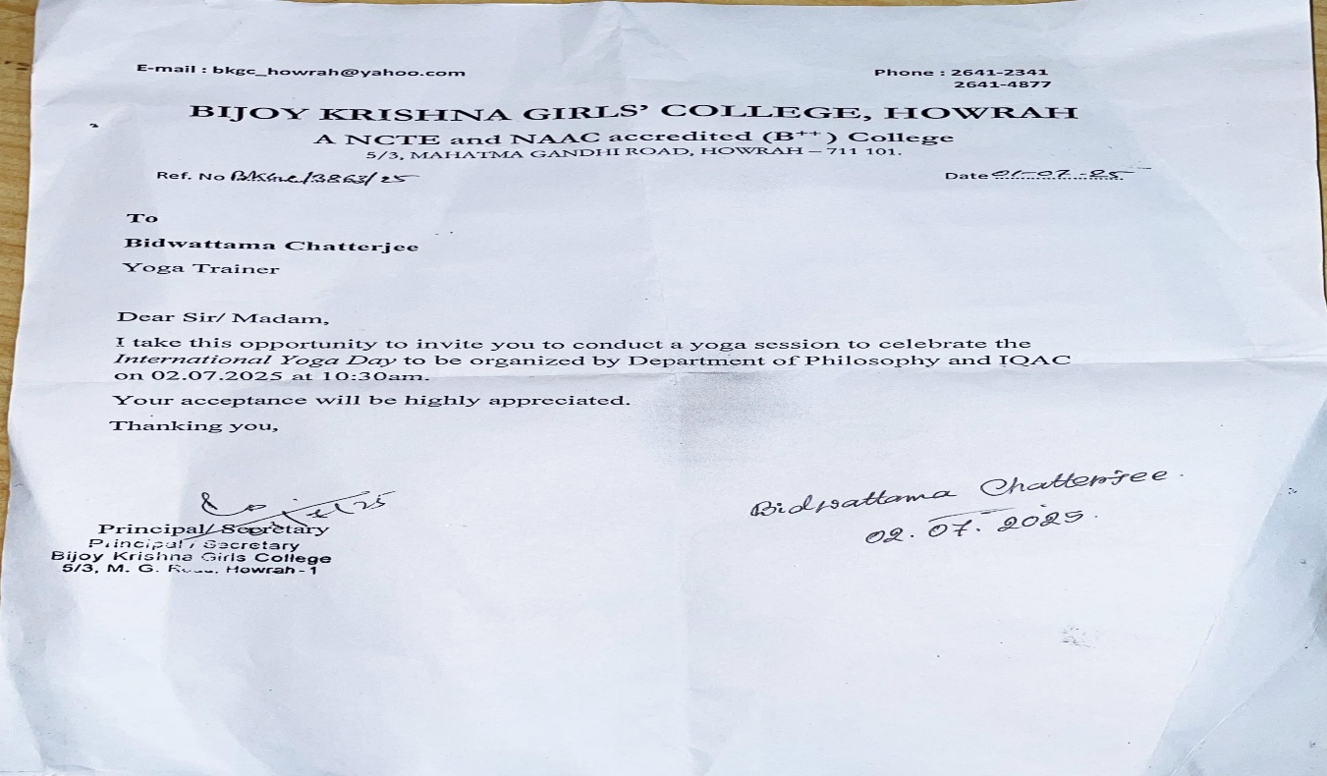
10. Number of Participants (with proof):
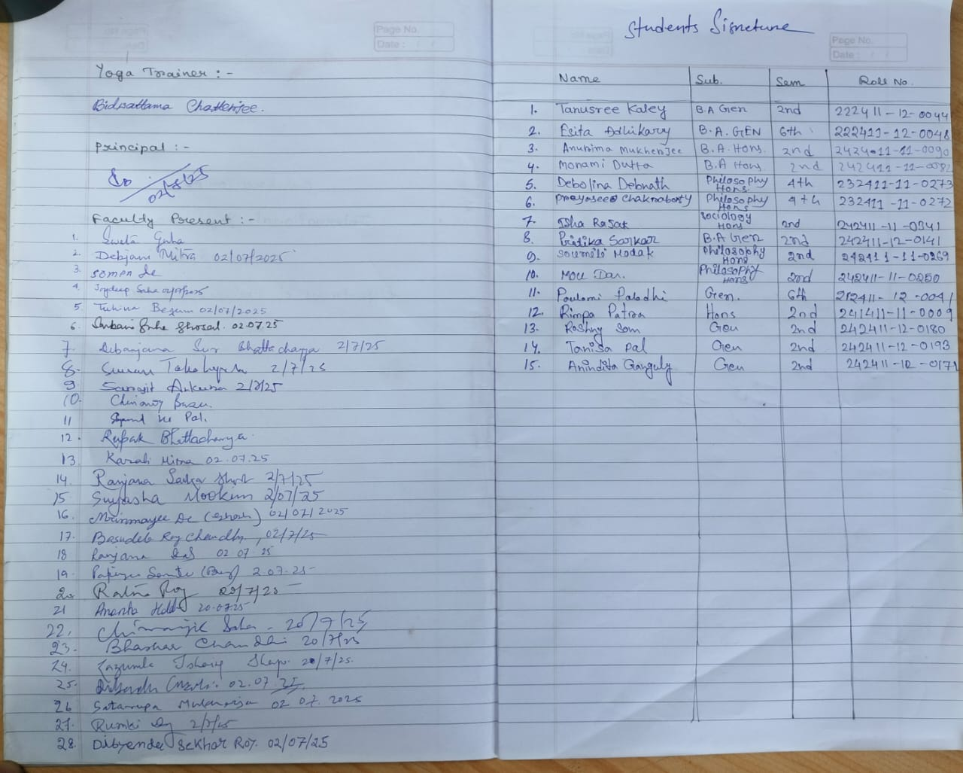
11. Report on the Programme: On the occasion of International Yoga Day, the Department of Philosophy & IQAC, Bijoy Krishna Girls’ College, Howrah, organized a special programme to promote awareness of yoga and its philosophical significance. The event began with a gracious inaugural speech by the Honourable Principal, Dr. Ruma Bhattacharjee, who highlighted the importance of yoga in maintaining harmony between body and mind. She also spoke about its philosophical relevance. IQAC Coordinator & Associate Professor of Philosophy, Dr. Sweta Guha delivered the Keynote Address, emphasizing the international significance of Yoga Day and the role of yoga in promoting holistic health and well-being. The practical session was conducted by Ms. Bidwattama Chatterjee, an experienced yoga trainer and former student of the Philosophy Department. She guided students and faculty through various yoga postures and breathing exercises on the college grounds. The participation of faculty members made the event even more inclusive and encouraging. The event was well-planned and coordinated under the guidance of Dr. Jhuma Paul, Head of the Department of Philosophy. The program concluded with a vote of thanks delivered by Assistant Professor Atanu Saha, expressing gratitude to all contributors. The program witnessed active participation from faculty members of the Philosophy Department as well as from other departments.
12. Programme Outcome:
- Increased Awareness: The program enhanced awareness about the benefits of yoga among students and staff.
- Community Participation: Faculty members and students practiced yoga together, fostering a spirit of unity.
- Alumni Engagement: The involvement of an alumna added meaning and strengthened departmental bonding.
- Promotion of Indian Heritage: The event honored Indian knowledge systems, especially the philosophical foundation of yoga.

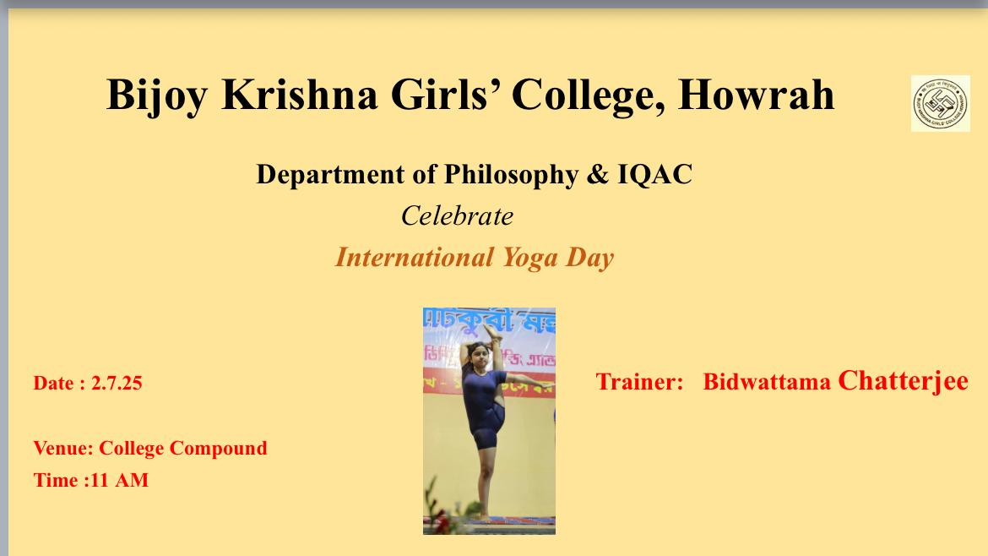
13. Poster/Brochure/Banner:
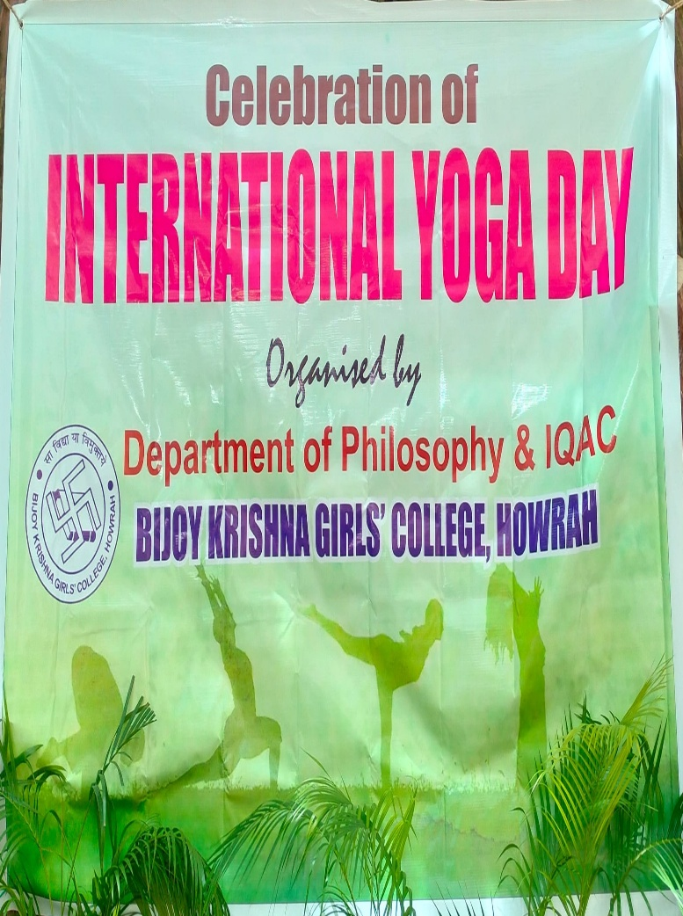
14. Sample Certificate: Nill
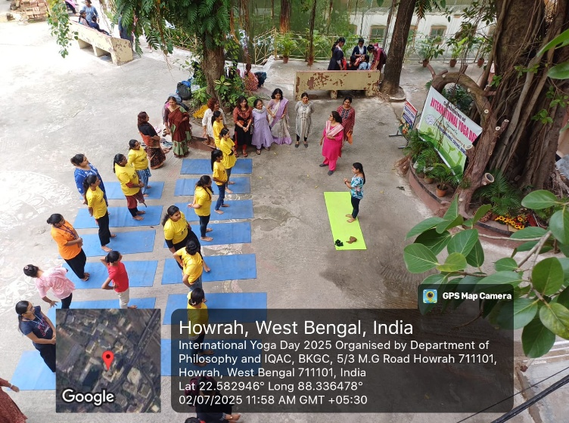
15. Pictures (Geotagged):
