Report on World Philosophy Day-2025
- Workshop/Seminar/Conference/Invited or Extension Lecture: World Philosophy Day Celebration
  - Online/Offline: Offline
  - Institutional/International/National/Regional: Institutional
  - Title of the Event: World Philosophy Day Celebration
  - Date of the Event: 21/11/2025
  - Organizer(s): Department of Philosophy & IQAC, Bijoy Krishna Girls’ College, Howrah
  - Funding (with proof): The college’s internal budget funded the event.
  - Collaborators: The event had no external collaborators. The college’s internal departments organized it.
  - Resource Persons:
Dr. Gargi Goswami, Department of Philosophy, Jadavpur University
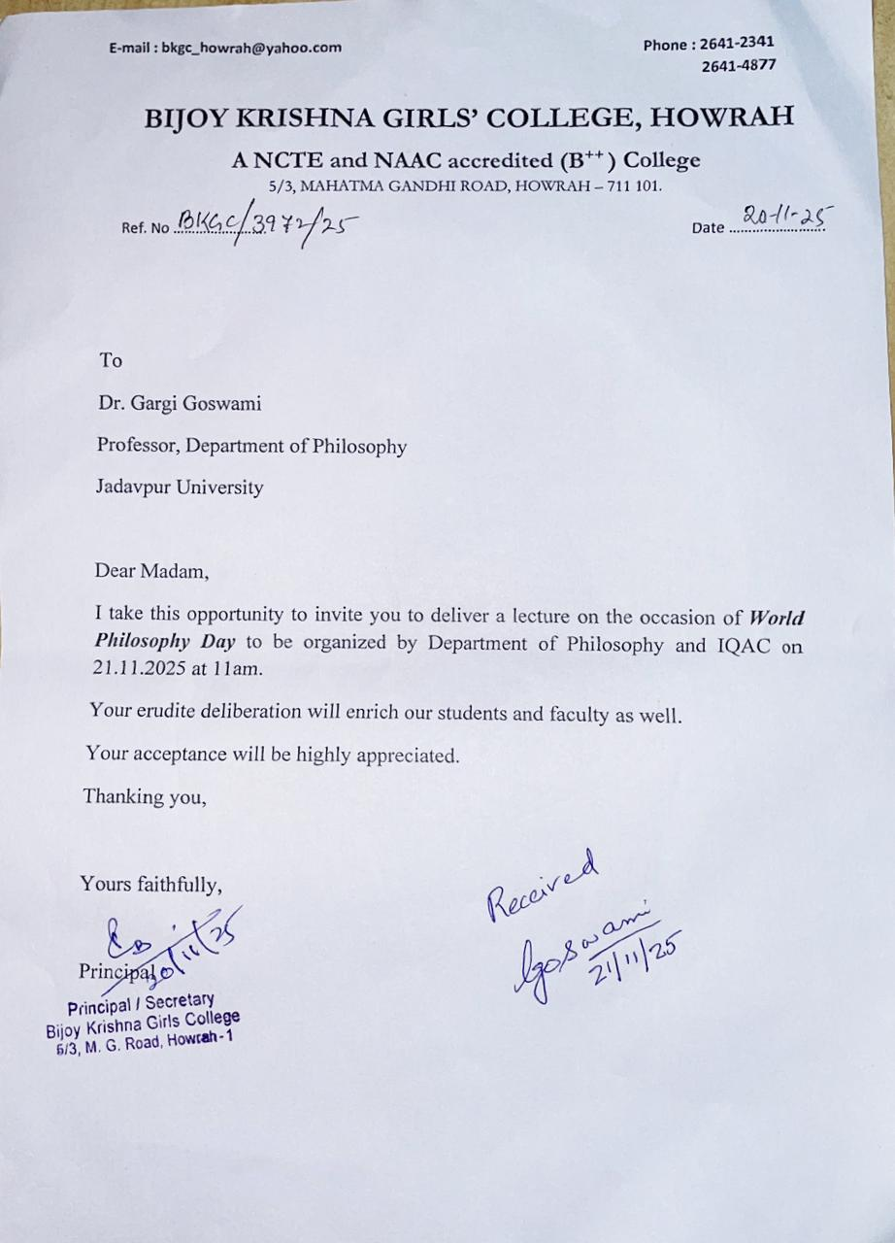

- Judge for Paper Presentation Competition
- Dr. Gargi Goswami, Department of Philosophy, Jadavpur University
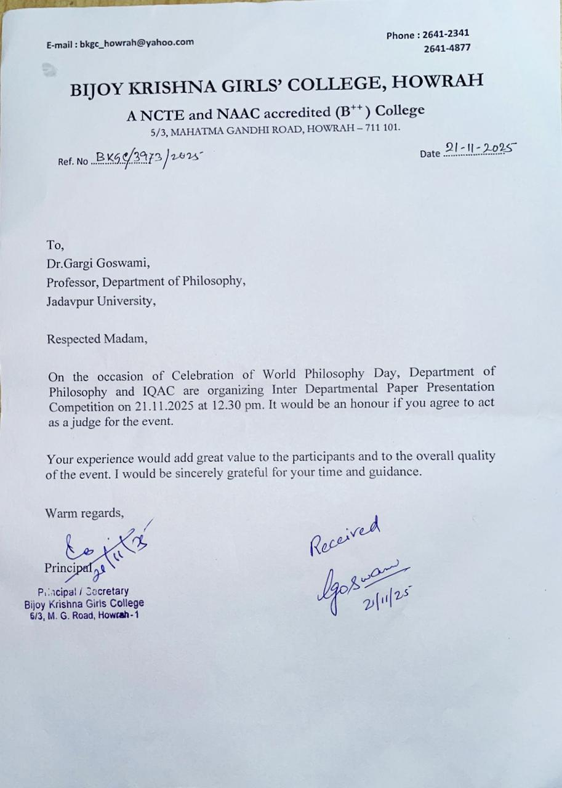

- Dr. Baisakhi Ghosh, Department of Sanskrit, Bijoy Krishna Girls’ College, Howrah
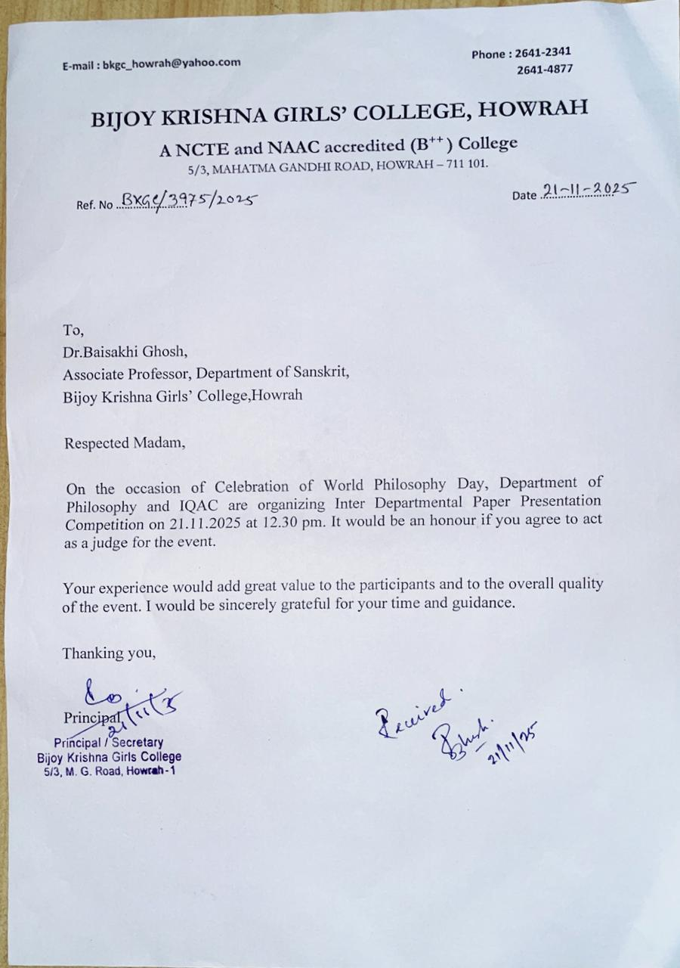
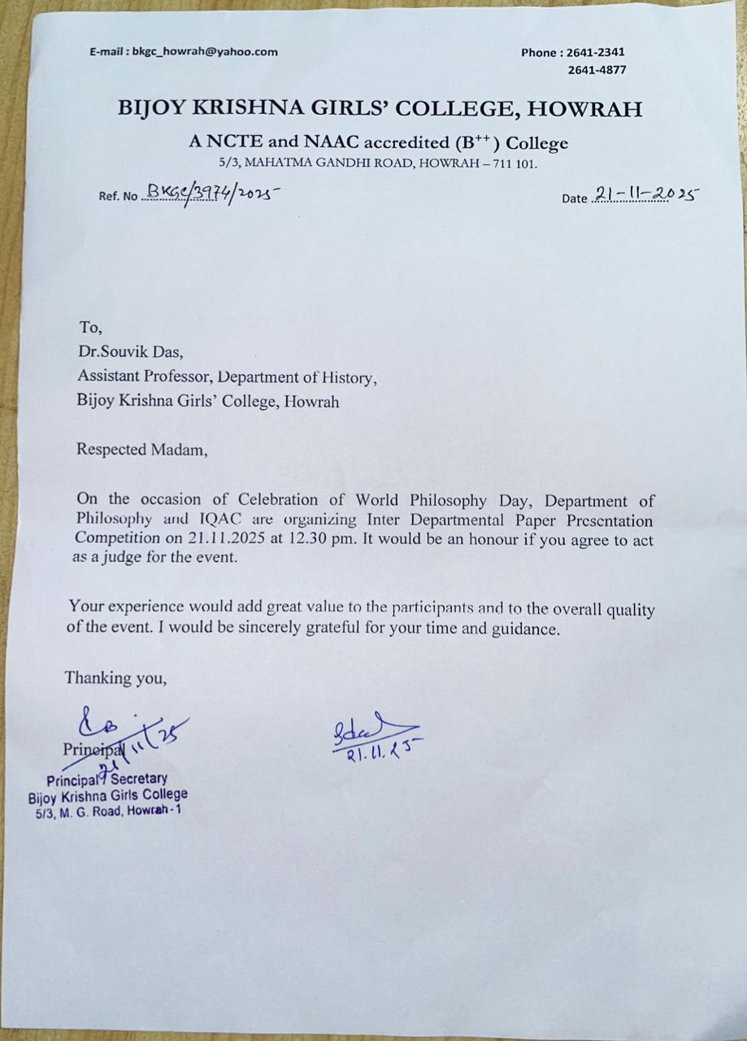
- Dr. Souvik Das, Department of History, Bijoy Krishna Girls’ College, Howrah

  - Number of Participants (with proof) Total: 57
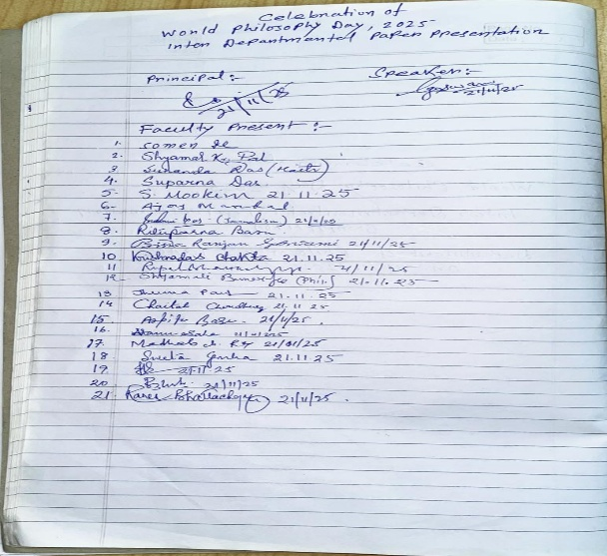
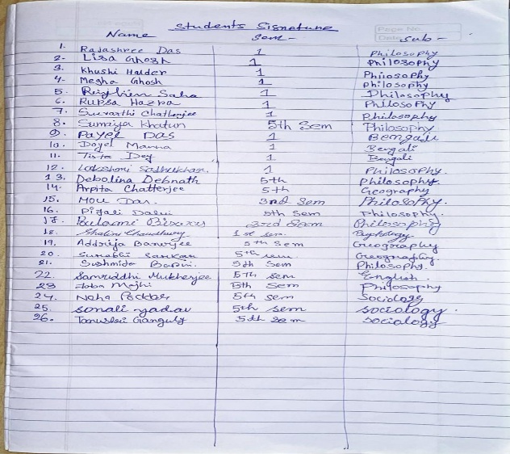

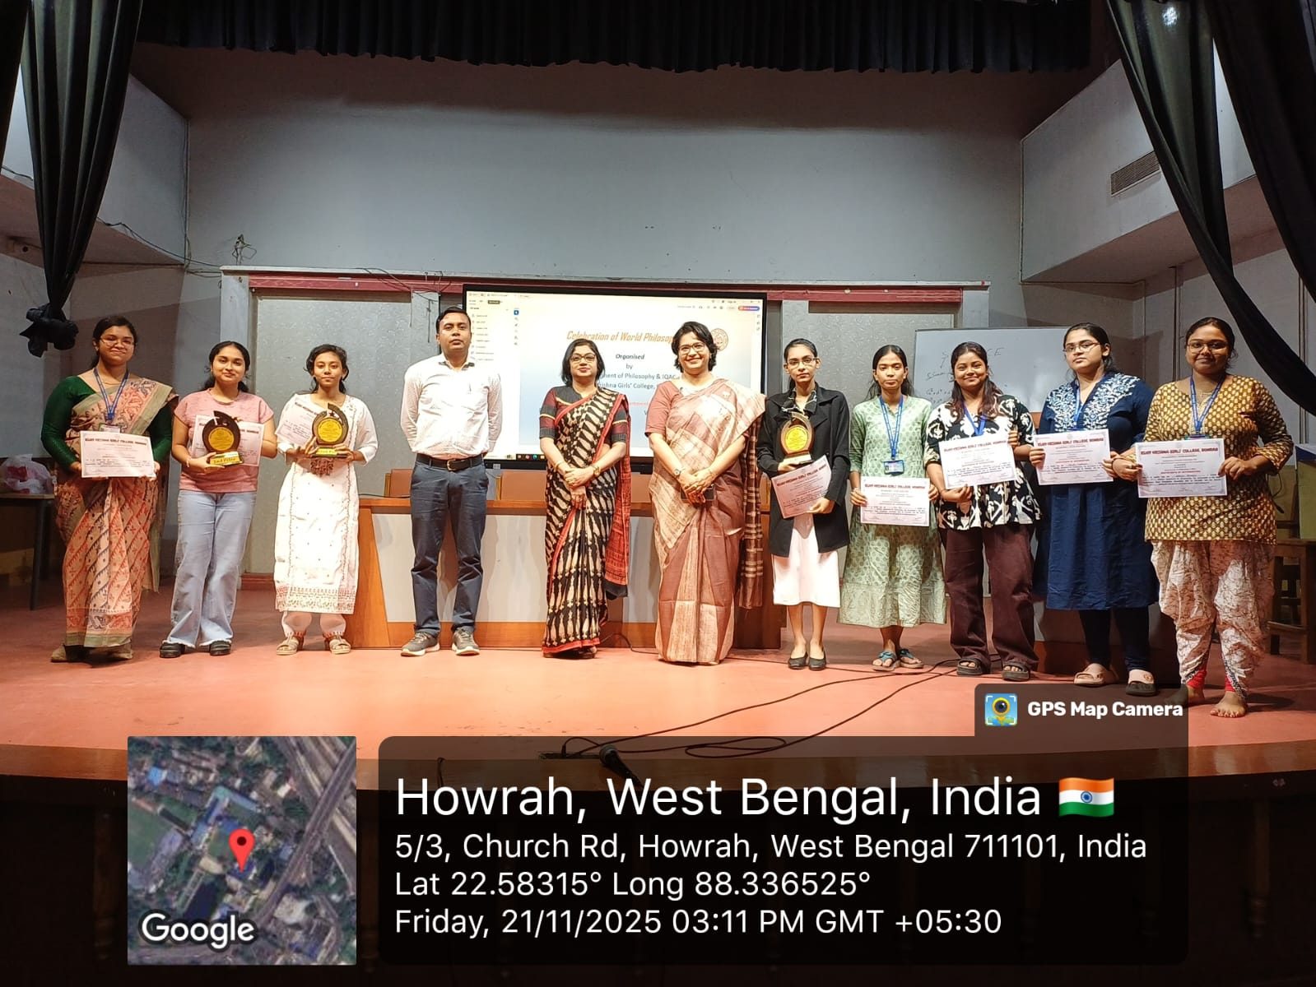
Paper Presentation Competition Participants: 08 students from various departments participated in the debate.
  - Report on the Programme:
The Department of Philosophy and IQAC at Bijoy Krishna Girls’ College celebrated World Philosophy Day with activities, including a floral tribute to founder principal Sri Bijoy Krishna Bhattacharya’s statue, a lamp-lighting ceremony, and speeches by distinguished guests. Dr. Ruma Bhattacharyya, the Principal, highlighted the significance of the day and its relevance in today’s world. Dr. Sweta Guha, IQAC Coordinator presented the keynote address, explaining the importance of philosophical thinking in shaping society. Dr. Gargi Goswami delivered a lecture on “Navigating Ethics in a Multidisciplinary World,” offering valuable insights into the topic. The second part of the event was an Inter-Departmental Paper Presentation Competition. Three students were awarded the Best Speaker prize, and certificates were given to all participants.

  - Programme Outcome:
The event was a great success, fostering intellectual engagement and promoting philosophical discussions among students and faculty.
It provided a platform for students to express their views on important contemporary topics.
The debate competition helped students enhance their critical thinking, public speaking, and argumentation skills.
  - Poster/Brochure/Banner:
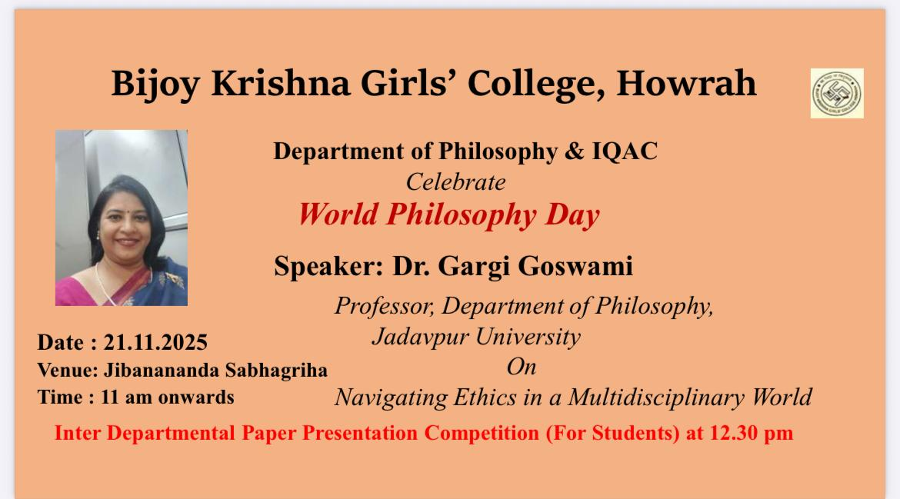
  - Sample Certificate:
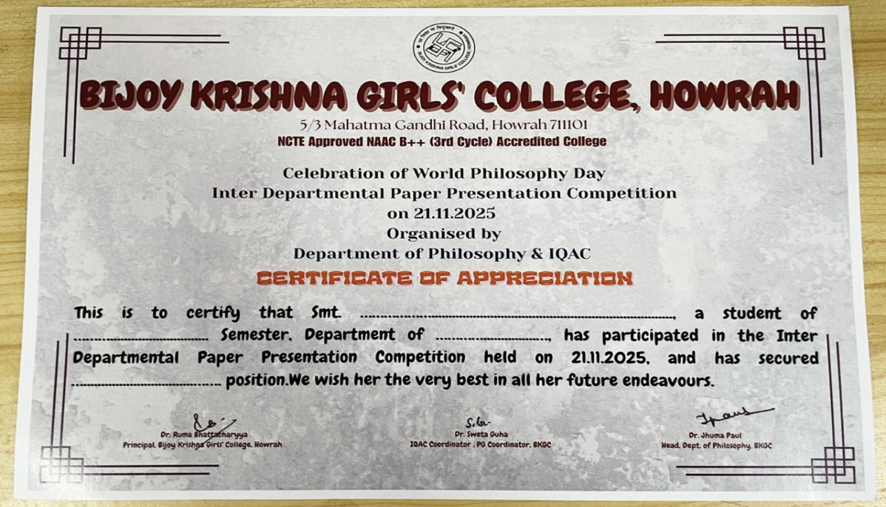
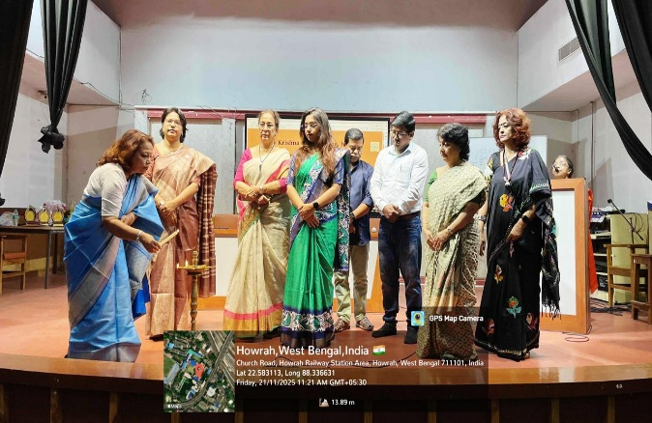
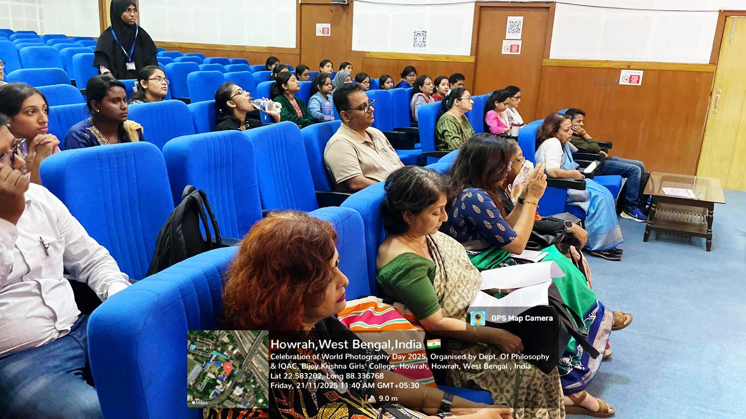
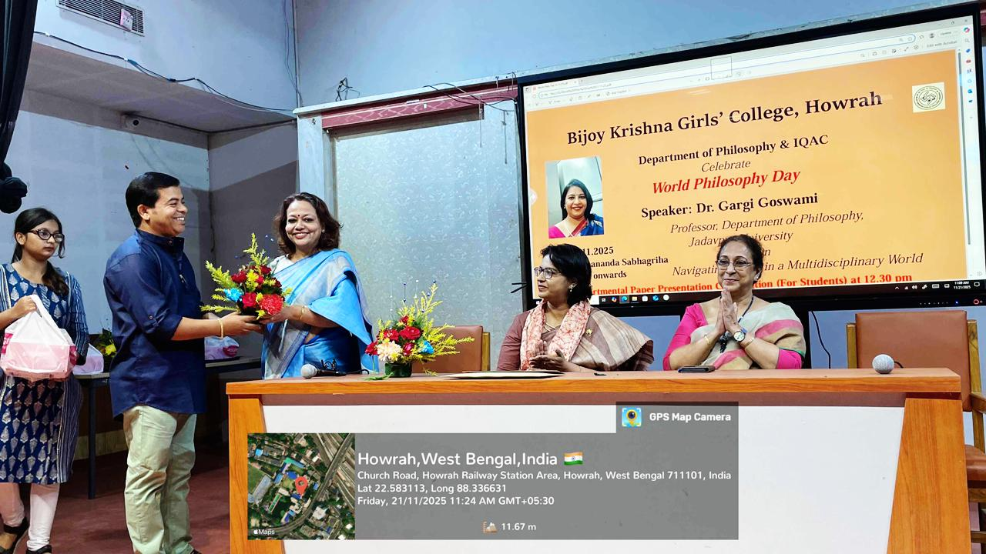
  - Pictures (Geotagged):
