Report on Alumni Reunion: 2024-25
1. Workshop/Seminar/Conference/Invited or Extension Lecture: Extension Activity (Alumni Reunion)
2. Online/Offline: Offline
3. Institutional/International/National/Regional: Institutional
4. Title: Alumni Reunion, organised by the Department of Philosophy
5. Date: 5/04/2025
6. Organizer(s): Department of Philosophy, Bijoy Krishna Girls’ College, Howrah
7. Funding (with proof): NA
8. Collaborators (with proof): NA
9. Resource Persons (with invitation and acceptance letters): NA
10. Number of Participants (with proof) & typed list of participants in Excel sheet:
Total participants: 09
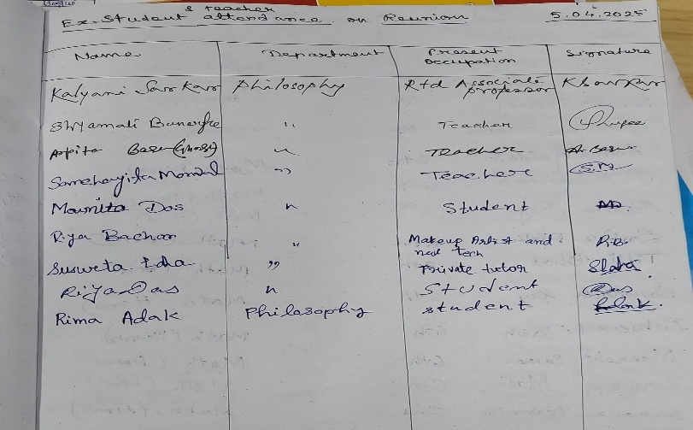
11. Report on the Programme:
The Department of Philosophy, Bijoy Krishna Girls’ College, Howrah, organized a heartfelt Alumni Reunion on 5/04/2025. The event brought together former students of the department from different batches, creating a warm and nostalgic environment. The programme began with a welcome address by the Head of the Department, followed by a brief introduction of attending alumni. Alumni shared their college memories, professional journeys. Faculty members interacted with the alumni, appreciating their contributions in various fields and inviting them to support ongoing academic and mentoring initiatives. The reunion served as a platform for strengthening the bond between the past and present of the department. Alumni also expressed their interest in forming a formal alumni association and contributing to departmental development in the future.
12. Programme Outcome:
I. Reconnected alumni with their alma mater and department faculty.
II. Enabled exchange of professional insights and future collaborations.
III. Encouraged alumni to take part in academic mentoring, internships, and funding initiatives.
13. Poster/Brochure/Banner: NA
14. Sample Certificate: NA
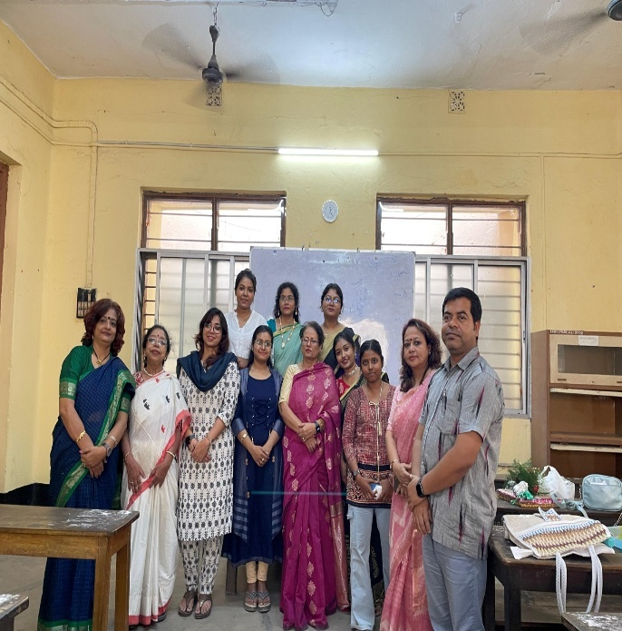
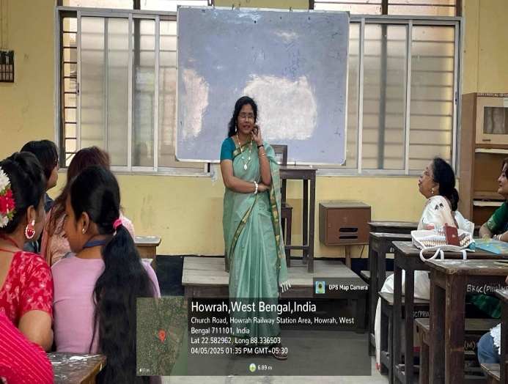
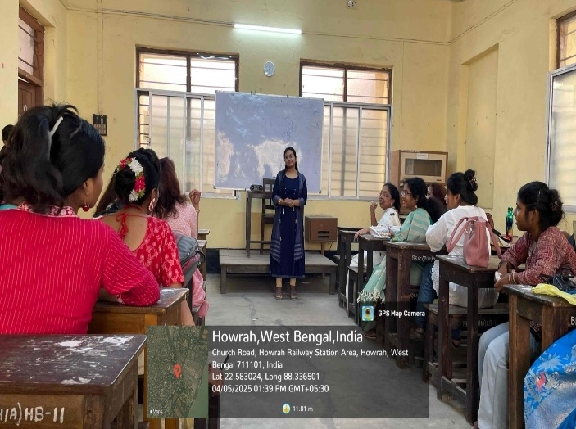
15. Pictures (Geotagged):
