1. Workshop/Seminar/Conference/Invited or Extension Lecture: Intra-Departmental Quiz

2. Online/Offline: Offline

3. Institutional/International/National/Regional: Institutional

4. Title: Intra-Departmental Quiz Competition

5. Date: 21.05.2025

6. Organizer(s): IQAC and Department of Philosophy

7. Funding (with proof): NA

8. Collaborators (with proof): NA

9. Resource Persons (with invitation and acceptance letters): NA

10. Numer of Participants (with proof) & typed list of participants in excel sheet.- 18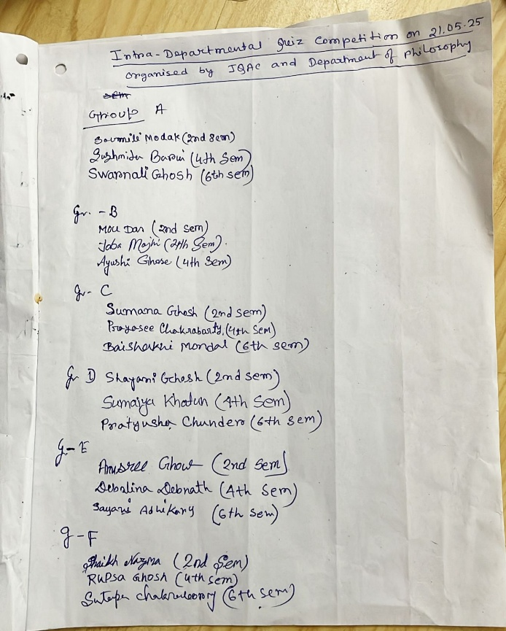

11. Report on the programme: An intra-departmental quiz competition was held on 21.05.2025. Students of UG 2nd, 4th and 6th semesters have participated in the competition. There were 6 groups of 3 students. We prepared 6 rounds of questionnaire. We eliminated the lowest scorer group after 3rd round. And after 6th round we got winner, 1st runner up and 2nd runner up team. The students of those 3 teams were awarded.

12. Programme Outcome: As the intra-departmental quiz competition focused on the subject oriented disciplines, it can reinforce students’ in-depth understanding of the subject. Students analyse the question, recall relevant information, and formulate logical answers, which sharpens their critical thinking skills. It also enhancing their problem-solving abilities.

13. Poster/Brochure/Banner:
14. Sample Certificate:
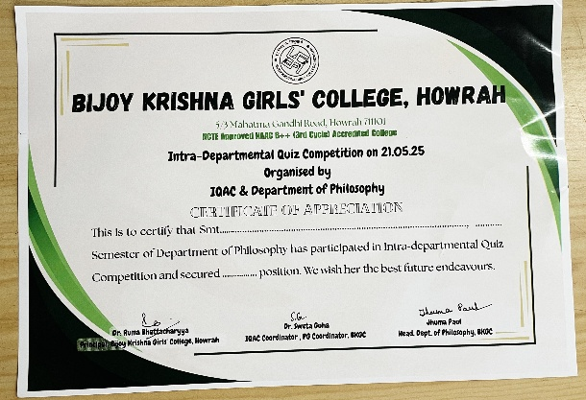
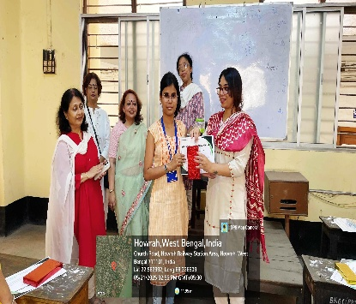
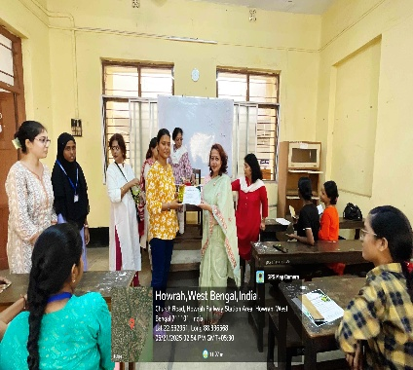
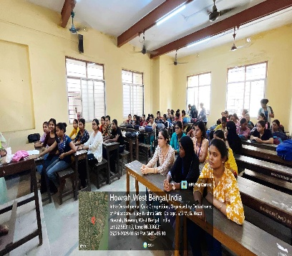
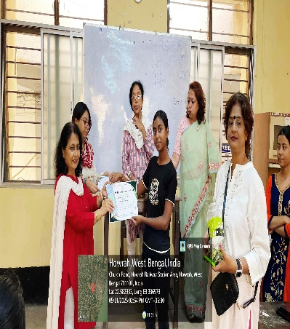
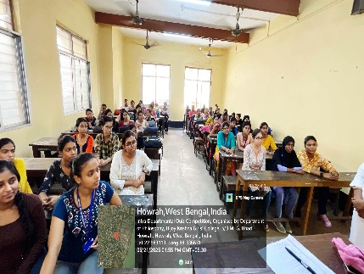
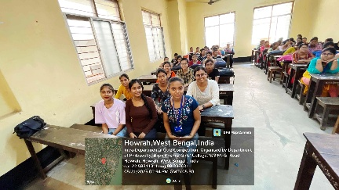
15. Pictures (Geotagged ):

