Report of Special International Talk-2026
1. Workshop/Seminar/Conference/Invited or Extension Lecture: Invited Special International Talk
2. Online/Offline: Offline Mode
3. Institutional/International/National/Regional: International Level
4. Title: Special International Talk on “Gut Feelings and Effortful Thinking.”
5. Date: 16 January 2026
6. Organizer(s): The programme was organized by the Department of Philosophy, Department of Economics, and IQAC of Bijoy Krishna Girls' College.
7. Funding (with proof): The programme was organized with the internal academic support of the college. No external funding was received for this event.
8. Collaborators (with proof): The programme was organized in collaboration with
Ramakrishna Mission Vidyamandira, Belur.
9. Resource Persons (with invitation and acceptance letters):
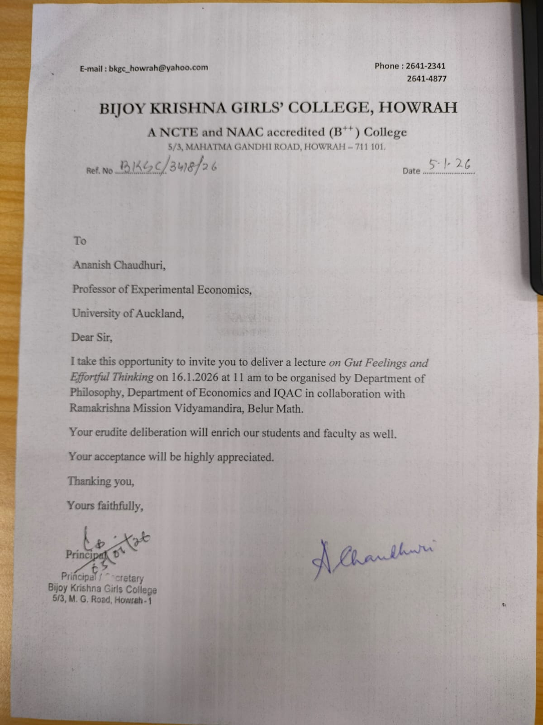
Dr. Ananish Chaudhuri, Professor of Experimental Economics, University of Auckland.
10. Number of Participants (with proof): Total = 67
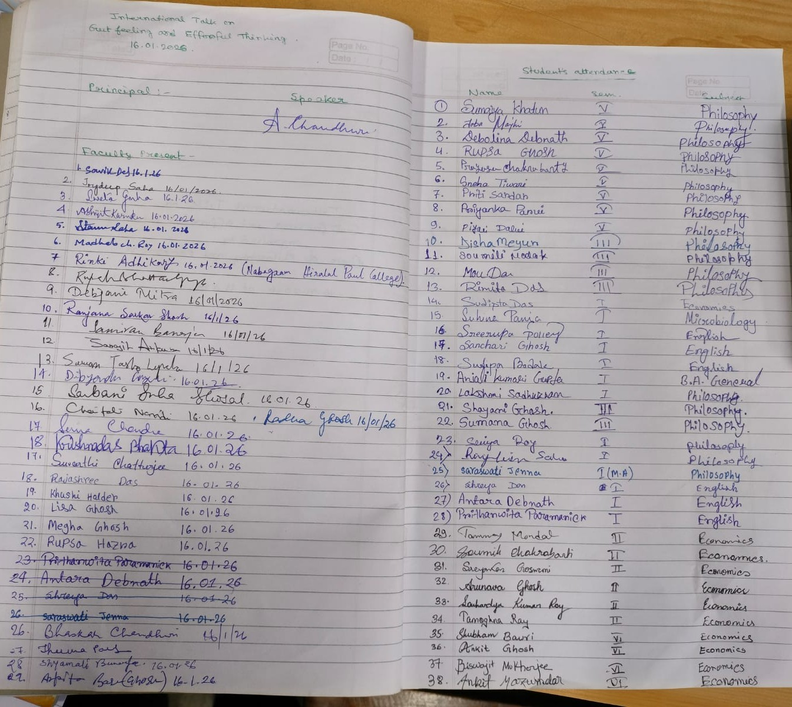
Attendance Sheet
Name | Designation | Institution/Organisation
Agnik Basu Mallik | Student | Ramakrishna mission vidymandira
Anjali Kumar Gupta | Student | Bijoy Krishna Girls’ College, Howrah.
Ankit Ghosh | Student | Ramakrishna Mission Vidyamandira
Ankit Mazumdar | Student | Ramkrishna mission vidyamandira
Ankita Chowdhury | Student | Bijoy Krishna Girls' College, Howrah.
Antara Debnath | Student | Bijoy Krishna Girls' College, Howrah.
Arunaksha Ray | Student | Ramakrishna Mission vidyamandira
Arunava Ghosh | Student | RKMVM
Barshan Jana | Student | Ramakrishna Mission Vidyamandira Belur Math
Biswajit Mukherjee | Student | Ramakrishna Mission Vidyamandira
Bristhi Das | Student | Bijoy Krishna Girls' College, Howrah.
Debkumar Chakrabarti | Associate Professor | Ramakrishna Mission Vidyamandira
Debolina Debnath | Student | Bijoy Krishna girl's college Howrah
Disha Meyur | Student | Bijoy Krishna Girls’ College
Dr Joydeep Saha | Assistant Professor | Bijoy Krishna Girls’ College Howrah
Dr Radha Ghosh | Associate Professor | Bijoy Krishna Girls’ College, Howrah
Dr Ratna Roy | Assistant Professor | Bijoy Krishna Girls' College Howrah
Dr Rinki Adhikary | State aided college teacher | Nabagram Hiralal Paul College
Dr Samiran Banerjee | Assistant Professor | Bijoy Krishna Girls' College, Howrah
Dr Sweta Guha | Associate Professor | Bijoy Krishna Girls' College, Howrah.
Dr. Debjani Mitra | Assistant Professor | Bijoy Krishna Girls' College, Howrah
DR. DIBYENDU GANGULI | Assistant Professor | Bijoy Krishna Girls' College, Howrah
Dr. Jhuma Paul | Assistant Professor | BKGC
Dr. Neela Sarkar | Associate Professor | New Alipore College
Dr. Rupak Bhattacharyya | Assistant Professor | Bijoy Krishna Girls' College, Howrah
Dr. Shreya Mitra | Associate Professor | Behala College (Autonomous)
Dr. Somen De | Associate Professor | Bijoy Krishna Girls' College, Howrah
Farhana khatun | Student | Bijoy Krishna Girls' College, Howrah.
HARU MONDAL | Assistant Professor | SONARPUR MAHAVIDYALAYA
Joba Majhi | Student | Bijoy Krishna Girls' College, Howrah.
Lakshmi Sadhukhan | Student | Bijoy Krishna Girls' College, Howrah.
Madhab Ch Roy | Assistant Professor | Bijoy Krishna Girl' College, Howrah
Mou Das | Student | Bijoy Krishna Girls' College, Howrah.
Niladri Sekhar Biswas | Student | Ramakrishna Mission Vidyamandira, Belur Math
Madhab Ch. Roy | Assistant Professor | Bijoy Krishna Girls' College, Howrah.
Piyali Dalui | Student | Bijoy Krishna Girls' College, Howrah.
Pratap Mondal | Assistant Professor | Bijoy Krishna Girls' College, Howrah.
PRAYASEE CHAKRABORTY | Student | Bijoy Krishna Girls' College, Howrah.
Prithanwita Paramanick | Student | Bijoy Krishna Girls' College, Howrah.
Prithanwita Paramanick | Student | Bijoy Krishna Girls' College, Howrah.
Priti sardar | Student | Bijoy Krishna Girls' College, Howrah.
Priyanka Parui | Student | Priyanka Parui
Priyanka ray | Student | College
Prodipta Saha | Student | Ramakrishna Mission Vidyamandira
Raj Sarkar | Student | Ramakrishna Mission Vidyamandira
Rajashree Das | Student | Bijoy Krishna Girls' College
Reetobrato Bagli | Student | Ramakrishna Mission Vidyamandira, Belur Math
Rimjhim Saha | Student | Bijoy Krishna Girls' College, Howrah.
Rupkatha Mukherjee | Associate Professor | Bijoy Krishna Girls' College, Howrah.
Rupsa Hazra | Student | Bijoy Krishna Girls' College, Howrah.
Sanjay Biswas | Student | RAMAKRISHNA MISSION VIDYAMANDIRA
Sarajit Ankura | Assistant Professor | Bijoy Krishna Girls' College, Howrah
Saraswati Jenna | Student | Bijoy Krishna Girl's College
Sarbani Guha Ghosal | Associate Professor | Bijoy Krishna Girls' College, Howrah.
Shayani Ghosh | Student | Bijay Krishna girls' college
Shreya Das | Student | Bijoy Krishna Girls college
Shubharthi Dutta | Student | Ramakrishna mission Vidyamandira
Sindia sardar | Student | Bijoy Krishna Girls' College, Howrah.
Sohini Sen | Student | Bijoy Krishna Girls' College, Howrah.
Sohini Sen | Student | Bijoy Krishna Girls' College, Howrah.
Souhardya Kumar Roy | Student | Ramakrishna Mission Vidyamandira
SOUMIK CHAKARABARTI | Student | RAMAKRISHNA MISSION VIDYAMANDIRA
Soumili Modak | Student | Bijoy Krishna Girls' College, Howrah.
Souvik Das | Assistant Professor | BKGC
Atanu Saha | Assistant Professor | Bijoy Krishna Girls' College, Howrah.
Sreerupa polley | Student | Bijay Krishna girls' college
Sreyaskar Goswami | Student | Ramakrishna Mission Vidyamandira
Sriya Roy | Student | Bijoy Krishna Girls' College, Howrah.
Sudipta Das | Student | Bijoy Krishna Girls' College, Howrah.
Sumaiya Khatun | Student | Bijoy Krishna Girls' College, Howrah.
Sumana Ghosh | Student | Bijoy Krishna Girls' College, Howrah.
Suvarthi Chatterjee | Student | Bijoy Krishna Girls' College, Howrah.
Swarnavo Das | Student | Asutosh College
TANMOY MONDAL | Student | Ramakrishna Mission Vidyamandira

11. Report on the Programme:
The Department of Philosophy, Department of Economics, and IQAC of Bijoy Krishna Girls’ College organized a Special International Talk on “Gut Feelings and Effortful Thinking” on 16 January 2026 at Jibanananda Sabhagriha of the college.
The programme was organized in collaboration with Ramakrishna Mission Vidyamandira, Belur. The invited speaker was Dr. Ananish Chaudhuri, Professor of Experimental Economics at the University of Auckland. In his lecture, Professor Chaudhuri discussed the relationship between intuitive thinking (gut feelings) and deliberate or effortful thinking in human decision-making. He explained how individuals often rely on quick intuitive judgments in everyday life, while careful reasoning and analytical thinking are necessary in complex situations. The speaker also discussed the importance of experimental research in economics and social sciences to understand human behaviour and decision-making processes. The lecture was informative and thought-provoking for both students and teachers.
The session was interactive. Participants actively asked questions and engaged in discussion with the speaker. The programme created a valuable opportunity for students to learn from an internationally recognized academic scholar.

12. Programme Outcome:
The programme had several important academic outcomes:
(I). Students gained knowledge about the relationship between intuition and rational thinking.
(II). The lecture introduced participants to the basic ideas of experimental economics and decision-making.
(III). The programme encouraged students to think critically about human behaviour and reasoning.
(IV). It strengthened academic collaboration between the participating institutions.
(V). Students were exposed to an international academic perspective.
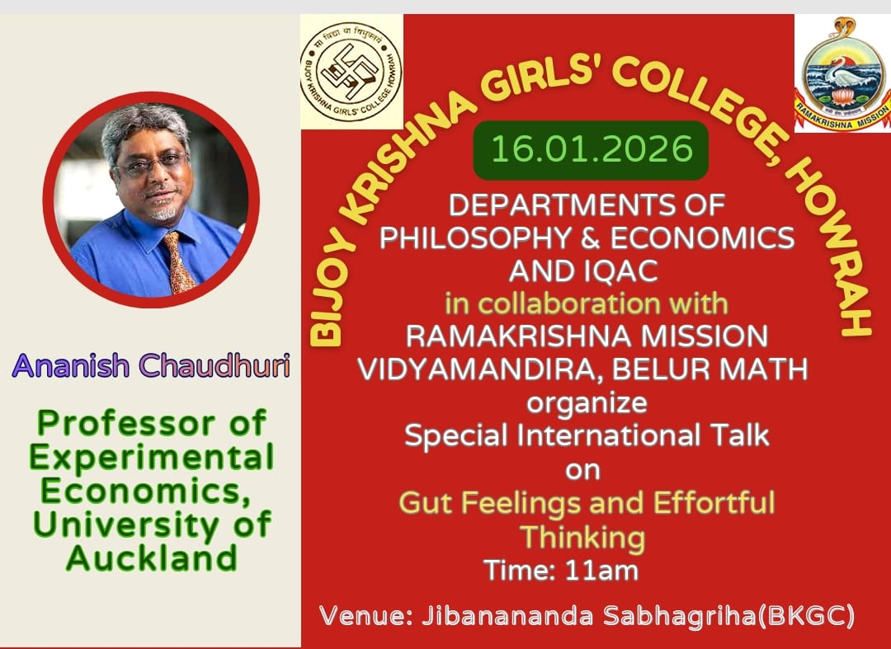
13. Poster/Brochure/Banner:

14. Sample Certificate:
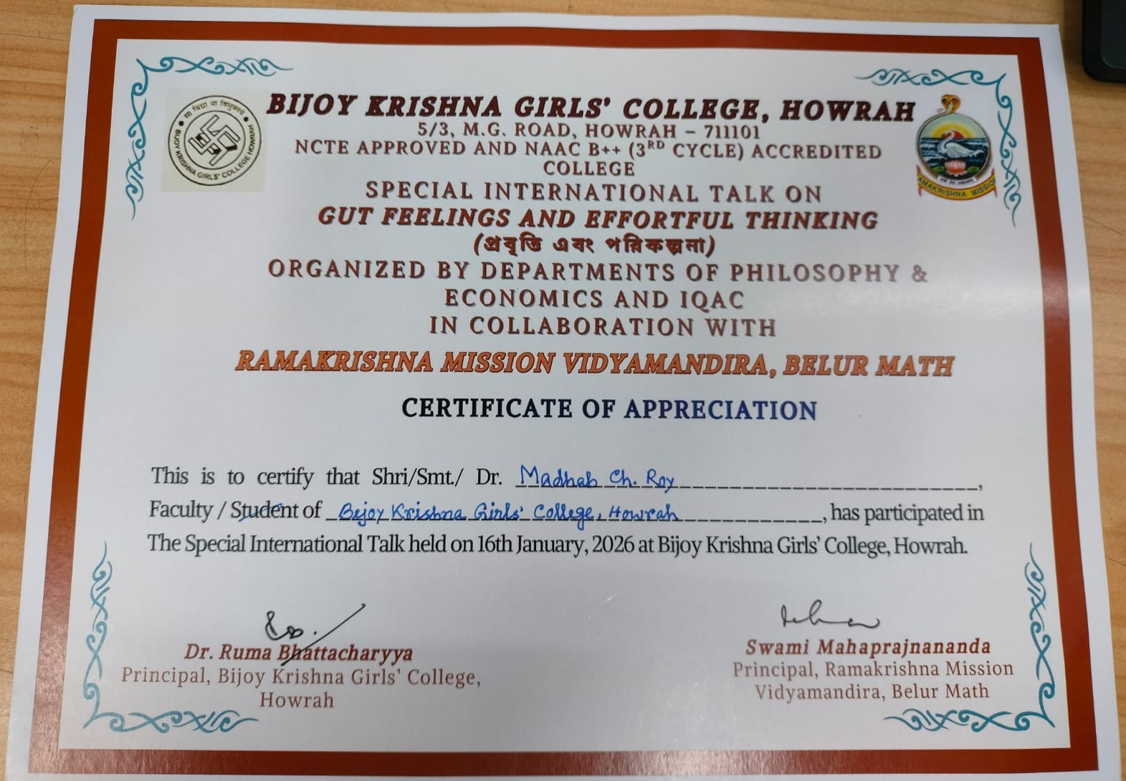
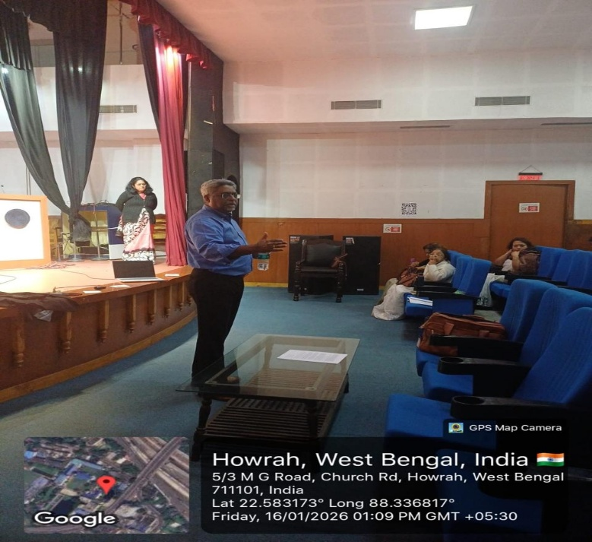
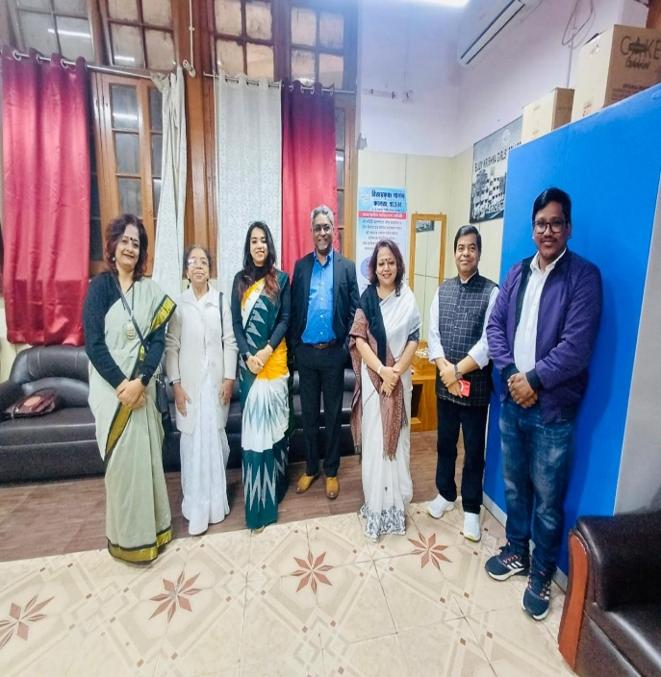
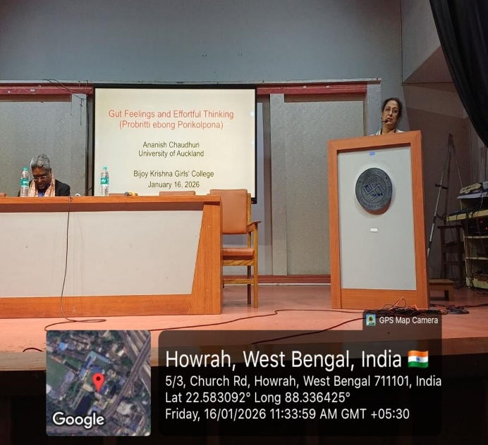
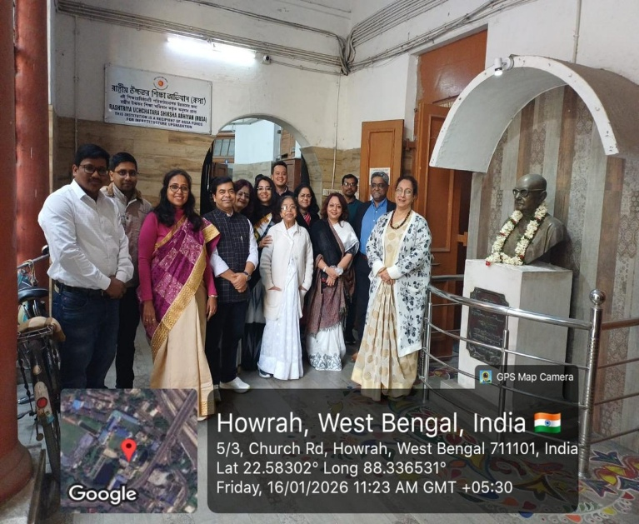
15. Pictures (Geotagged):

