Report on Parent–Teacher Meeting- 2026

1. Workshop/Seminar/Conference/Invited or Extension Lecture: Parent–Teacher Meeting
2. Online/Offline: Offline Mode
3. Institutional/International/National/Regional: Institutional Level
4. Title: Parent–Teacher Meeting of the Department of Philosophy
5. Date: 14 January 2026
6. Organizer(s): Department of Philosophy, Bijoy Krishna Girls’ College.
7. Funding (with proof): N/A
8. Collaborators (with proof): N/A
9. Resource Persons (with invitation and acceptance letters): N/A
10. Number of Participants (with proof): Total =22
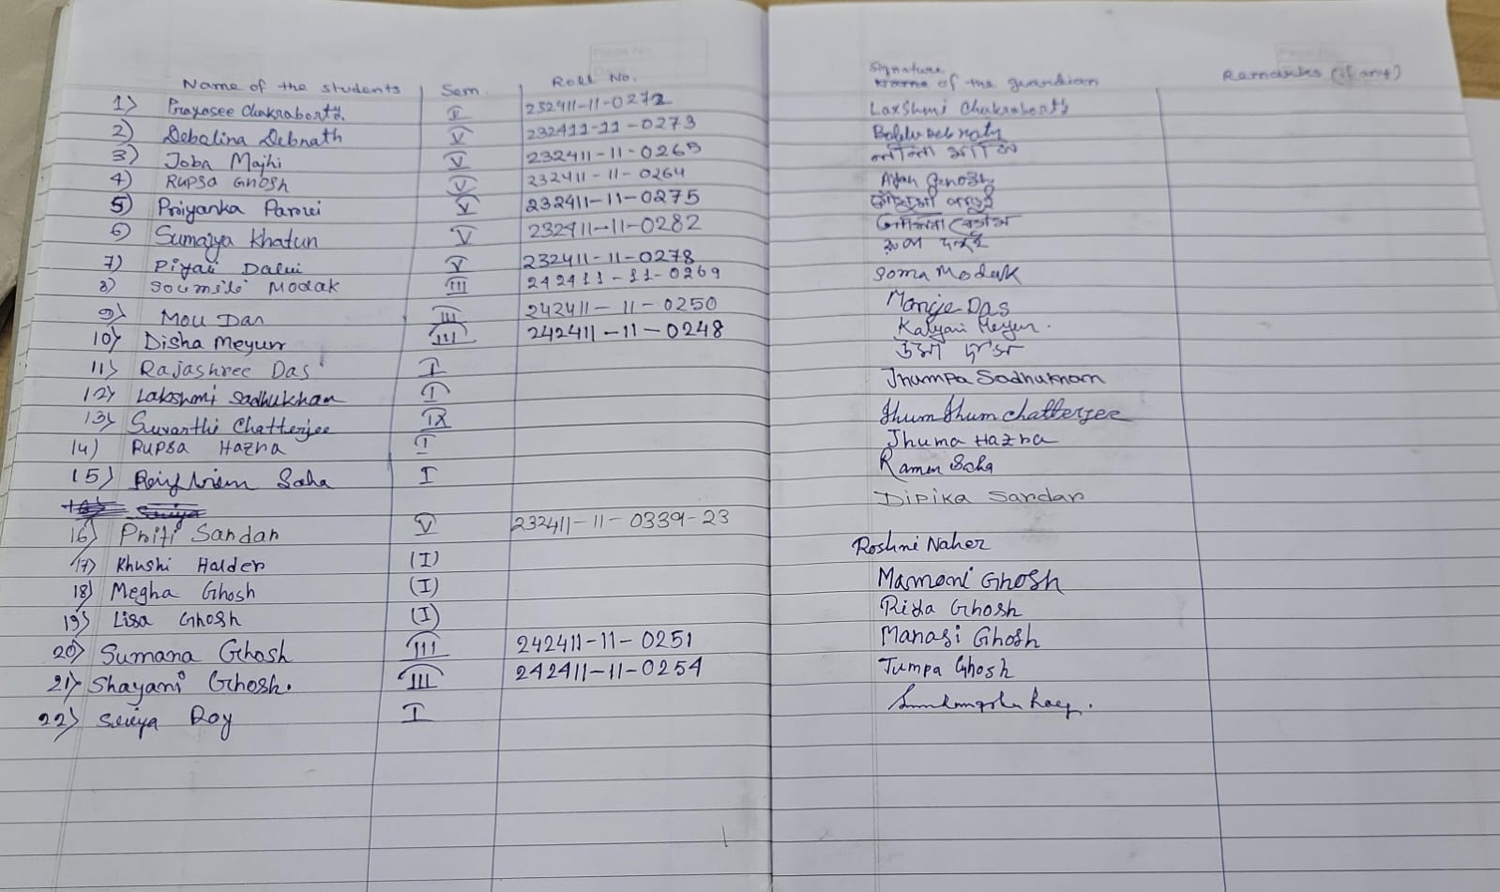
11. Report on the Programme:
The Department of Philosophy of Bijoy Krishna Girls’ College organized a Parent–Teacher Meeting on 14 January 2026 in the college. The aim of the meeting was to discuss the academic progress, attendance, and overall development of the students. Teachers interacted with parents and informed them about the academic expectations of the department. Parents also shared their views and suggestions regarding their wards’ studies.
12. Programme Outcome:
(I). It improved communication and understanding between teachers and parents.
(II). Parents became aware of the academic progress and attendance of their wards.
(III). Students were encouraged to be more sincere and regular in their studies.
(IV). The meeting helped create a supportive academic environment for students.
13. Poster/Brochure/Banner: N/A
14. Sample Certificate: N/A
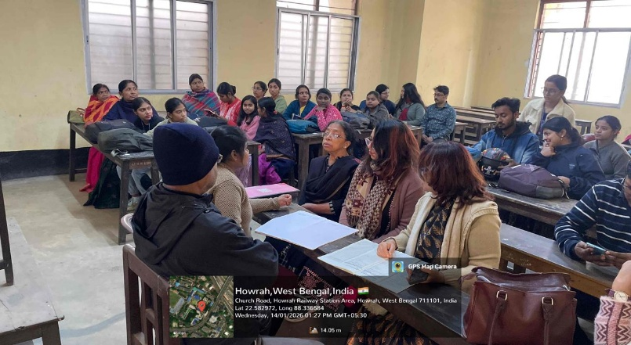
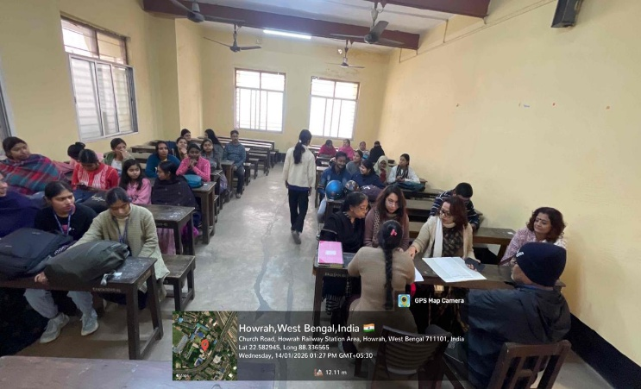
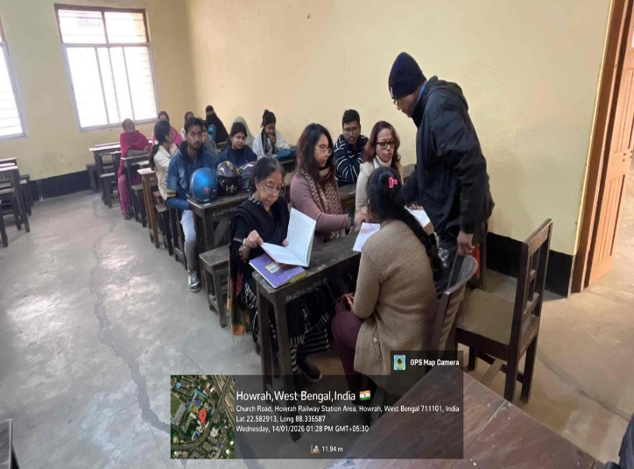
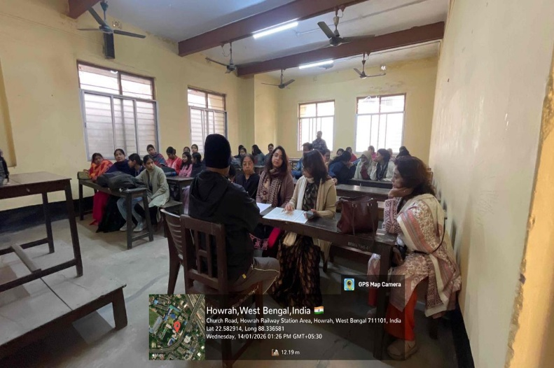
15. Pictures (Geotagged):

