Alumni of Department of Microbiology
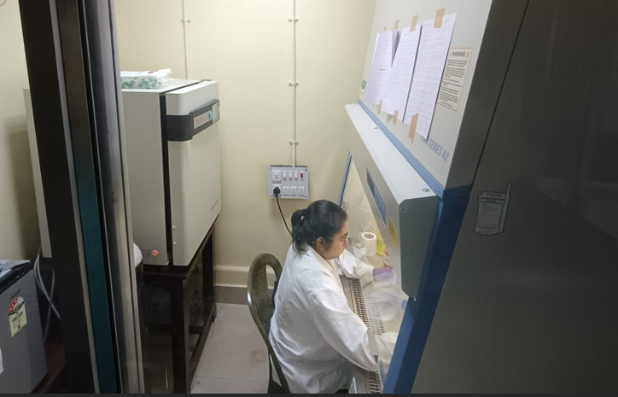
- Srijani Dey, Batch 2019
PhD scholar, now working at Healthcare science and Technology, Indian Institute of engineering Science and Technology, Shibpur

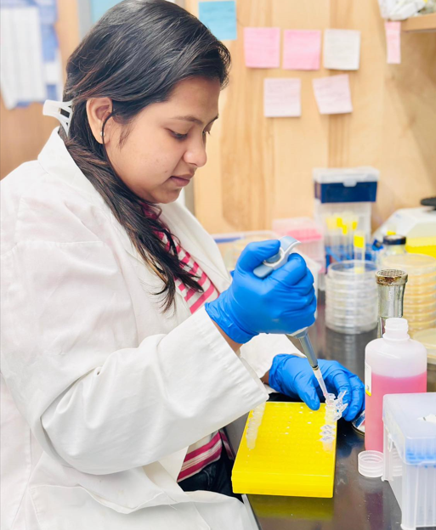
- Ishita Banerjee, Batch 2017
PhD scholar in the department of Biochemistry Cellular and Molecular Biology, University of Tennessee, Knoxville

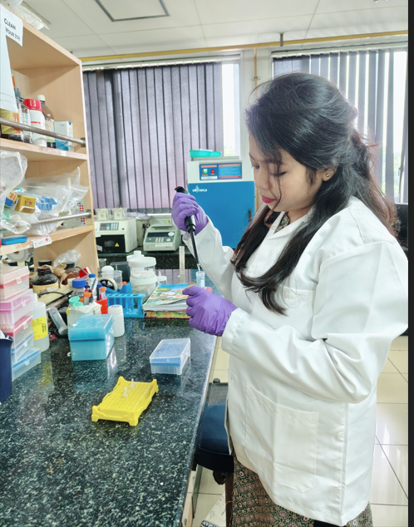
- Oindrila Das,Batch 2021
PhD scholar, now working at National Institute of Cholera and Enteric Diseases, Kolkata

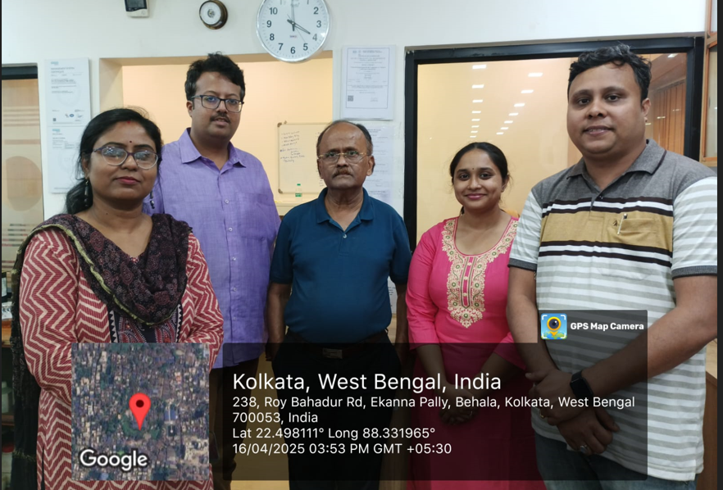
- Mehuli Adhikari, Batch 2022, now working as Chemist in Sun Oil Private Limited , Kolkata
She Worked as a “Analytical Chemist”in Food Industry Chemical analysis such as Nutritional & FSSAI guideline in Qualissure Laboratory Services, Kolkata, India (March 2024-October 2024). Now she is working as a “QC Chemist” in Sun Oil Company Pvt. Ltd, Kolkata, India (October 2024 – Present) in Petro-Chemical Industry based on Kinematic Viscosity calculation (Lube Oil),

