REPORT ON FIELDTRIP AT
VIVEKANANDA WATER TREATMENT PLANT , BELUR



DEPARTMENTOFMICROBIOLOGY
BIJOYKRISHNAGIRLS’COLLEGE

Howrah,WestBengal711101

Name of visit: VIVEKANANDA WATER TREATMENT PLANT
Location of visit:BelurMath,Howrah

Date of visit: 28th August 2025

WASTEWATERTREATMENT

INTRODUCTION

On 28th August 2025, our department was given the valuable opportunitytovisittheVivekanandawaterTreatmentPlant atBelurMath,Howrah.Thisvisitwasorganizedbyour collegeauthoritiesaspartofourcurriculum tounderstand the practical aspects of water treatment and quality assessment.

As a Microbiology student, this visit was highly informative becausewastewatertreatmentnotonlyinvolvesphysicaland chemical purification processes but also addresses microbial contamination, which is crucial for public health.

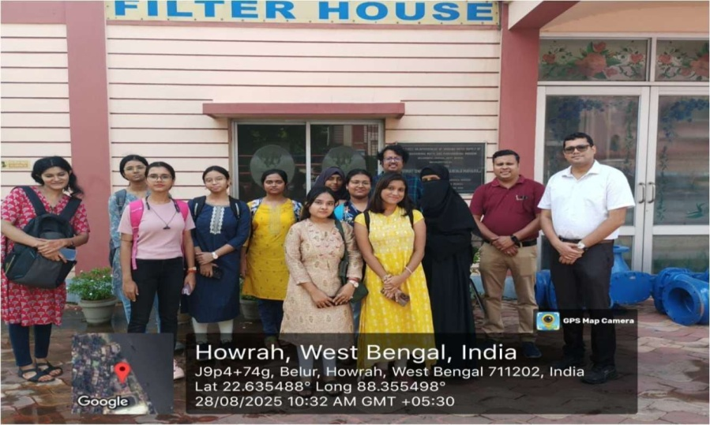

The following report summarizes our observations and learning during the visit.

LEARNINGREPORT

AlumSolutionTank
- Capacity:1900 liters
- Chemical Used:
Alum(Aluminiumsulphate, Al₂(SO₄)₃·18H₂O)

Function:
- Alumreactswithbicarbonatealkalinitiesinwatertoformflocsof aluminium hydroxide.

- Theseflocstrapfinesuspendedparticles,microbes,andcolloids,making them settle down.
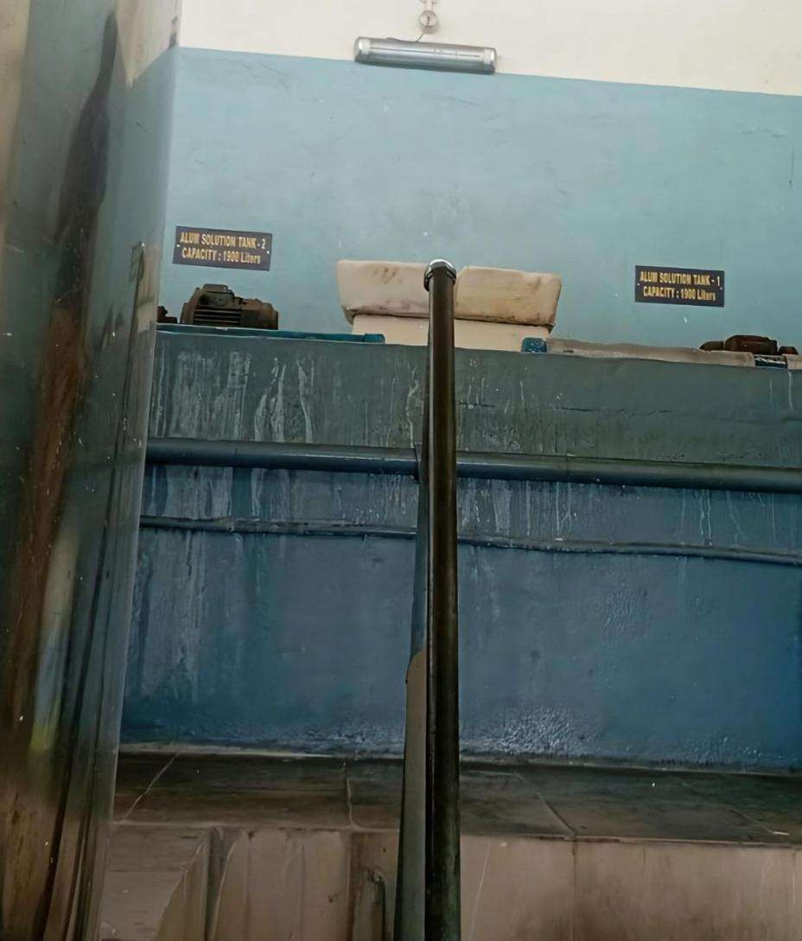

PolyelectrolyteSolutionTank
- Capacity:480liters
- ChemicalUsed:Polyelectrolytes(preparedat0.1–0.5%concentration) Function:

- Aidsinflocculationbybindingsmallparticlestogetherintolargeraggregates.
- Enhancestheremovalofcolloidalorganicmatterwheremicrobesoften thrive.

- Reducesmicrobialloadbyensuringmicrobesgetentrappedwithinlarger flocs.
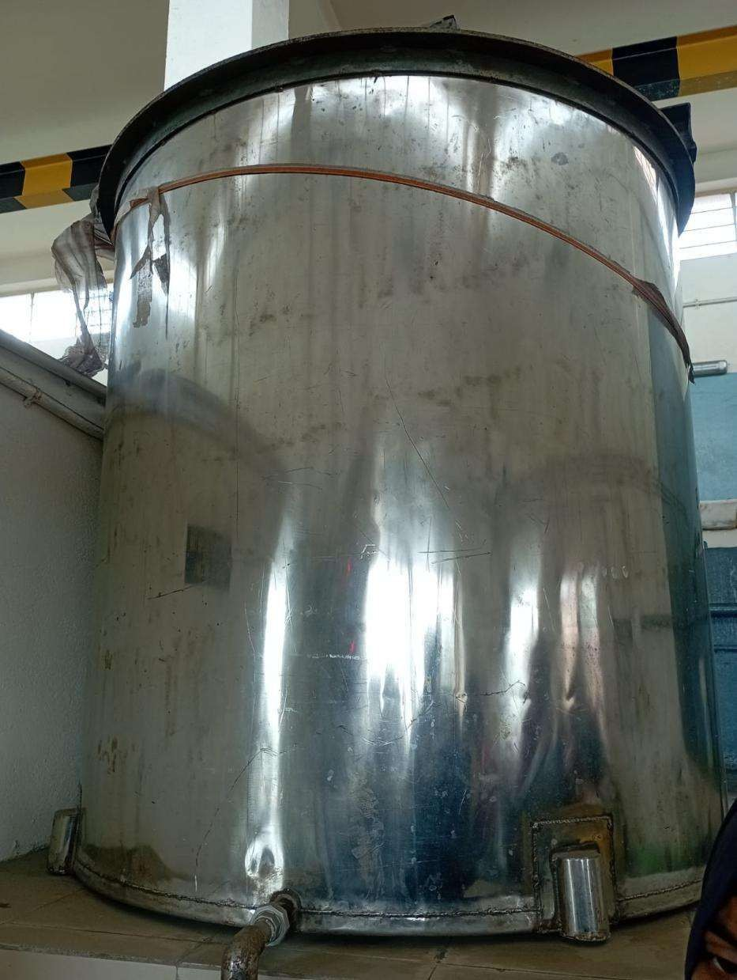

StillingChamber

function:
  - To minimizetheflowofeffluentsenteringfromthesourcewater.

  - Suddensurgesinflowcandisturbsettledparticlesandrelease microbes into clean water.
  - Thischamberensuressmoothwaterentry,maintainingmicrobial sedimentation efficiency.

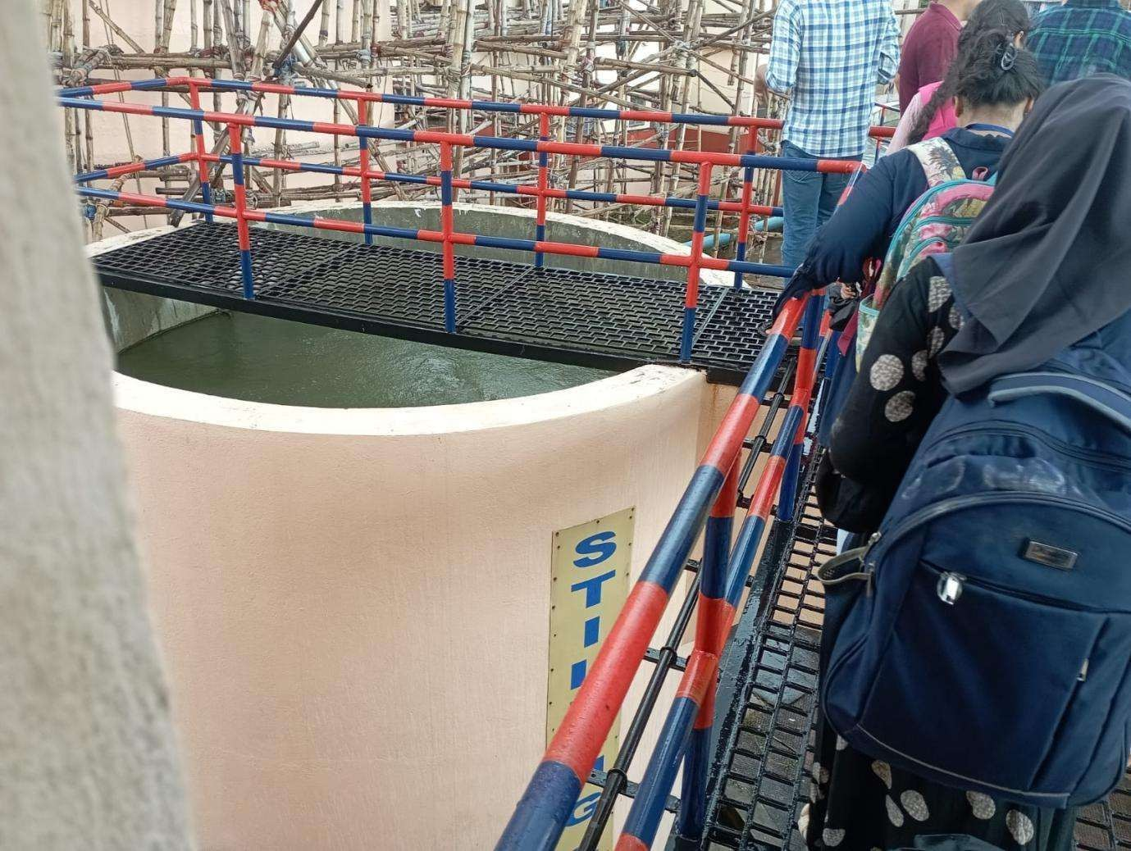

CircularWaterReservoirs

- Onelargecircular reservoirholdsrawwater.

- Asmallerreservoirholdstreatedwater(≈95%pure). Function:
- Largereservoirsallowlongerretentiontime, whichpromotessettlingof suspended matter and microorganisms.

- Thesmallertreatedwaterreservoirstoressafewater,readyfordistribution.

ChemicalLaboratoryVisit

Observation:

- Inthelaboratory,therawwaterqualityfromtheGangaRiverwas analyzed.
Function:
- A turbid meter was demonstrated. It had several revolving beakers containing raw water samples with varying turbidity levels.
- Turbidity is caused by clay, silt, and fine organic matter. These particles not only make water appear cloudy but also provide surfaces for microorganisms to attach and survive.
- In these beakers, clari-flocs (flocculated particles) were gradually terminated, showing how the treatment reduces suspended solids.
- Theplantwasshowntoeffectivelyremoveturbidcomponentsupto
0.012mg/lit.

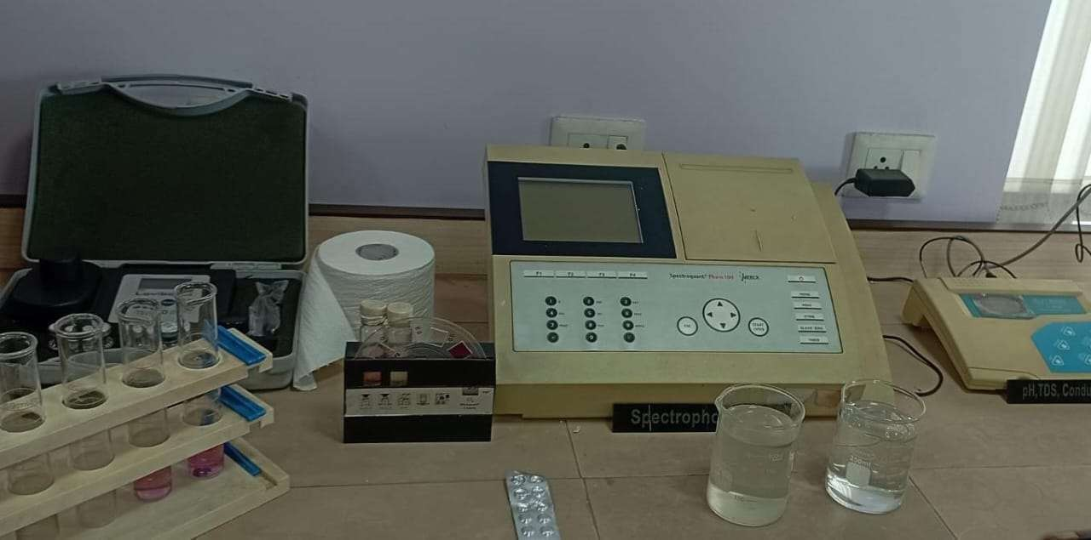
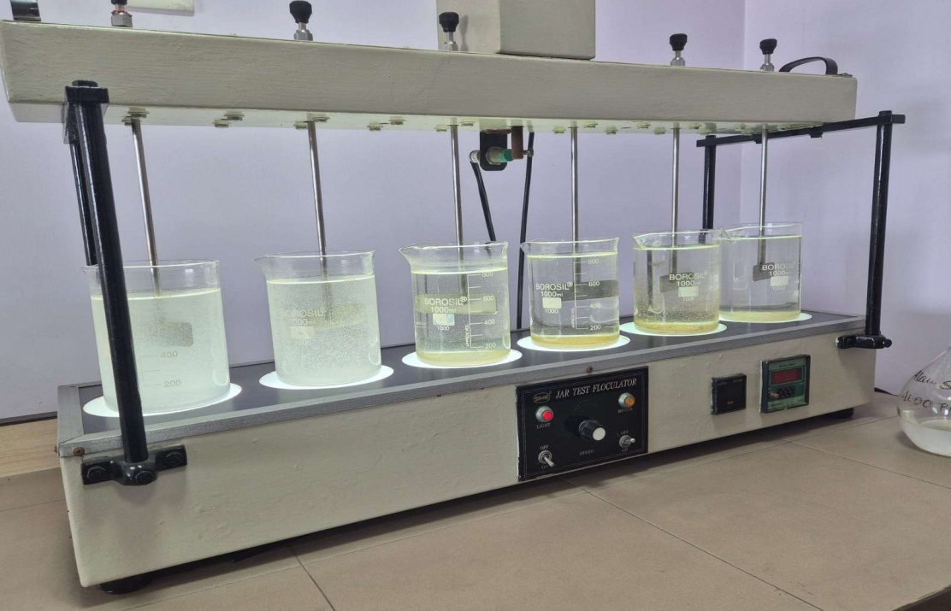

Step5:ChlorinationProcess

Chlorination is the primary disinfection step to kill or inactivate microorganisms.
AtBelurMath plant, itis applied intwophases:
- Pre-chlorination

Chlorineisaddedbeforesedimentationandfiltration. Functions:

  - Reducesalgalgrowthon filters.
  - Minimizesbadtasteandodour.
  - Lowersthemicrobialloadbeforephysicaltreatment.

- Post-chlorination
  - Chlorineisaddedafterfiltration,justbeforewaterisstoredor distributed.
  - Thisensuresthatanyremainingbacteria,viruses,orprotozoaare destroyed.
  - Actsasaresidualdisinfectantinthepipelinestoprotectagainst contamination during distribution.

Dosage:
  - Normaldose:0.1–0.2mg/lit.
  - Ifcontaminationishigh,dosagecanincreaseto5–10mg/lit.

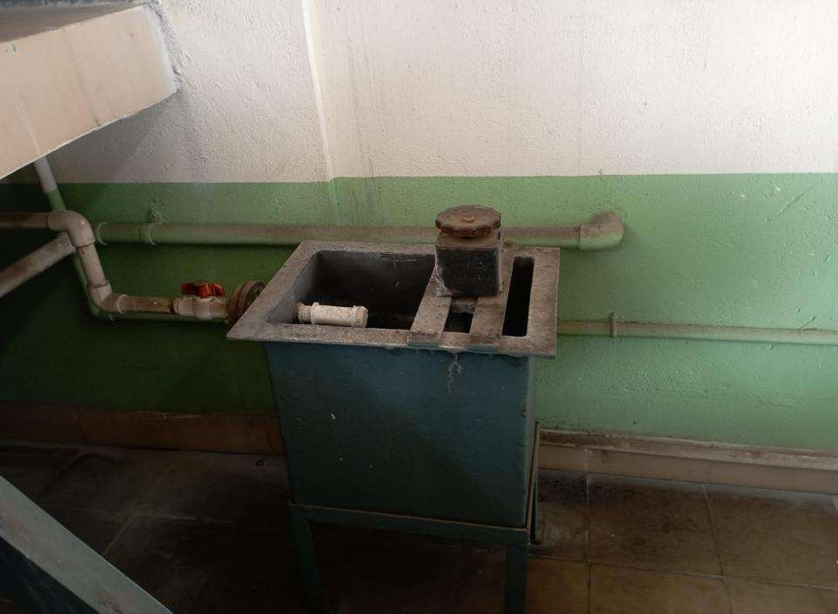

Step6:RapidGravityFiltrationandBackwashing

  - RapidGravityFilters(RGFs)consistoflayersofsandandgravelthrough which water flows downwards.
  - Theyphysicallytrapparticles,microbes,and organicmatter.
  - Overtime,filtersgetcloggedwithdebris,biofilms,andmicroorganisms. Backwashing Process:
  - Conductedevery24–48 hours.
  - High-speedwaterispumpedupwardstodislodgeandwashoutthe trapped impurities.
  - Takesabout15 minutes.
  - Uses2–5%ofthefiltered water.
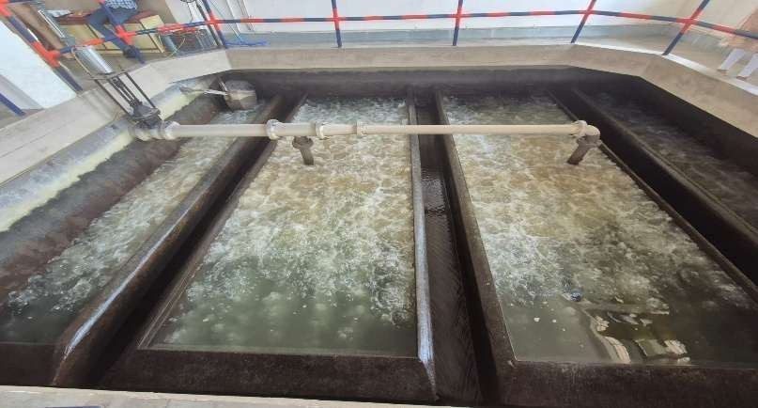

Step7:SCADASystem(SupervisoryControlandDataAcquisition)

  - Acomputerizedsysteminstalledattheplant.
  - Itallowsreal-timemonitoringandcontrolofeverystageofwater treatment.
  - Displaysaschematicdiagramofthetreatmentunits. Functions:
  - Monitorswaterquality(turbidity,chlorinelevels,pH).
  - Detectsmicrobialsafetyindirectly(throughresidualchlorine,turbidity data).

  - Alertsstaffifpurificationefficiencydrops.

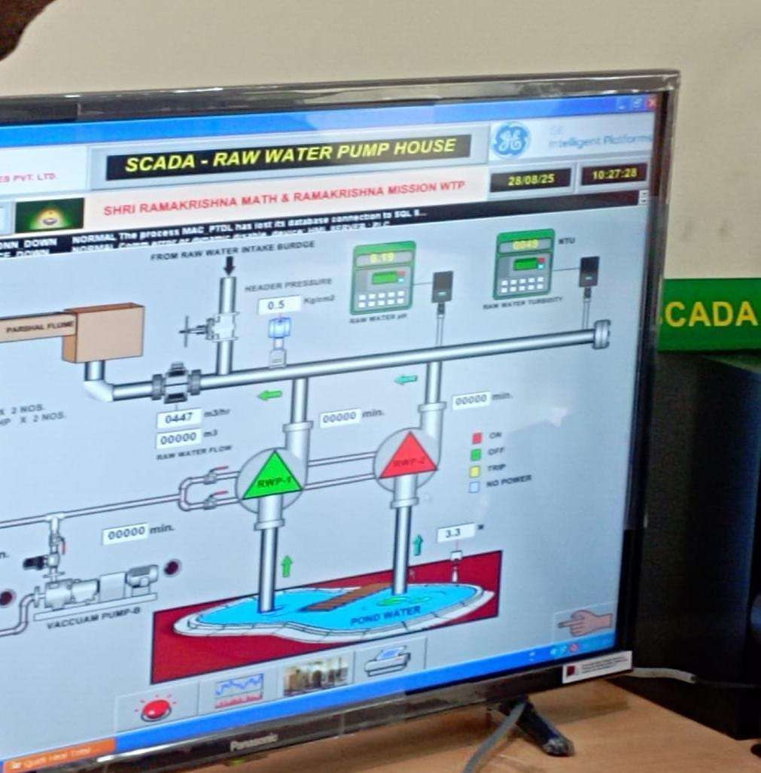

Step8:DischargeandStorageCapacity

  - Overhead TankCapacity:85lakh liters.
  - ClearWaterReservoirCapacity:6lakh liters.
  - DailyDischargeCapacity:~80liters/day(notedinplantrecords).
  - Afterpurification,waterisstoredinthesetanksbeforedistributionto the Belur Math region.

Studyofwatertreatmentandtechnologyupgradationat Vivekananda water treatment plant

The Vivekananda Water Treatment Plant (WTP) at Belur Math, maintained by the Ramakrishna Mission, is one of the most advanced and eco-friendly water treatment facilities in India. It draws water from the river Ganga, treats it through multiple physical, chemical, and microbiological steps, and suppliessafe drinking water to thousands of people daily.The wtp runs twice a day and the portable water as per who guidelines is distributed to devotees, buildings, nearby school, colleges, hospitals and bhandara griha everyday.
Vivekananda water treatment plant was earlier inaugurated on 21st December, 2010 by revered Srimat Atmasthanandaji Maharaj, president of Ramkrishna math&Ramkrishnamission,belurmathandhasbeenoperationalscience then.

ComponentsoftheWaterTreatmentPlant

1.SluiceGateSystem

- Controlsentryofwaterfromriver Gangatotheinternalpond.
- Operatedbymotorautomation basedonwaterlevel measurement.
- Preventsuncontrolledentryduringhightidesbymonitoringdifferential water levels between river and pond.

RawWatertoClariflocculator

  - Rawwaterentersviaaflashmixer.
  - Electromagneticflowmetersmeasurewater intake.
  - Parametersmeasured:pH,turbidityofraw water.

TreatmentProcess
  - Pre-treatmentand Post-treatmentchemicalprocesses.
  - Measurement ofpH,turbidity,chlorine residual.
  - Removalofsuspendedimpurities,microbialpathogens,andorganicmatter.
  - CleanWater Reservoir
  - Storesprocessedwaterbeforedistribution.
  - Automationofpumpsbasedonreservoirwaterlevelandpipeline pressure to optimize energy use.

OverheadReservoir:
  - Elevated reservoirwith capacityof5,00,000liters.
  - Equipped withflowmetersandautomatedpumpsystems.
  - Suppliestreatedwaterto nearbylocalities.
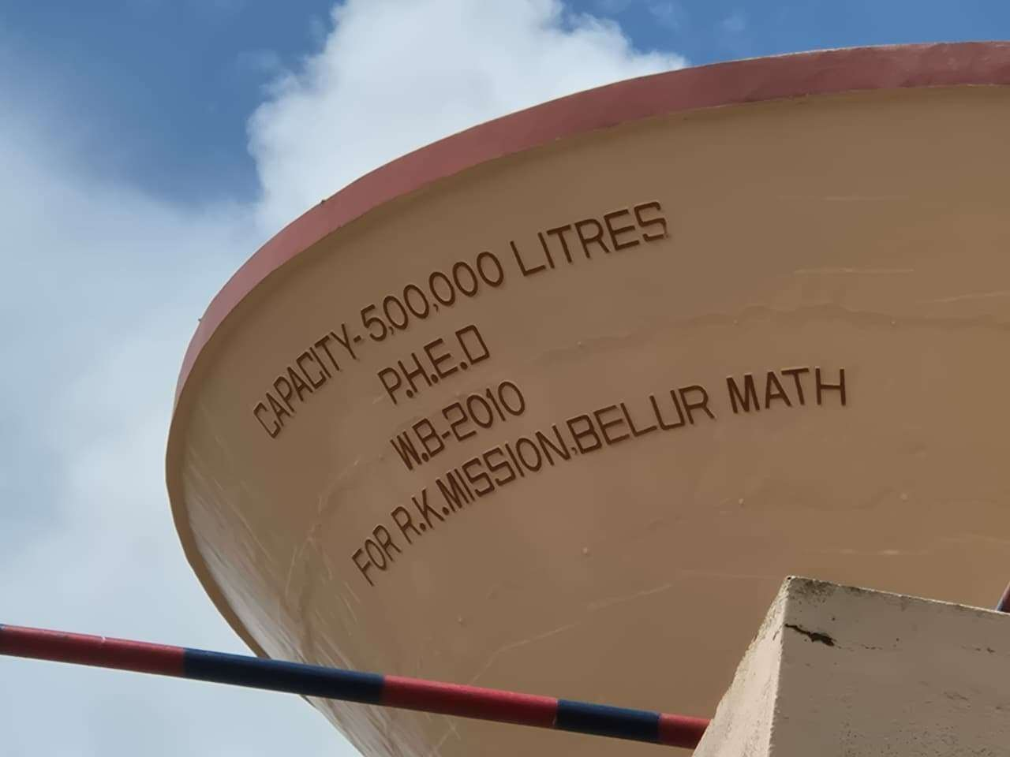

TechnologyandInstrumentsUsed:
  - Ultrasonic& Radar LevelSensors→monitorwater levels.
  - PressureTransmitters→maintainflowstability.

  - Magnetic Flow Meters→measurewatervolume.
  - ChlorineAnalyzer→monitors residualchlorinefordisinfection.
  - pHAnalyzer →checksacidity/alkalinity affectingmicrobial growth.
  - TurbidityAnalyzer →detectssuspendedimpuritiesandmicroorganisms.
  - SCADASystem(SupervisoryControlandDataAcquisition)→centralized computer control and monitoring.
  - MIS(ManagementInformationSystem–DaytoDayReporting)→ ensures data-driven operation and transparency.

Achievements fromtheWTP:

- Productionofhigh-quality,microbiologicallysafetreated water
- Recovering resources like sludge for fertilizer or generating biogas WTPs removes harmful pollutants, such as pharmaceutical drugs, high concentration of which can be disastrous for aquatic life.
- By removing harmful bacteria and chemicals revent waterborne diseases like cholera, typhoid and dysentery leading to better public health
- Technologies like membrane filtration, reverse osmosis effectively remove even trace pollutants, ensuring high-purity water for various application.

Conclusion

The Vivekananda Water Treatment Plant, Belur Math, is an example of how modern engineering technology and microbiological monitoring work together to ensure safe drinking water supply. From raw water intake to chemical treatment and advanced automation, each step playsa crucial role in removing microbial pathogens andensuring publichealth safety.

As a microbiology student, this project highlights the importance of microbial monitoring, disinfection strategies, and quality control in maintaining a safe and sustainable drinking water supply for the community.

