Routine of Department of Education
Even semester 2025

Mon | 1 0 | 1 1 | 1 2 | 1 -  1 .30 | 1 .30 | 2.30 | 3.30 | 4.30
Sem2 |  | 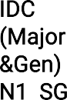 | Minor  Education  H.R.  N1 PSB |  |  | 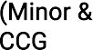  )  Education  N1 RG
Sem  4 |  | Library |  |  | N1 | 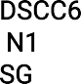 | 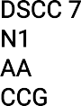  Education  N4  RG | 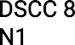
 |  |  | G7 |  |  |  |  | AA
 |  |  |  |  | Education
 |  |  |  |  | G6
 |  |  |  |  | SG
SEM  6 |  |  |  |  | . | Education  G7 PSB

H.R. Honours Room

Tues | 1 0 | 1 1 | 1 2 | 1 -  1 .30 | 1 .30 | 2.30 | 3.30 | 4.30
Sem2 |  |  | Minor  Education  N1 SDG |  |  | N5  Education  N1 SDG
Sem  4 |  |  |  |  | 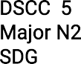 | 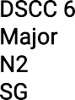 | 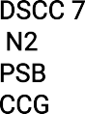  Education  N4  CS | 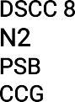  Education  N4  CS
SEM  6 | 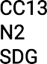 |  | PSB |  |   PSB | Education  G6 CS |   SG

Wed | 1 0 | 1 1 |  | 1 2 | 1 -  1 .30 | 1 .30 | 2.30 | 3.30 | 4.30
Sem2 | N1 .  CS |  |  | Minor  Education  N1 AA |  | Education | N1 SDG
Sem2 |  | N1  CS
Sem  4 |  | .  Education  N4  AA |  |  |  | Education  N1 |  | Education  N1
SEM  6 |  | RG |  | CS |  |  | Education  G7  CS

Thurs | 1 0 | 1 1 | 1 2 | 1 -  1 .30 | 1 .30 | 2.30 | 3.30 | 4.30
Sem2 | SDG |  | Minor  Education  N1  SG |  |  | 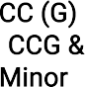  (  )  Education  G6  SG |  | NSS
Sem  4 |  | N1  SDG |  |  | 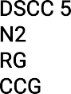  N4 | 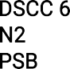  N5  RG |  | 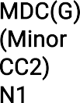
SEM  6 | AA |  |  |  | PSB | Education  N1 SDG
N1 .
CS

Fri | 1 0 |  | 1 1 |  | 1 2 | 1 -1 .30 | 1 .30 | 2.30 | 3.30 | 4.30
Reces
s
Sem  2 |  |  |  |  |  |  |  | SEC  Educatio  n N5  RG | N4  Educatio  n N5  RG
Sem  2 | 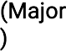  N1  AA |  | 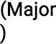  N1  AA
Sem  4 |  |  |  |  | 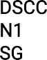 |  | 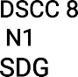
SEM  6 |  |  | CS |  |  |  | RG | N1 SG

Sat | 1 0 | 1 1 | 1 2 | 1 -  1 .30 | 1 .30 | 2.30 | 3.30 | 4.30
Sem2 | 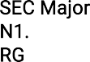 |  |  |  |  |   N1  CS  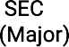  N5 | 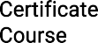
 |  |  |  |  |  | PSB
Sem  4 | Education  N5  AA |  | 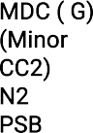 |  |  |  | 
 |  |  |  |  | l
SEM  6 | 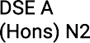  SDG | 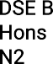  AA | G7 RG DSE  B(General) |  | RG  N1 PSB |  | 

G7 AA

