Multimedia & Animation Certificate Course
Academic year: Jan to May 2024
Name of the Program: Certificate course on Multimedia & Animation
Speaker:
Internal Speakers –
- Mr. Santosh Kumar Shrestha, Technical Assistant of Journalism and Mass Communication Department
- Mr. Joy Adhikary, SACT, Computer Science Department
- Mrs. Sushmita Pramanick, SACT, Computer Science Department
External Speaker –
- Kumarjit Mondal, Assistant Professor, Department of Computer Science, Shri Agrasain College
Date of commencement of classes: 28/03/2024
Funding: College

NOTICE
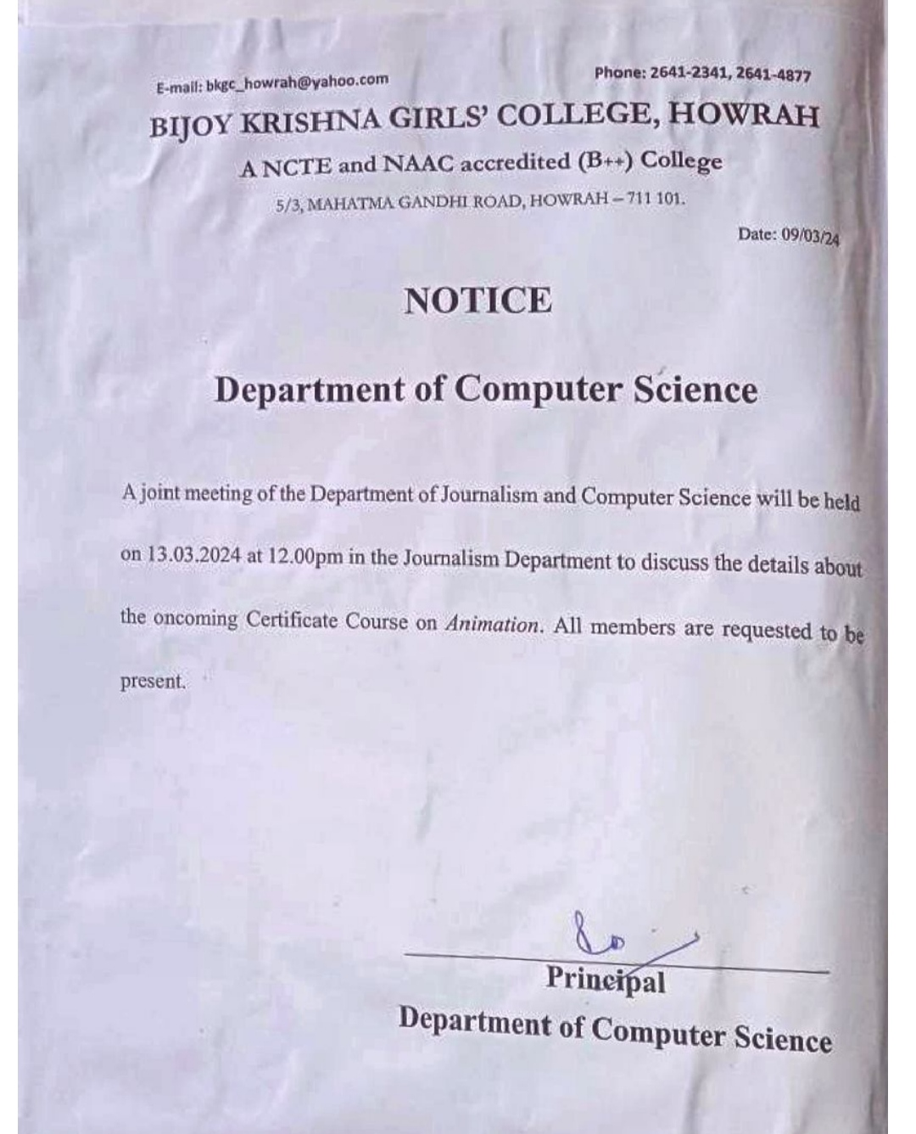

RESOLUTION OF THE MEETING HELD ON 13/03/2024
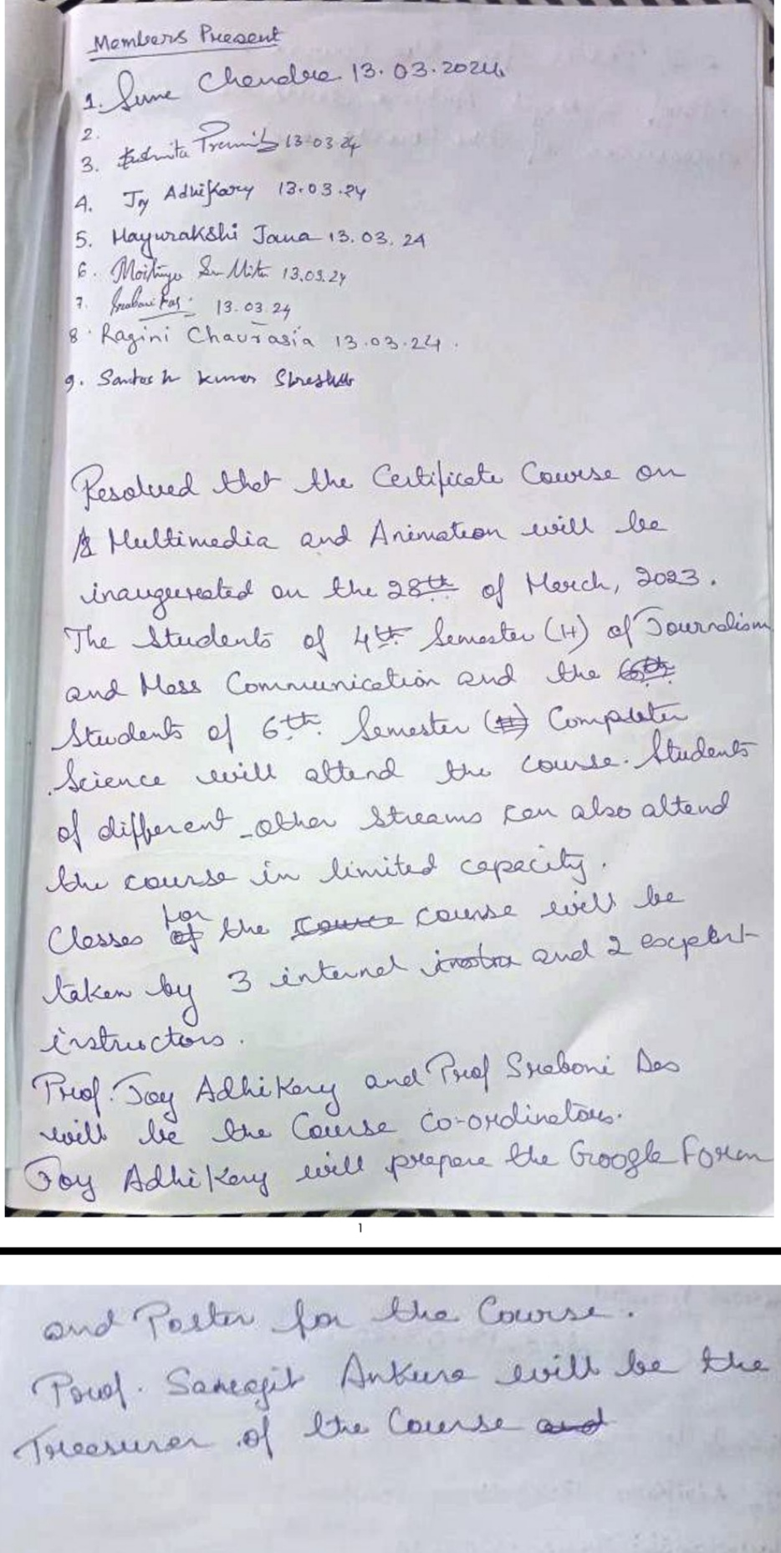

ATTENDANCE RECORD
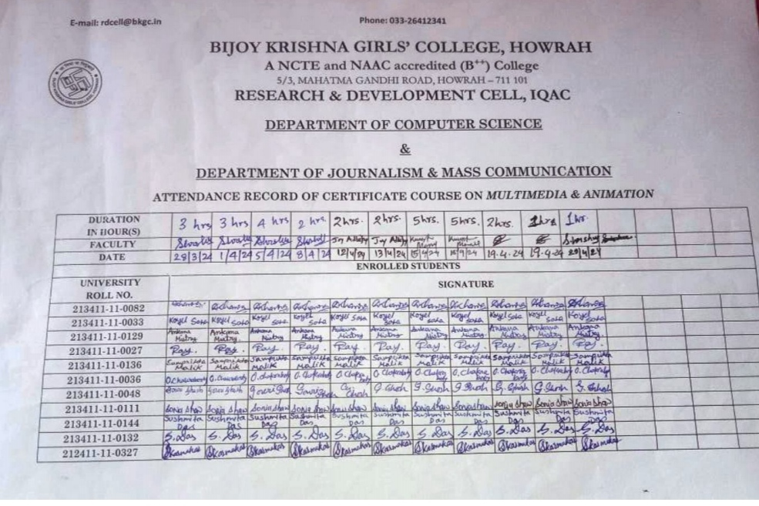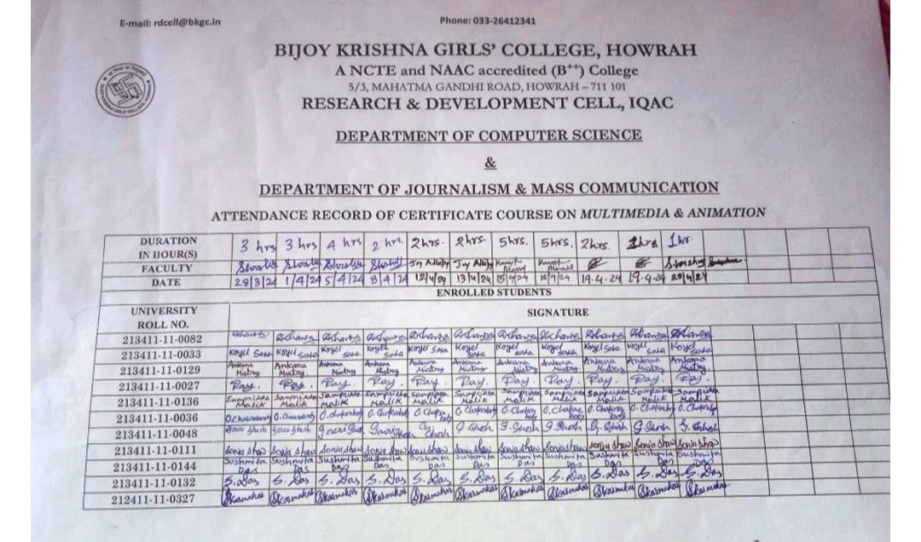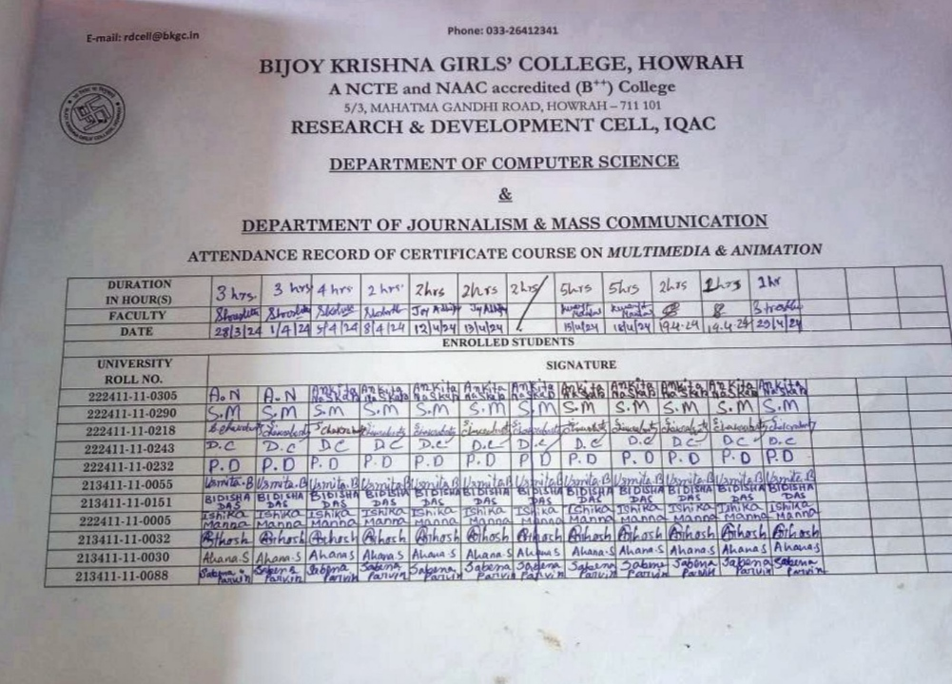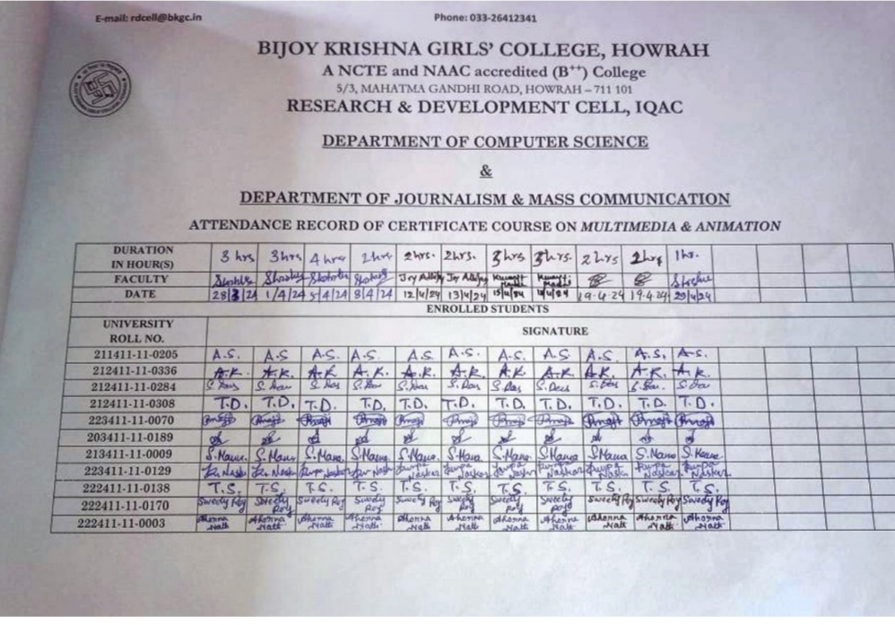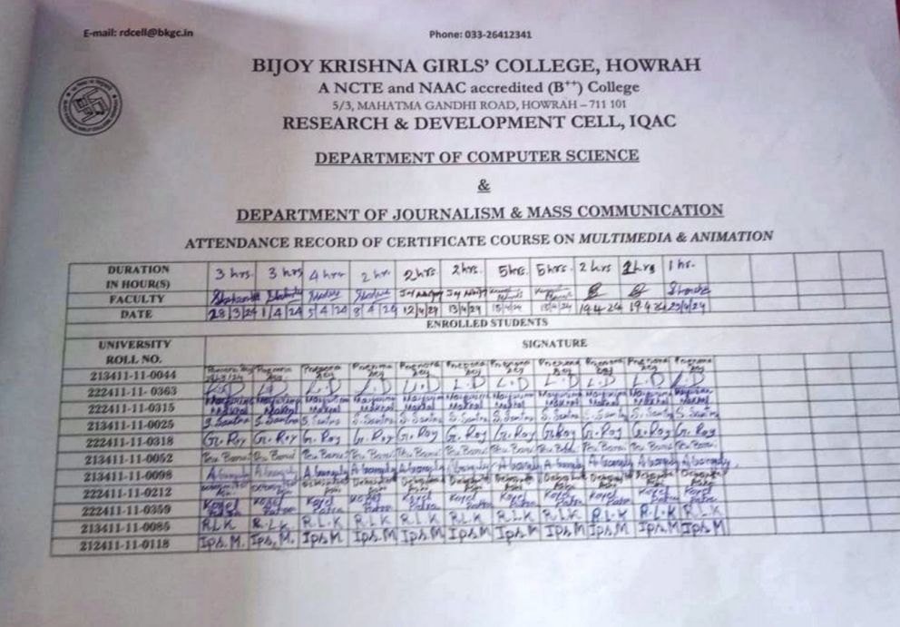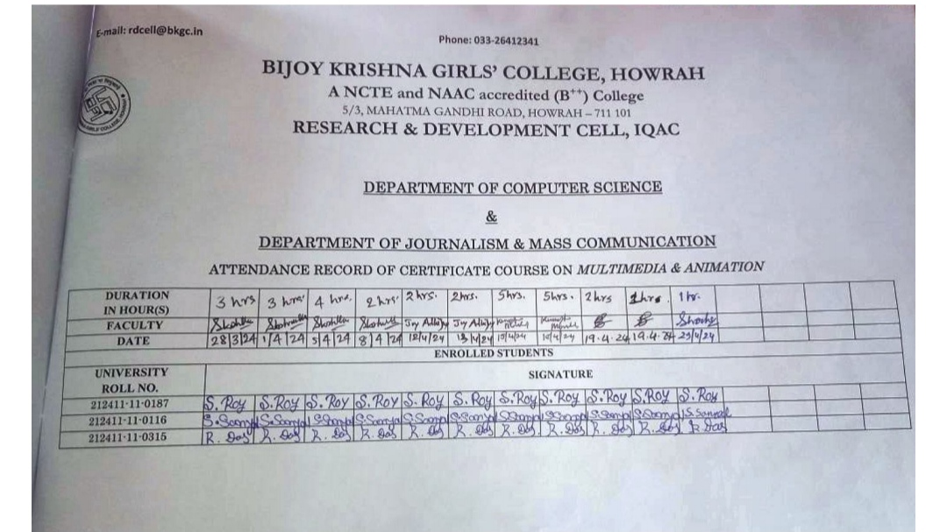
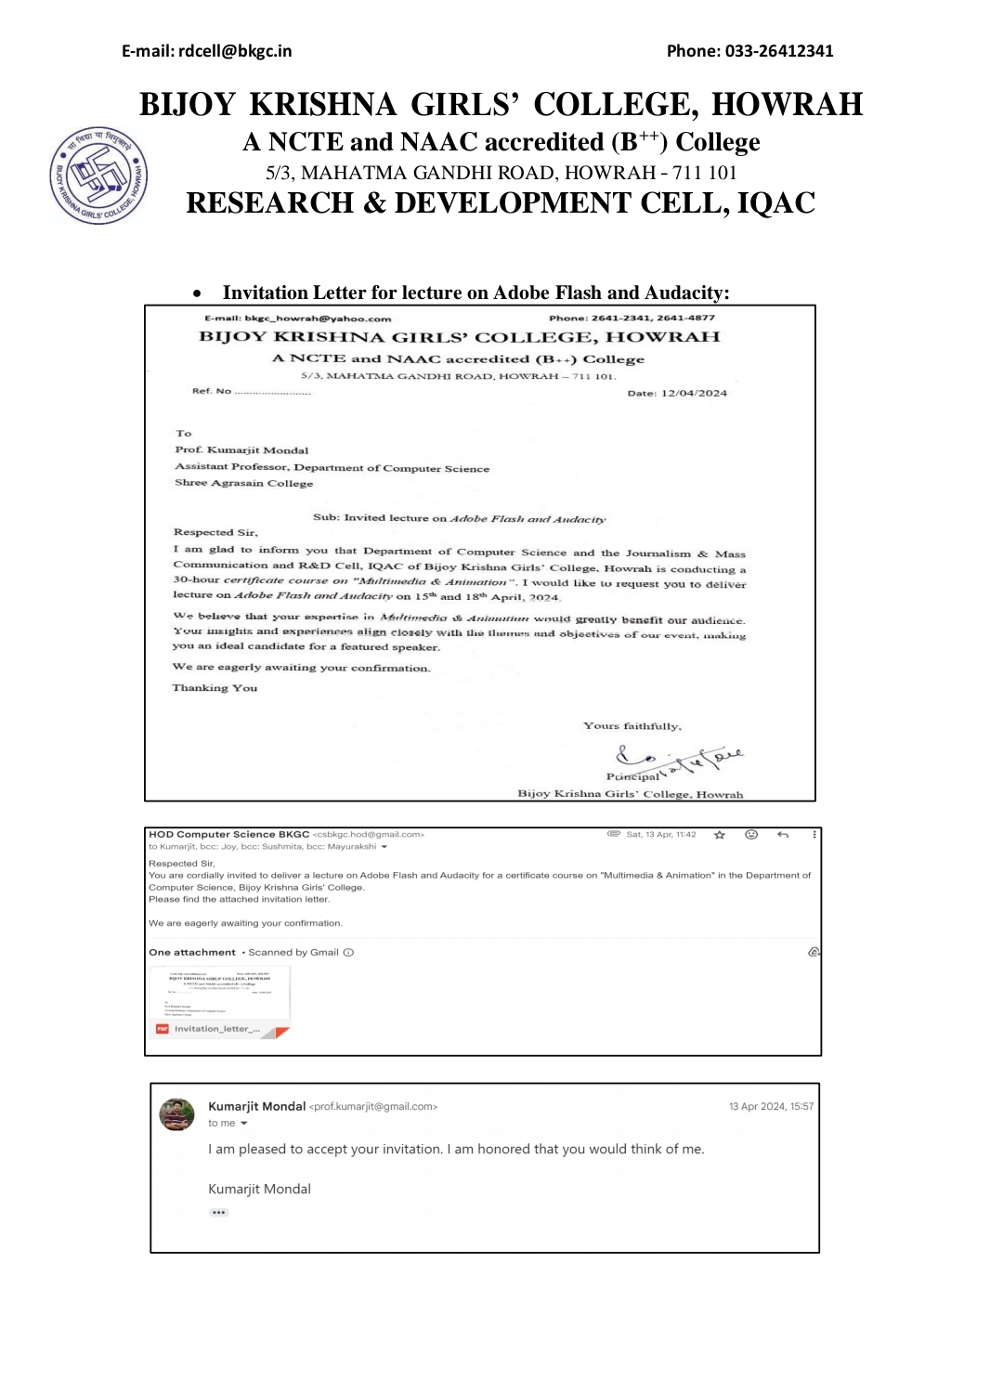
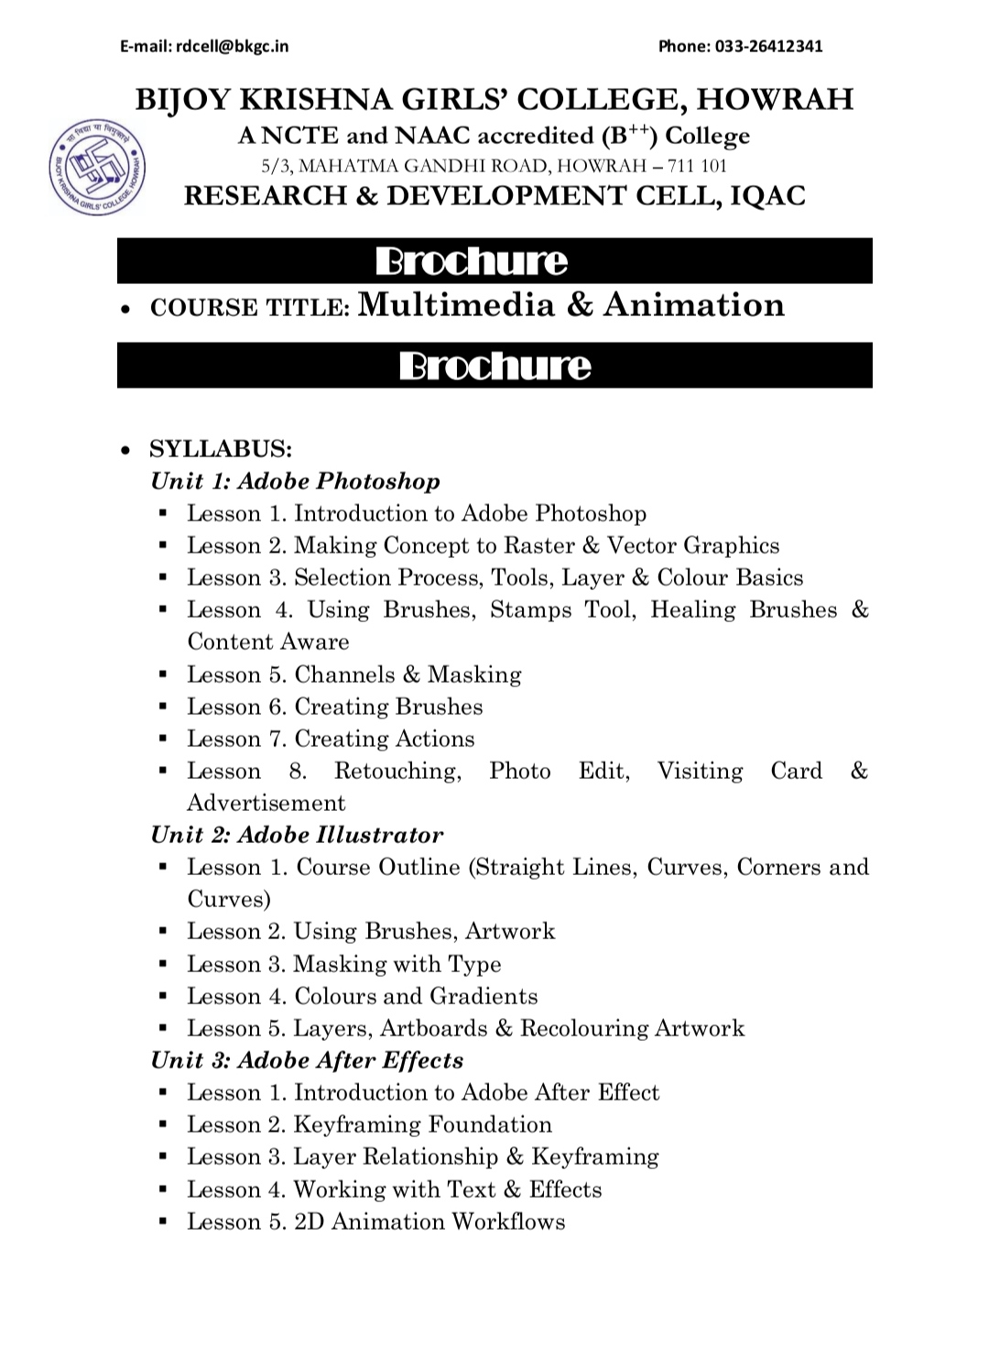
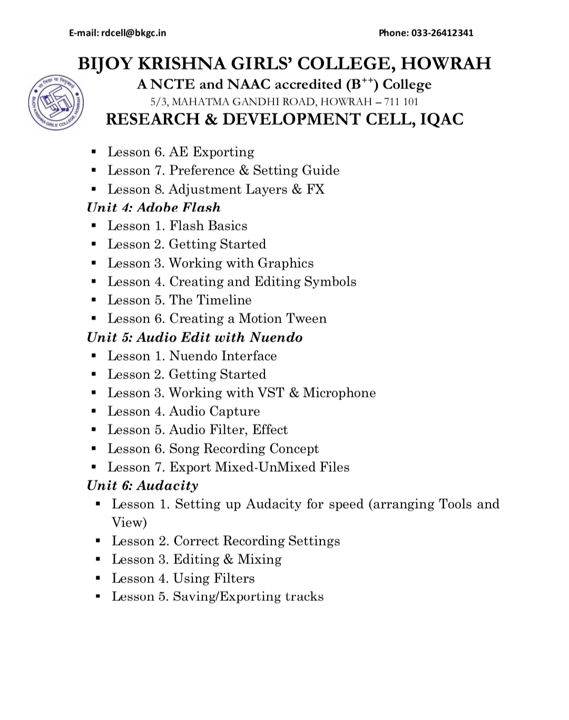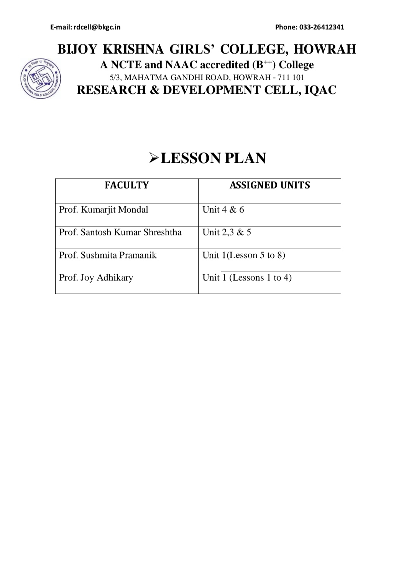
POSTER OF THE MULTIMEDIA COURSE

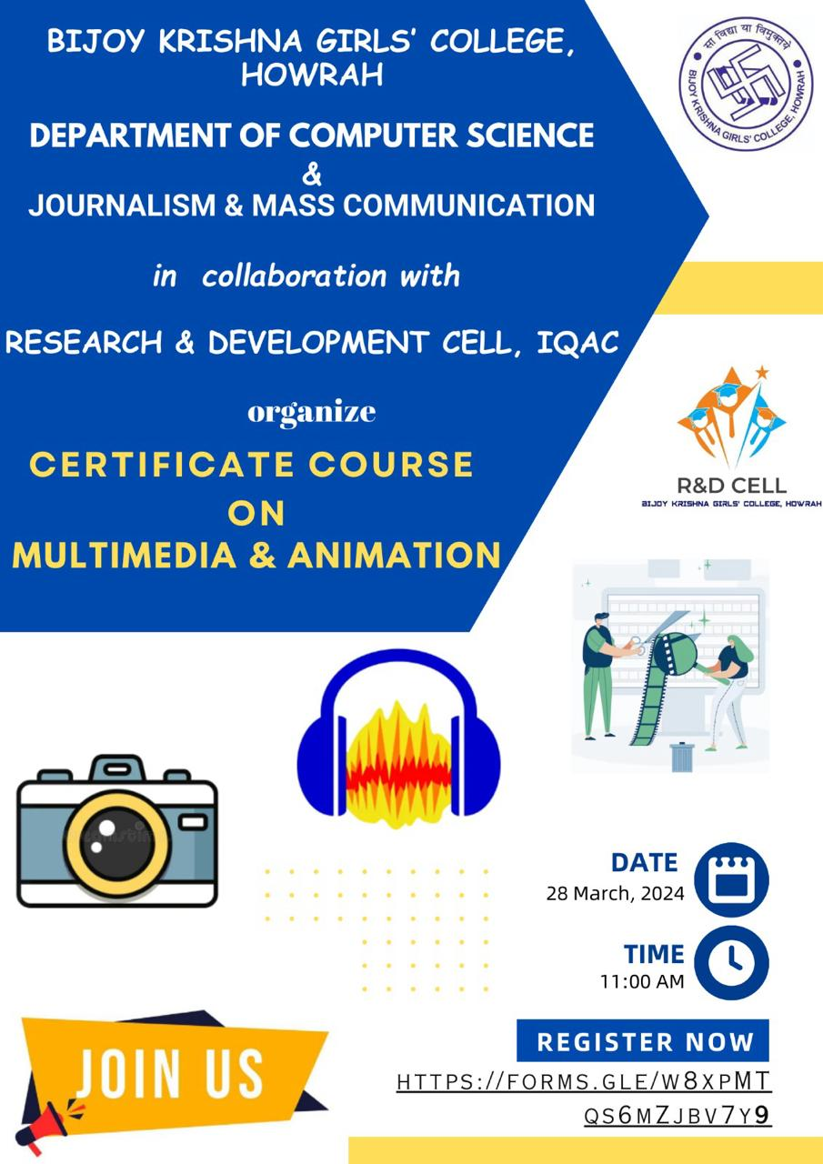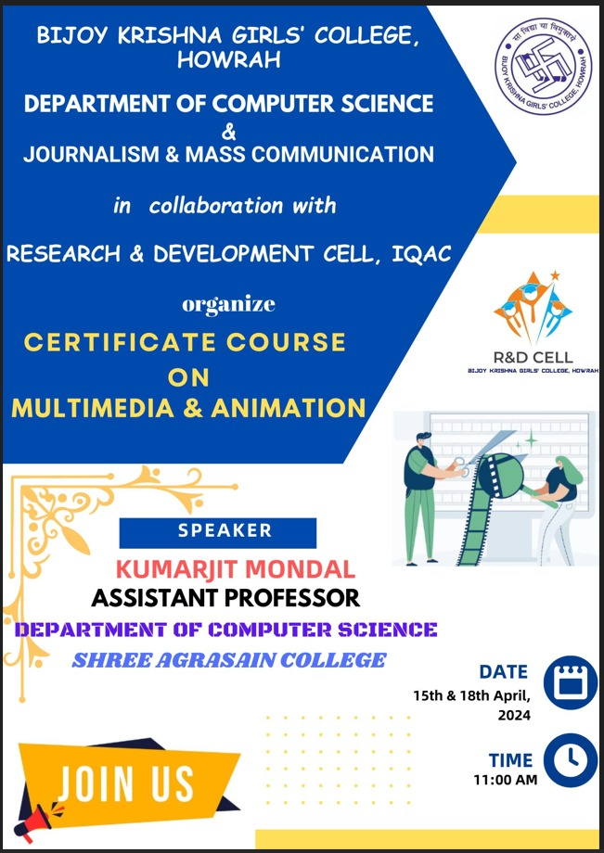

INAUGURATION DAY
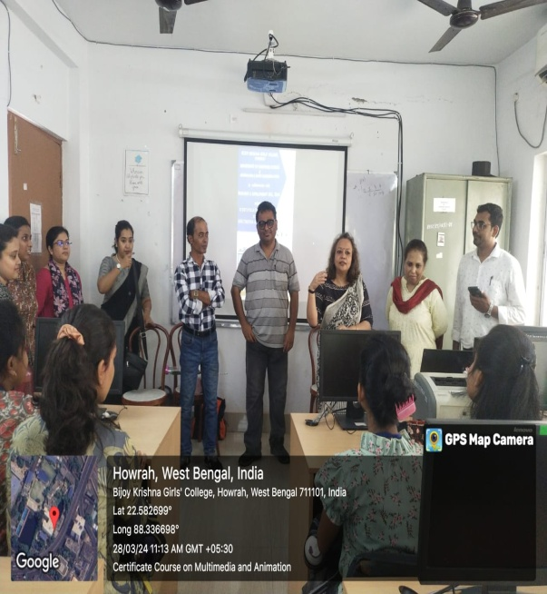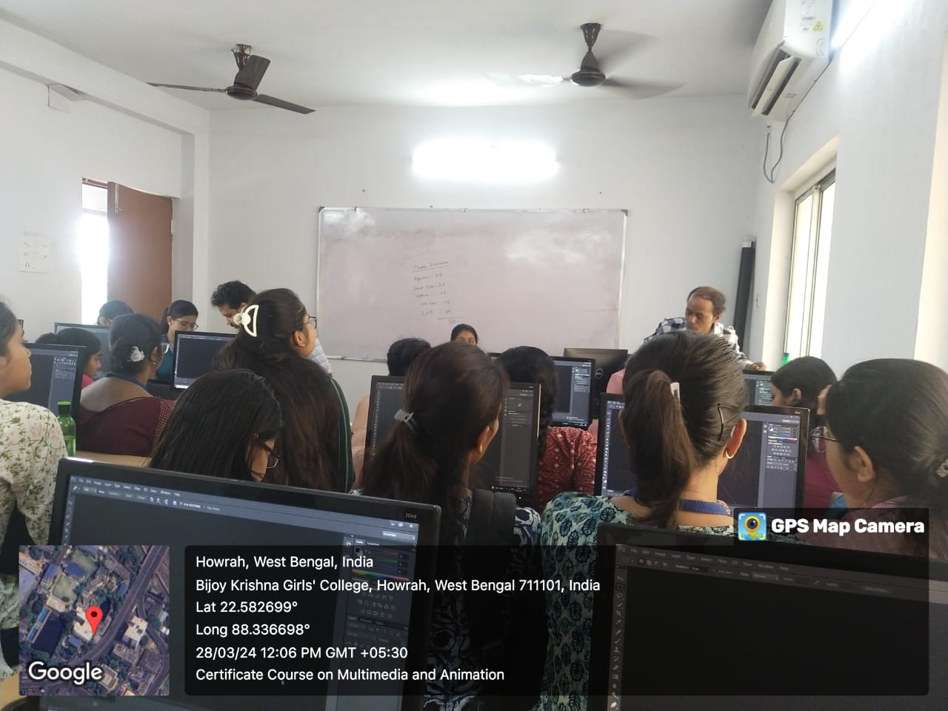

INTERNAL SPEAKER
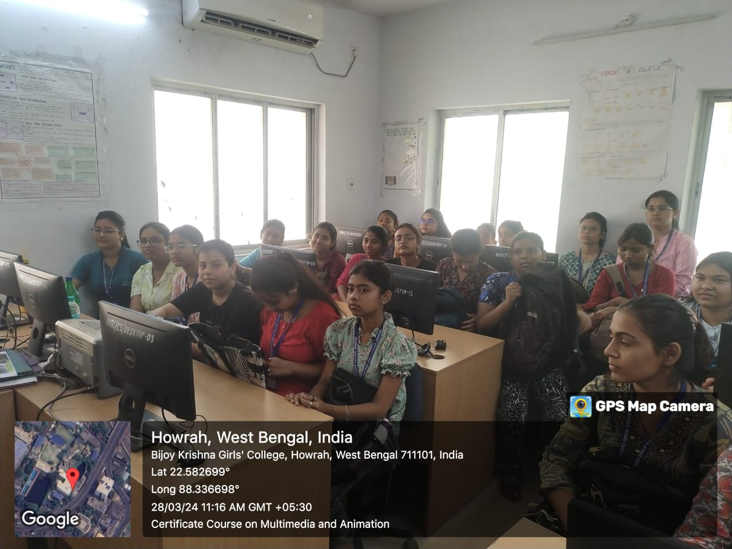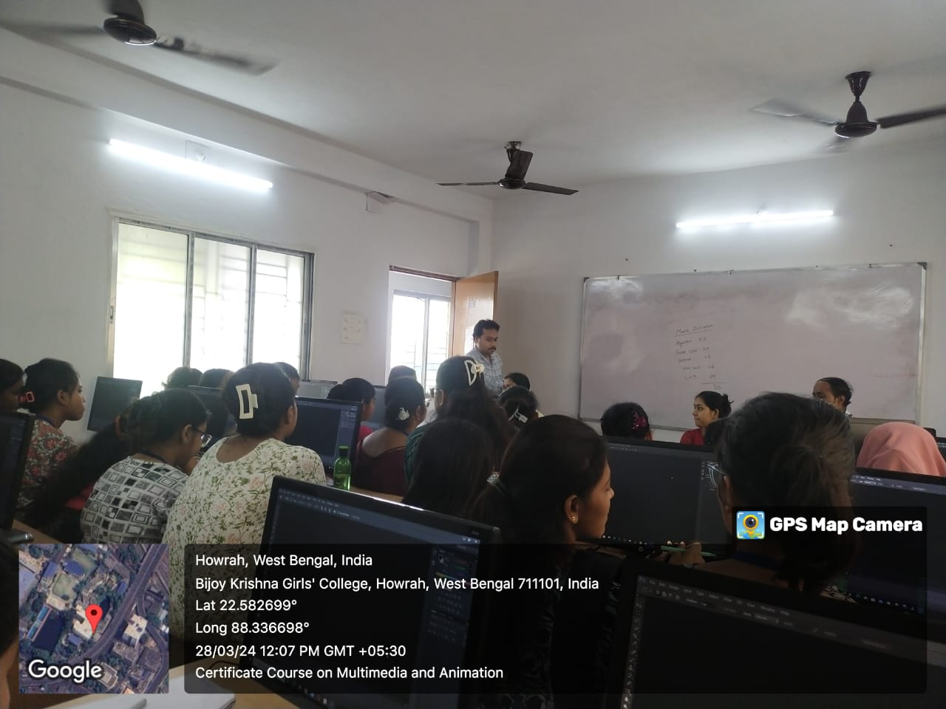

EXTERNAL SPEAKER
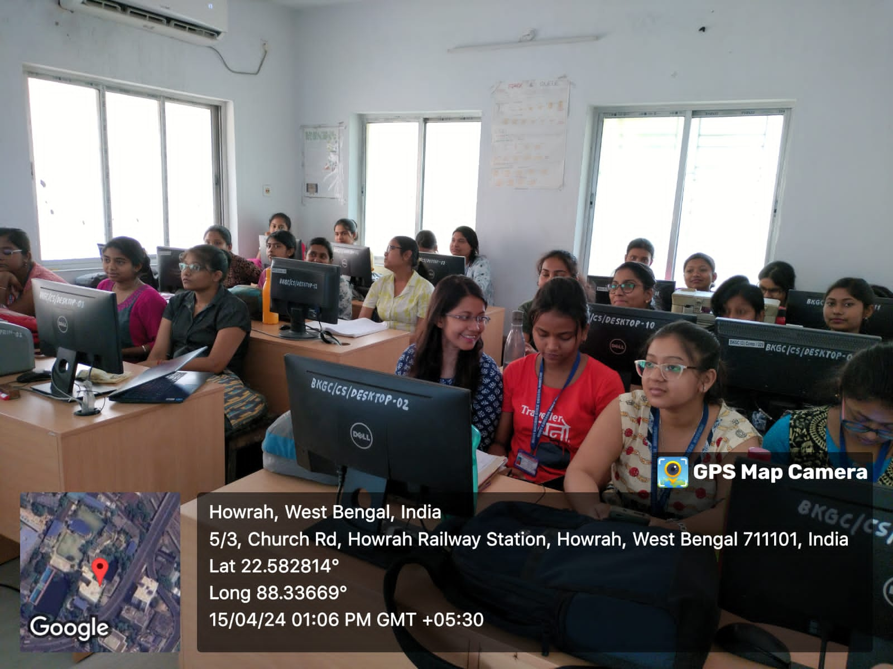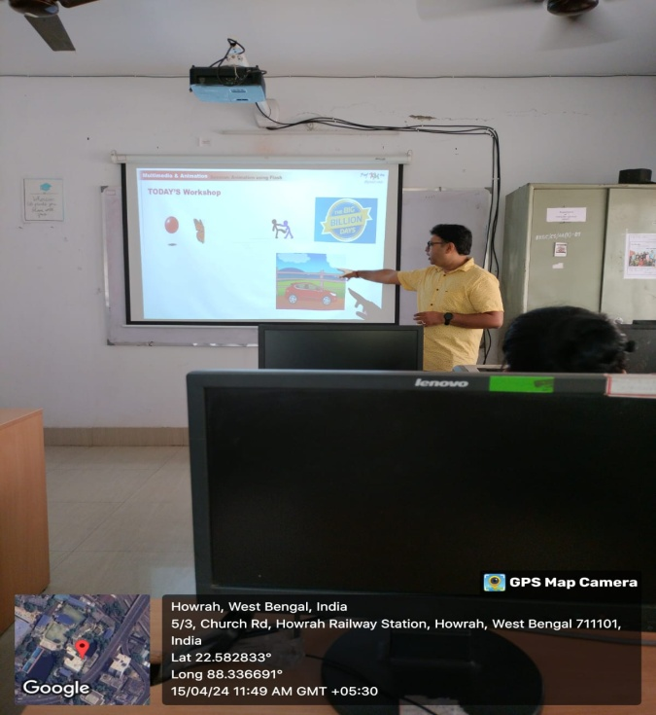

Program Outcome: The duration of this certificate course was thirty hours along with two hours examination. This course continued for one month. It was a great opportunity to the students to have this kind of certificate course. They learned all the basic skills of multimedia and animation. This course will help the students to think independently for making career in this field.

