Photo Journalism Certificate Course
Academic year: June, 2024 to May, 2025
Name of the Program: VISUAL STORY TELLING THROUGH PHOTO APPRECITION COURSE in collaboration with Third Eye
Speaker: Sri Atanu Paul and his team
Date of commencement of classes: 14/6/2024
Funding: College
Participants: Students of semester III of this college
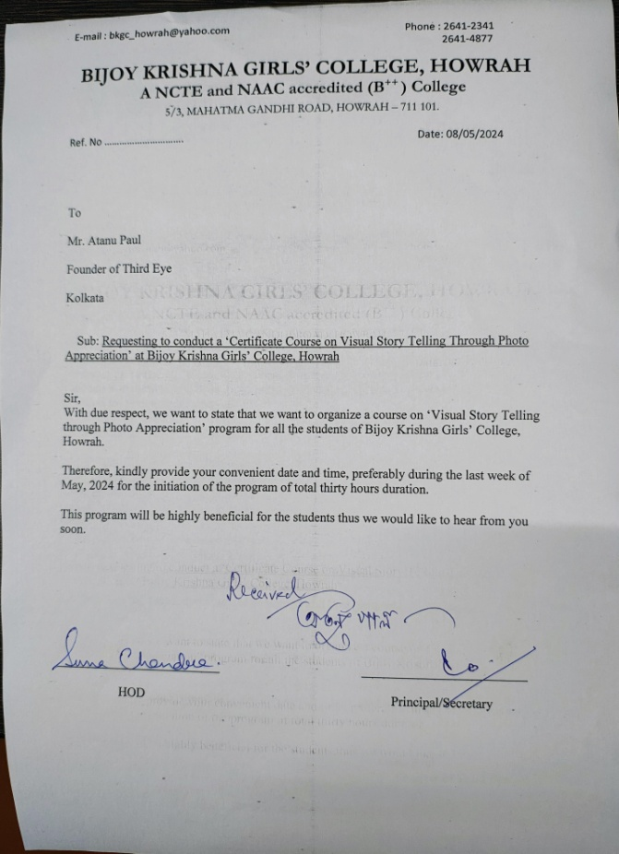

.

Proof of collaboration
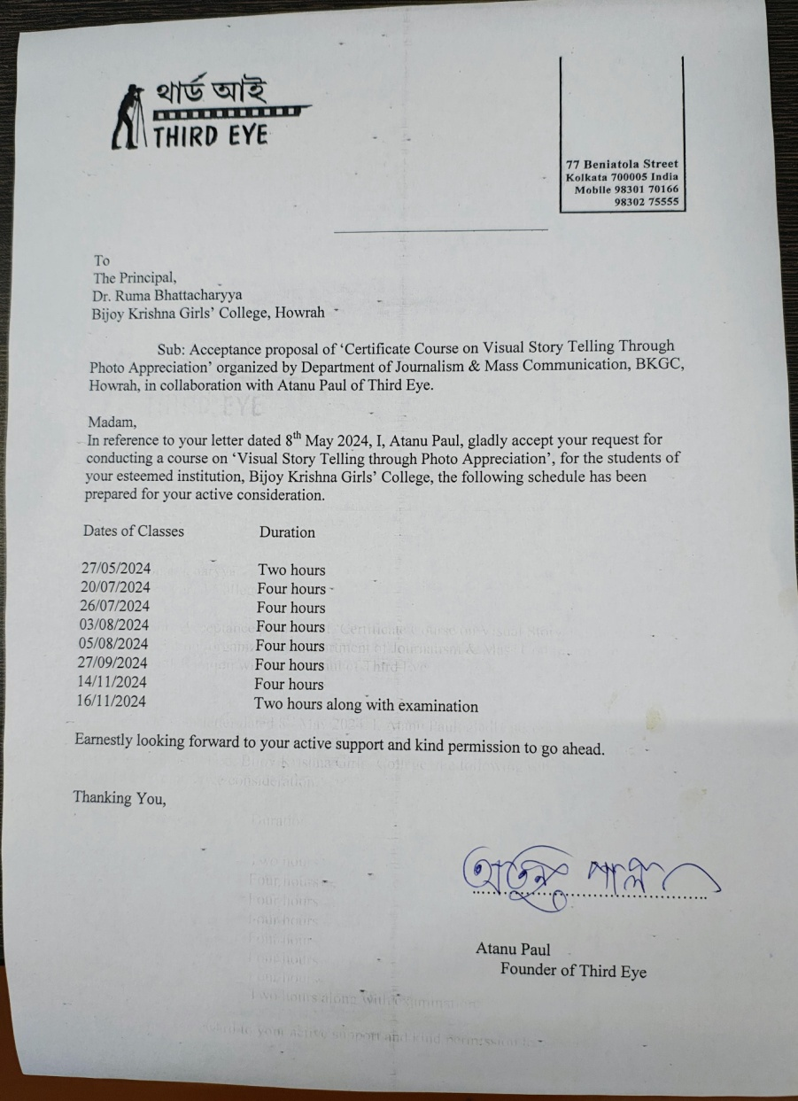

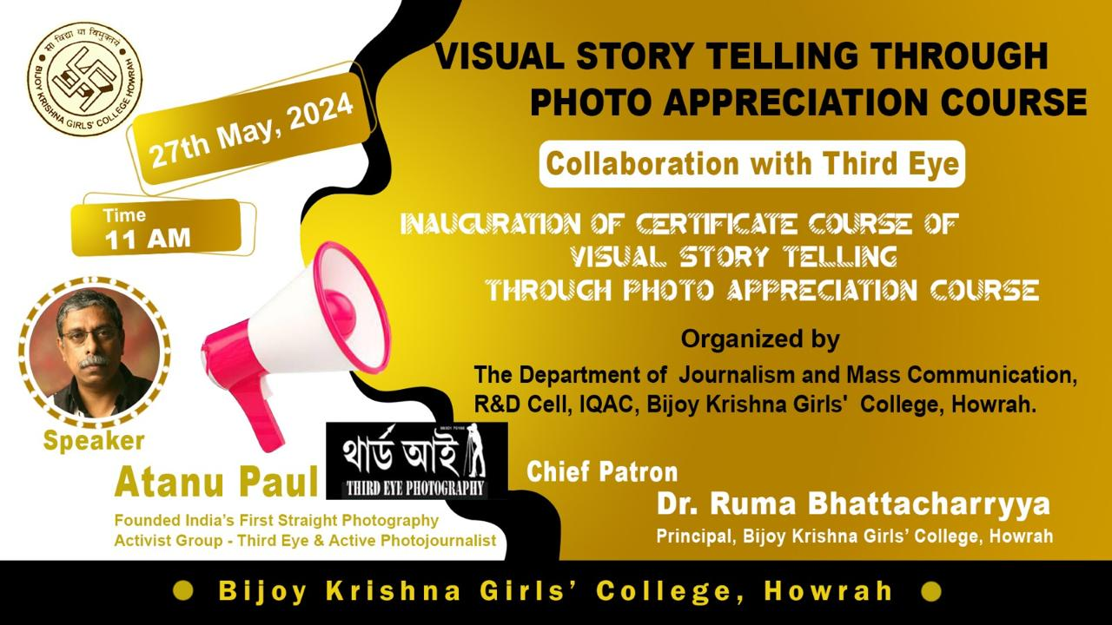

Day 1 Dates Durations
27.5.2024 Two Hours
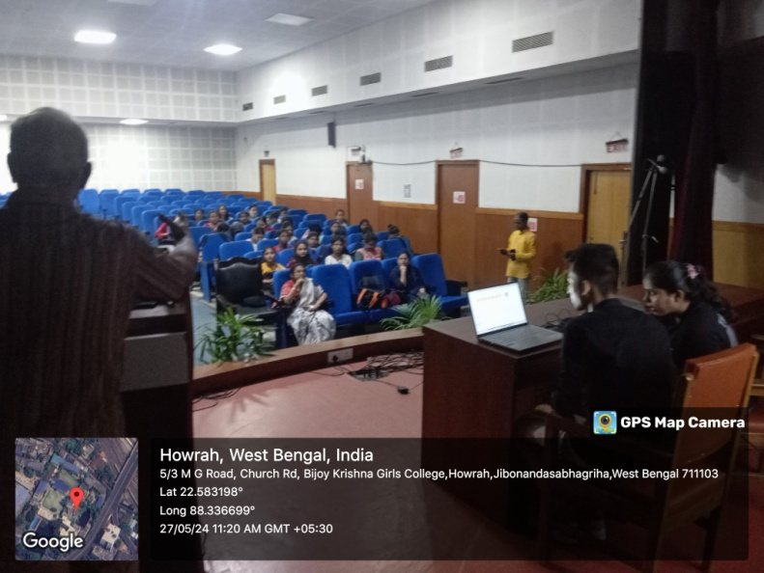
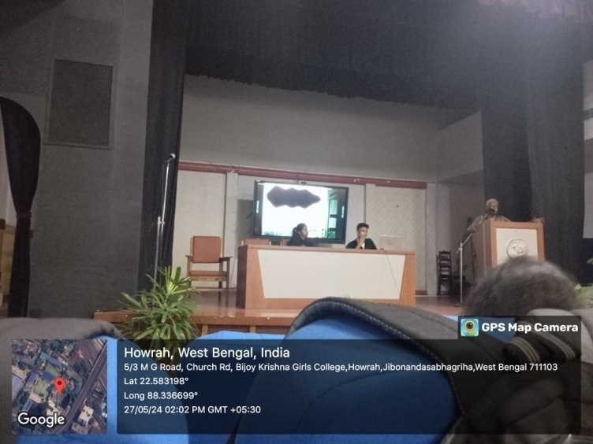

Day 2 Dates Durations
20.7.2024 Four Hours
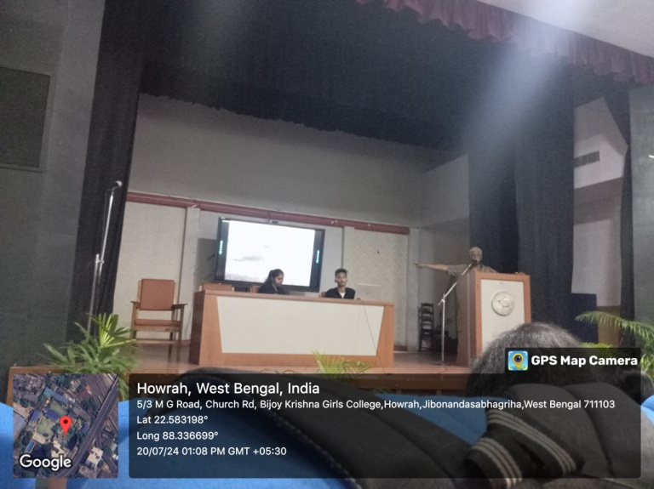
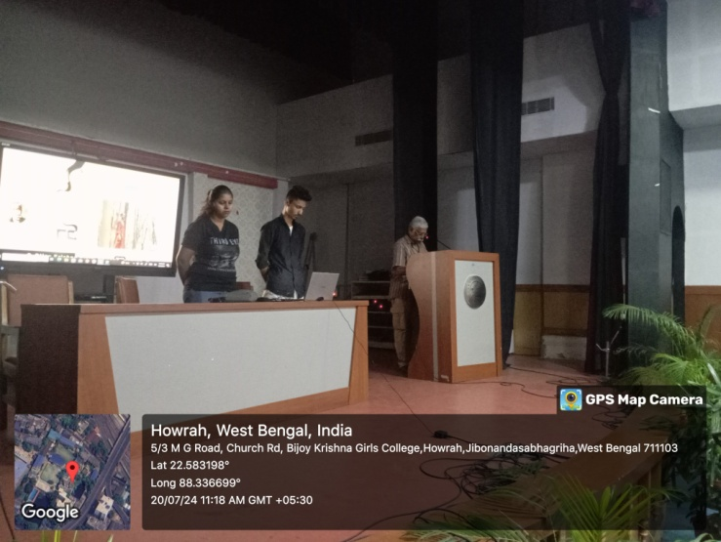

Day 3 Dates Durations
26.7.2024 Four Hours

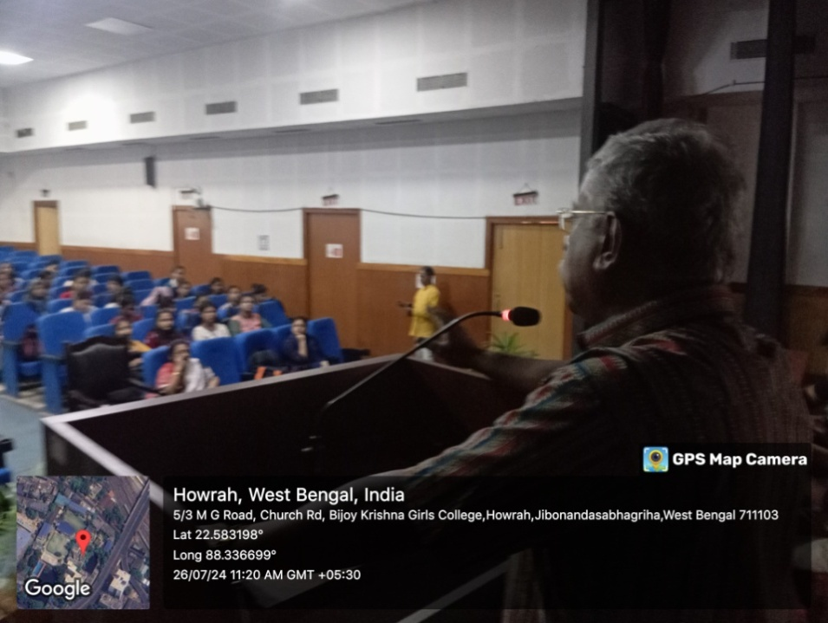
Day 4 Dates Durations
20.7.2024 Four Hours

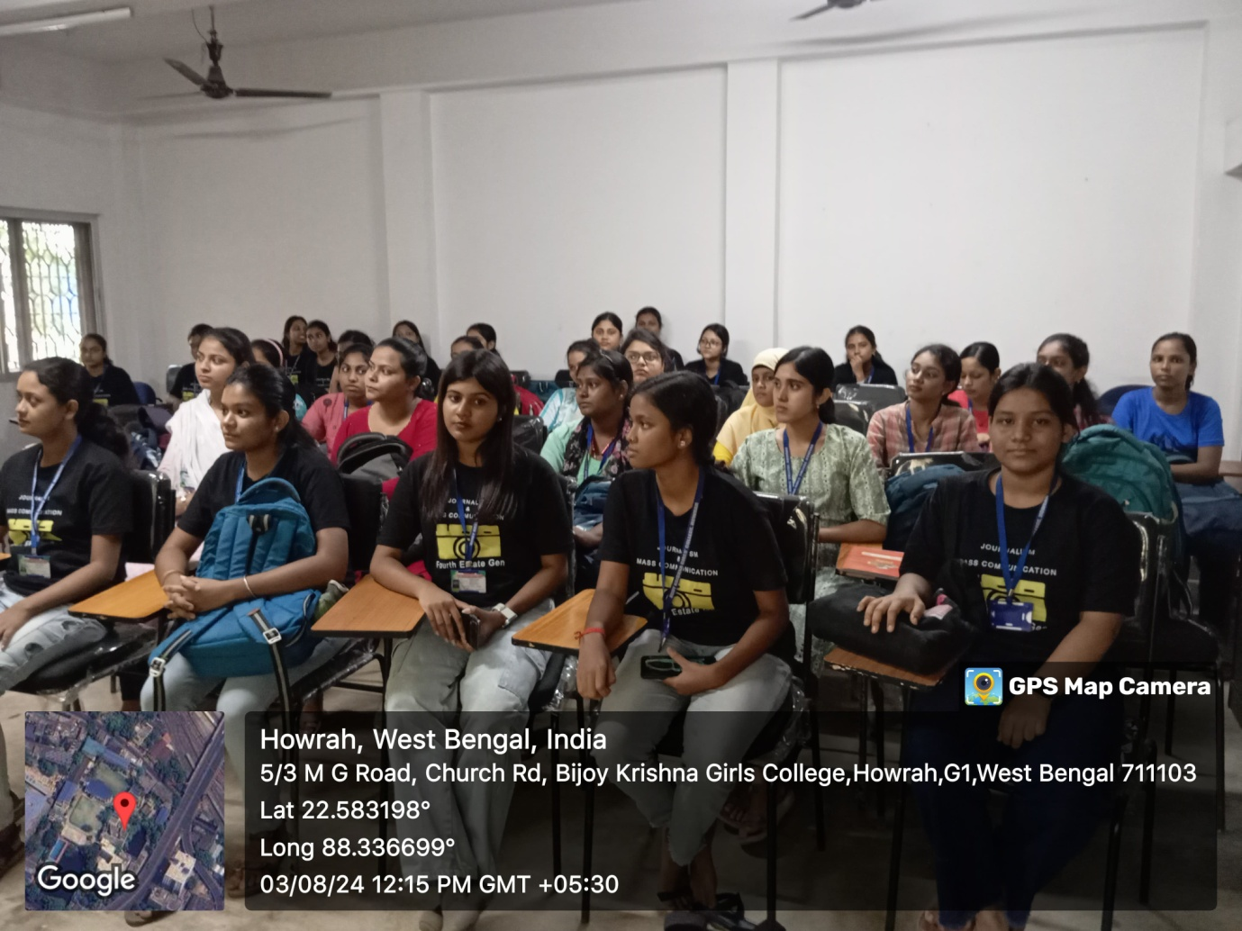

Day 5 Dates Durations
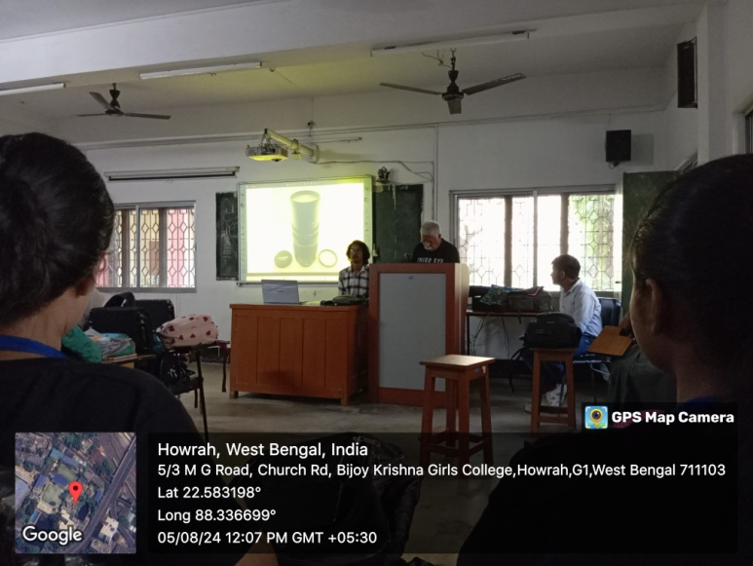
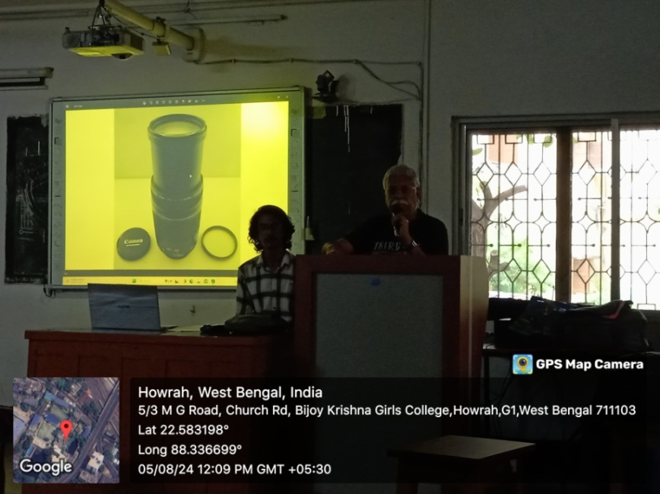
5.8.2024 Four Hours

Day 6 Dates Durations
27.9.2024 Four Hours
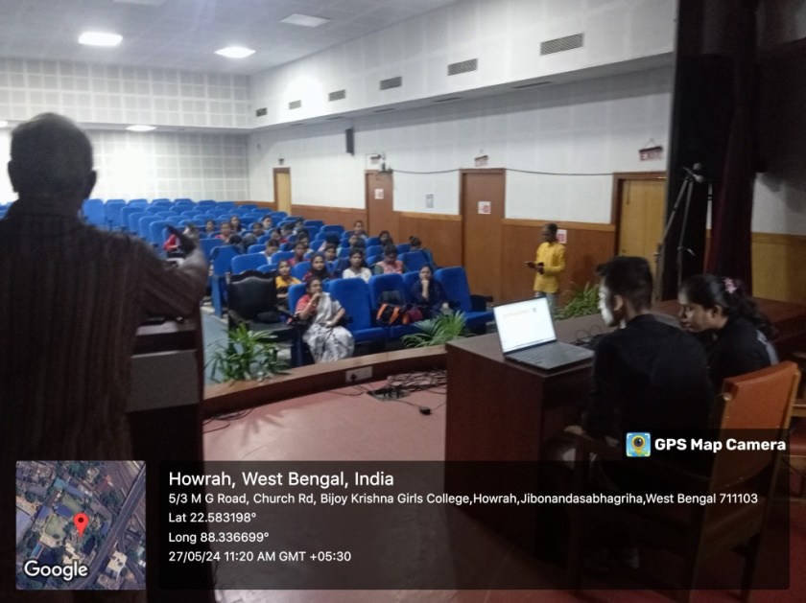
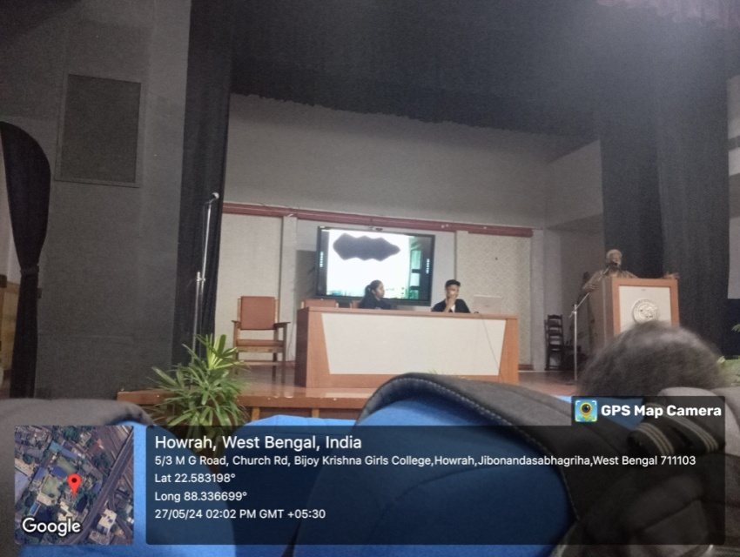
Day 7 Dates Durations
14.11.2024 Four Hours

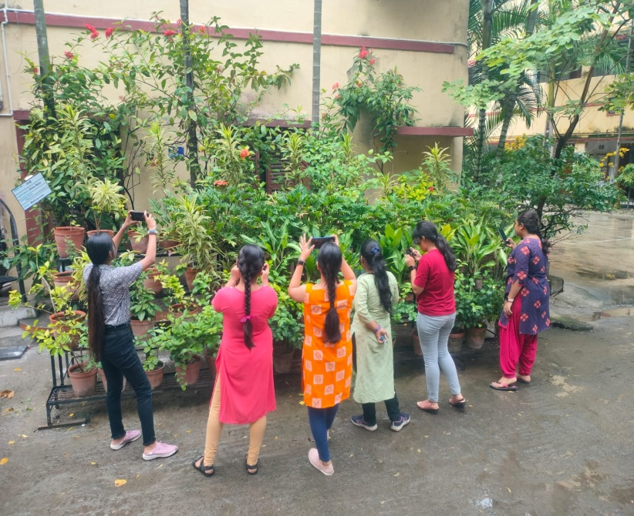
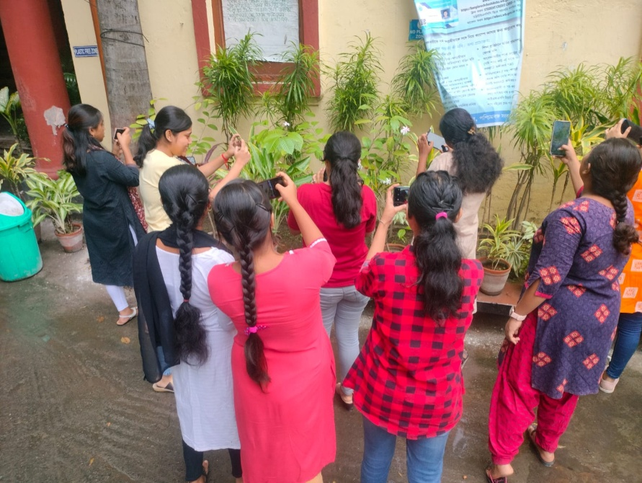
Day 8 Dates Durations
16.11.2024 Four Hours

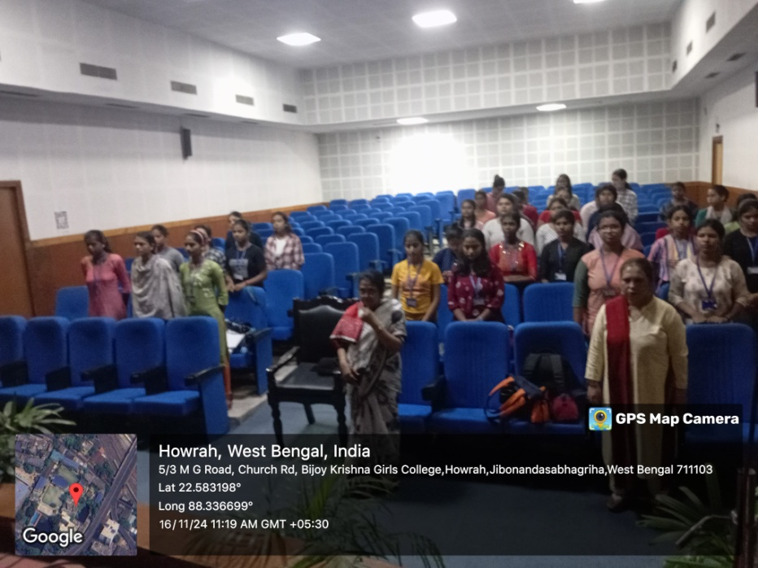
Student’s Attendance
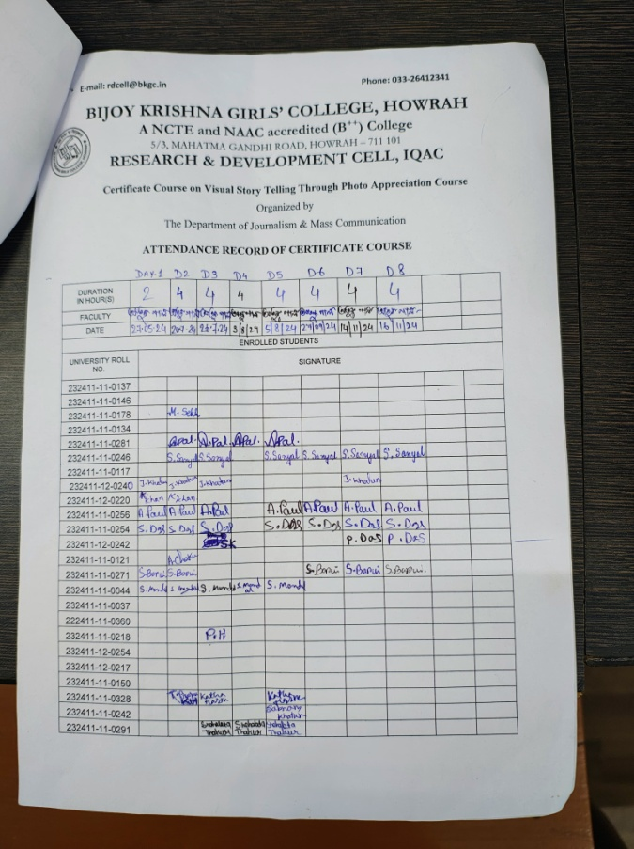
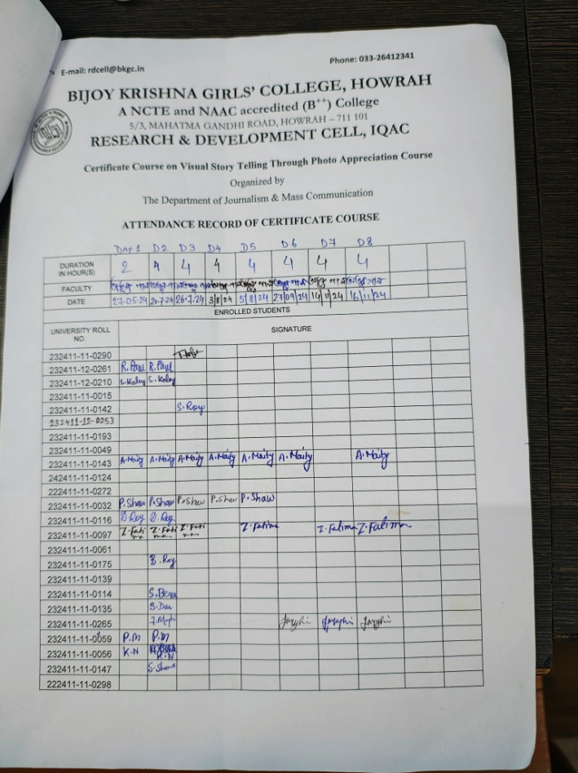
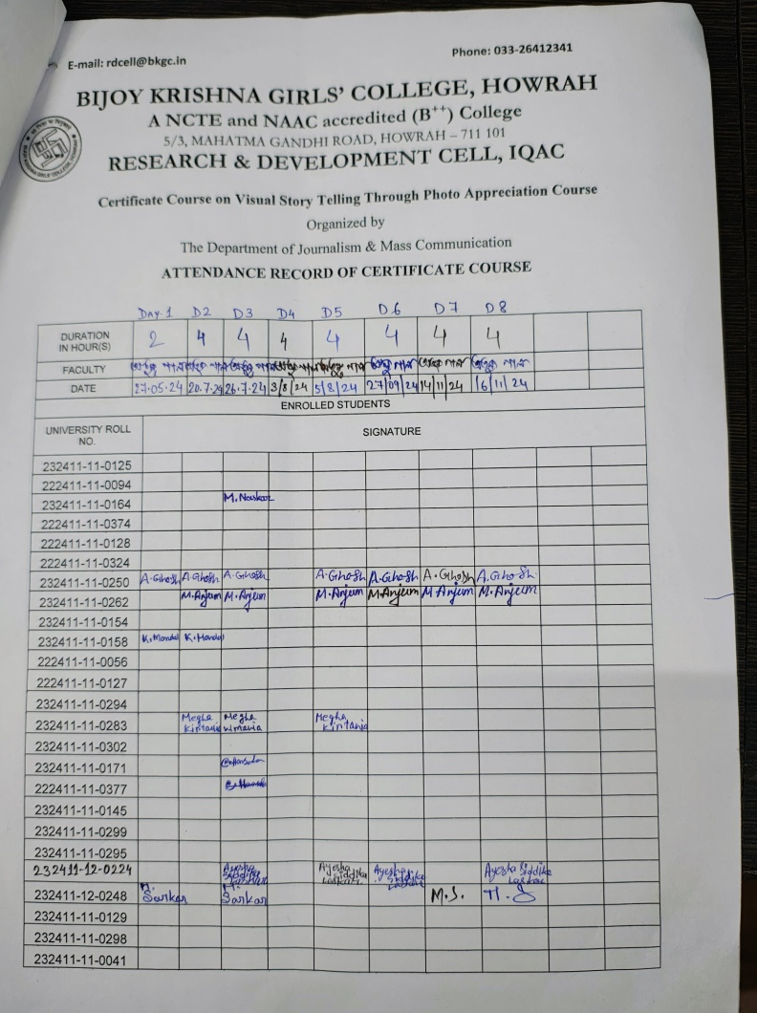
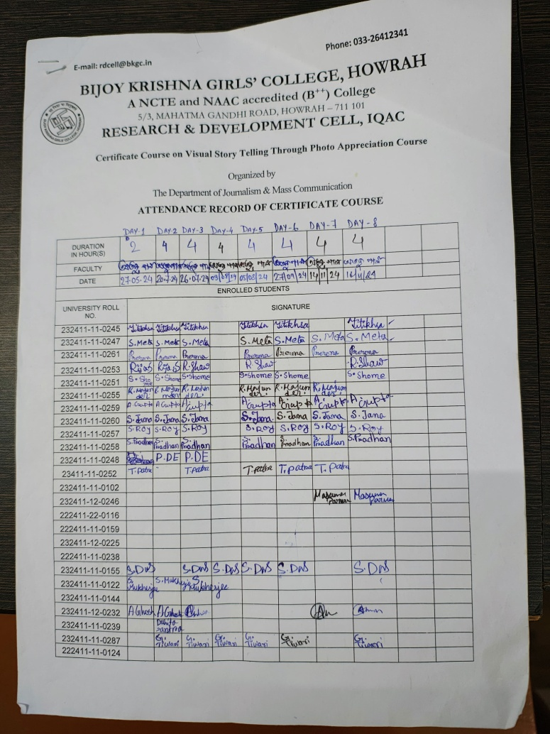
Student’s Attendance
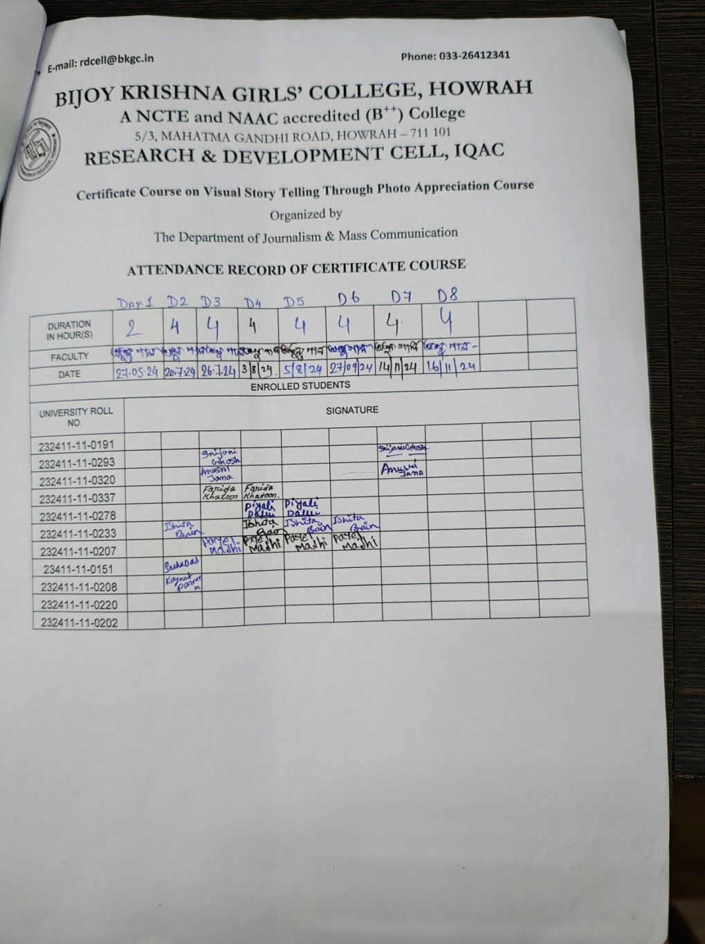
BIJOY KRISHNA GIRLS’ COLLEGE, HOWRAH
Department of Journalism & Mass Communication
Photography class 2024
List of exam qualified candidates
Name Of Student | CU Roll No.
Ayantika Maity | 232411-11-0143
Sudipa Das | 232411 – 11-0155
Ankita Ghosh | 232411-11-0232
Munmun Sarkar | 232411-11-0248
Ayesha Siddika Laskar | 232411-12-0224
Papiya Das | 232411-12-0242
Masuma Parveen | 232411-12-0246
Zakia Fatima | 232411-11-0097
Gayitri Tiwari | 232411-11-0287
Sushmita Barui | 232411-11-0271
Jaba Majhi | 232411-11-0265
Sutapa Das | 232411-11-0254
Arpita Paul | 232411-11-0256
Shreya Roy | 232411-11-0257
Sreetama Sanyal | 232411-11-0246
Shresthya Shome | 232411-11-0251
Sanchita Meta | 232411-11-0247
Anindita Ghosh | 232411-11-0250
Rija Shaw | 232411-11-0253
Titikhsa Goswami | 232411-11-0245
Antara Gupta | 232411-11-0259
Mania Anjum | 232411-11-0262
Sumita Pradhan | 232411-11-0258
Prerona Chowdhury | 232411-11-0261
Sneha Jana | 232411-11-0260

Valedictory Session
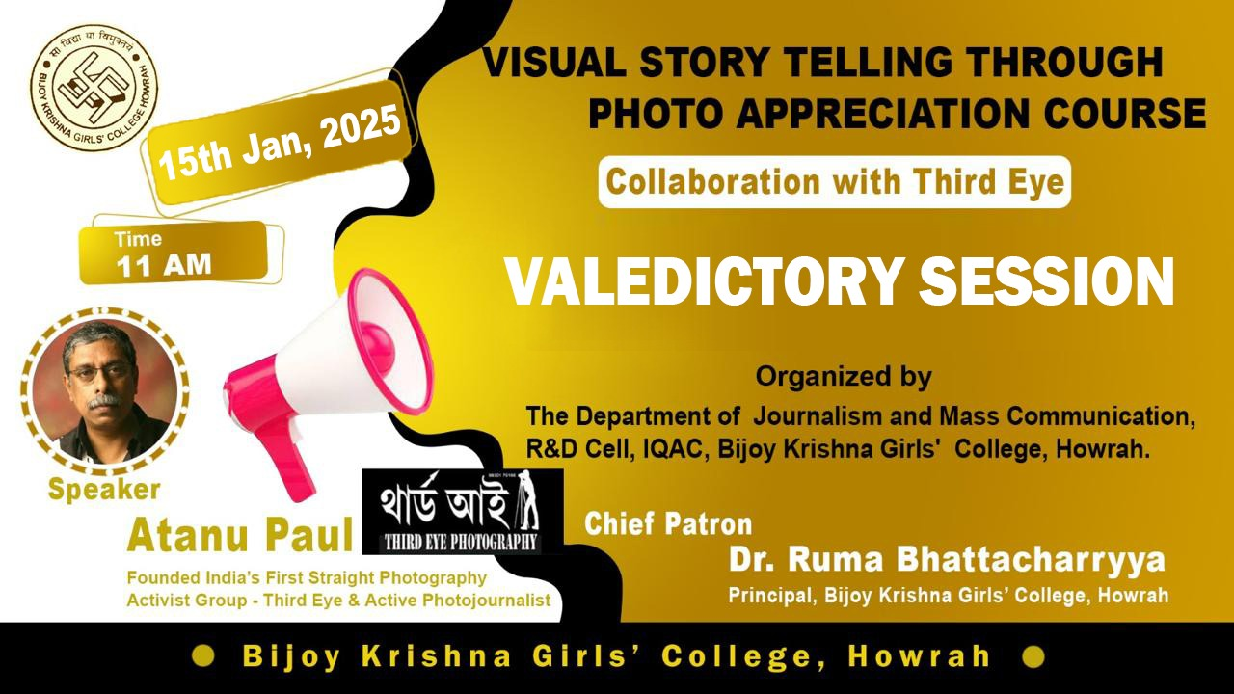

Certificate Distribution
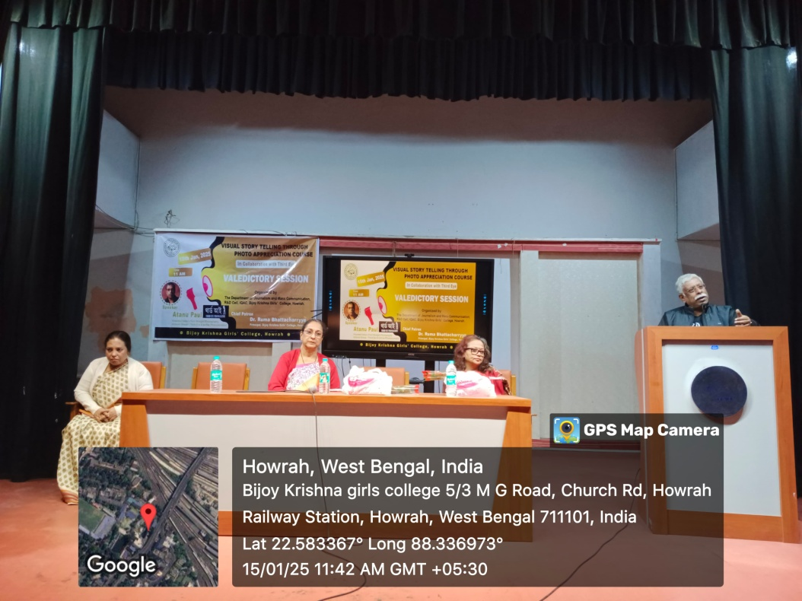
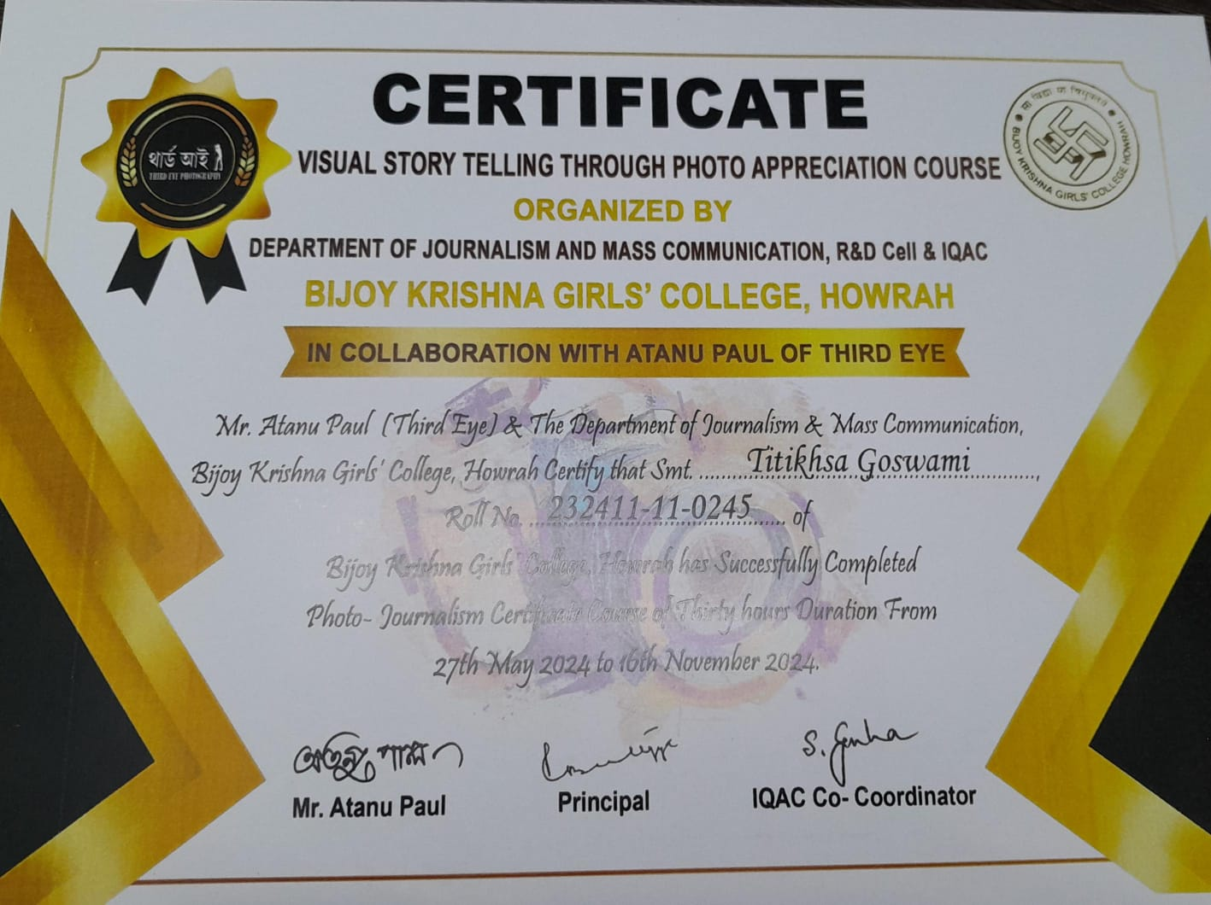
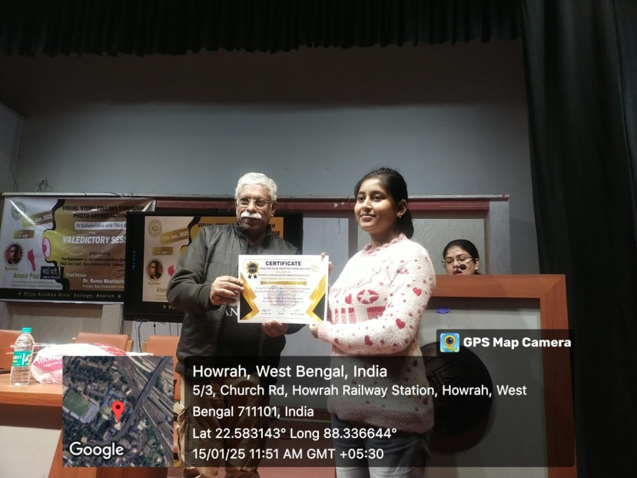
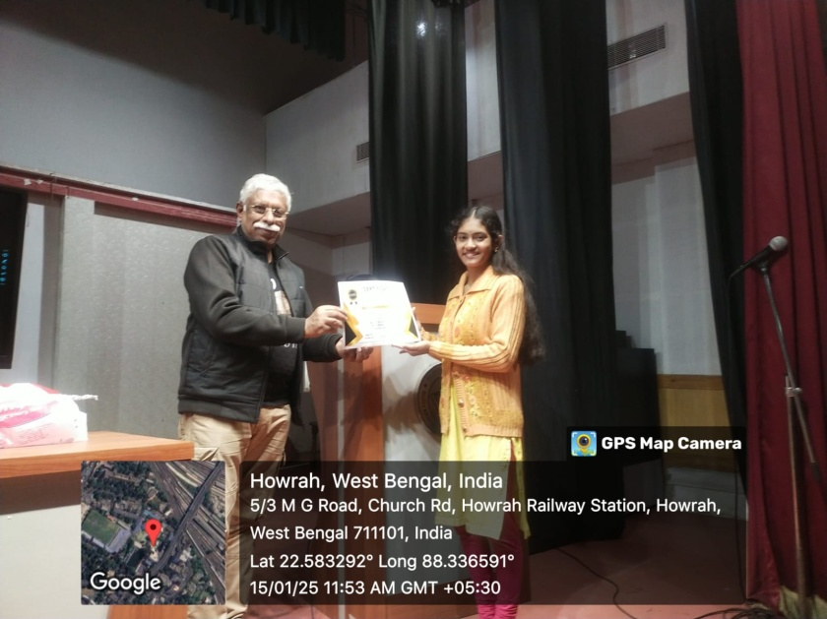

Program Outcome: The duration of this certificate course was thirty hours along with two hours examination. This course was continued till the end of the year. It was a great opportunity to the students to have this kind of certificate course. They learned all the titbit of camera and its angle. This course will help the students to think independently for making career in this photography field.
